DESIGN and TECHNOLOGY at West Kidlington Primary School –
Cycle A and Cycle B
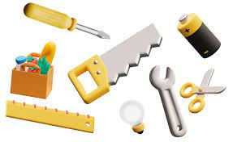 | YEAR 1/2 | YEAR 3/4 | YEAR 5/6
CYCLE A  (2023/24) | Textiles: Hanging decorations  Mechanics: Moving sea creatures  Structures: Shoebox castles  Cooking: Food from the rainforest  Construction: Flight | Construction: Build a bridge  Cooking: World foods Textiles:  Make an Anglo-Saxon purse  Electronics: Make a lighthouse  Mechanics: Pop-up books | Cooking: Apple, ginger, carrot muffins  Electronics: Steady hand game  Construction: Playgrounds  Mechanics: Automata toys  Textiles: cushion
CYCLE B  (2024/25) | Wheels and axles: Land pirate ships  Textiles: Hand puppets  Mechanics: Moving pictures  Cooking:  Structures: Tudor houses | Textiles: Weaving  Construction: Make a volcano  Cooking: WWII ration cookery  Mechanics: South America – The Amazon  Electronics: The Romans | Textiles: Christmas decoration  Electronics: Fairgrounds  Construction: Playgrounds  Cooking: Mayan food  Mechanics: Pneumatic monster

