HISTORY

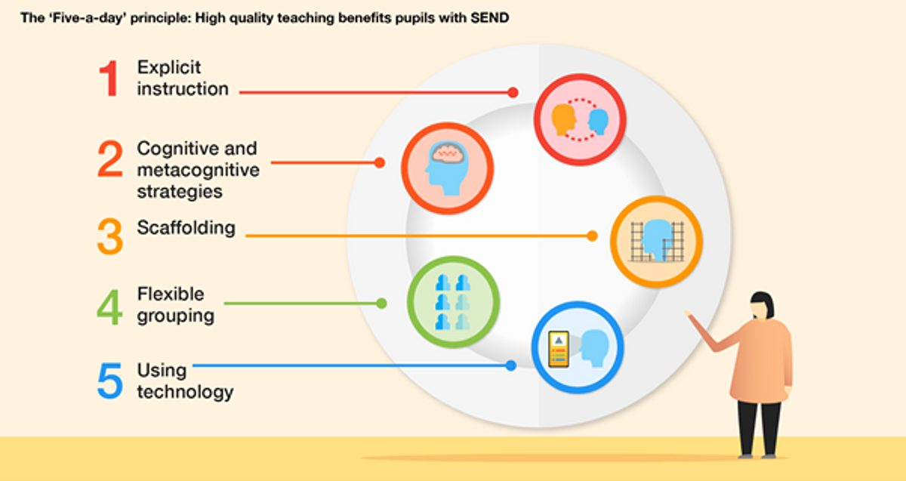

**Curriculum Intent**

At West Kidlington Primary and Nursery School, it is our intent to create historically curious pupils, who love learning about and exploring the past. Through the careful development of historical skills and concepts, the pupils are then able to make real links between the past and their present.

The teaching of good quality history lessons will help pupils to understand the complexity of people’s lives, the process of change, the diversity of societies and relationships between different groups, as well as their own identity and challenges of their own time.

Each year, the pupils will explore aspects of local, national and global history, helping them to develop their understanding of people, events and the story of the past in a chronologically cohesive way. In turn, helping them to understand where and how the aspect of history they are exploring fits into the bigger historical picture and developing their own view of the periods studied as well as being able to discuss and debate the views of other’s that might differ from their own.

**Curriculum Implementation**

The teaching and implementation of the History Curriculum is based on the National Curriculum and is embedded within our termly topics. Each topic has an enquiry-based question which allows pupils to ask perceptive questions, think critically, discuss evidence, consider arguments, and develop judgements. Through this we provide diversity and inclusion for every leaner. The progression of knowledge and skills are mapped out on our progression document and further details of the curriculum can be found on the long-term planning which spans over two cycles.

Oxfordshire has a long and diverse history going back to pre-history, which allows us to provide the pupils with enriching and relevant experiences such as artefacts from the Oxfordshire museum loan boxes, history workshops as well as school trips which all add to the wide and varied History Curriculum open to all pupils, enabling them to develop a deeper historical knowledge and understanding.

**Curriculum Impact**

By the end of Key Stage 2, West Kidlington pupils will:

* Have a secure knowledge and understanding of people, events and contexts from the historical periods covered.
* Have a secure knowledge of historical concepts and processes linked to these periods.
* The ability to think critically about history and communicate confidently in styles appropriate to a range of audiences.
* The ability to support, evaluate and challenge their own and other’s views using detailed, appropriate and accurate historical evidence derived from a range of sources.
* The ability to think, reflect, debate, discuss and evaluate the past, forming and refining questions and lines of enquiry.
* A passion for history and an enthusiastic engagement in learning, which develops their sense of curiosity about the past and their understanding of how and why people interpret the past in different ways.
* A respect for historical evidence and the ability to make robust and critical use of it to support their explanations and judgements.

As a result of inspiring and engaging History lessons, pupils have a desire to always want to know and find out more and are rewarded and celebrated when they utilise their skills beyond the classroom.