History at West Kidlington Primary School and Nursery 2023-2024: Curriculum Progression
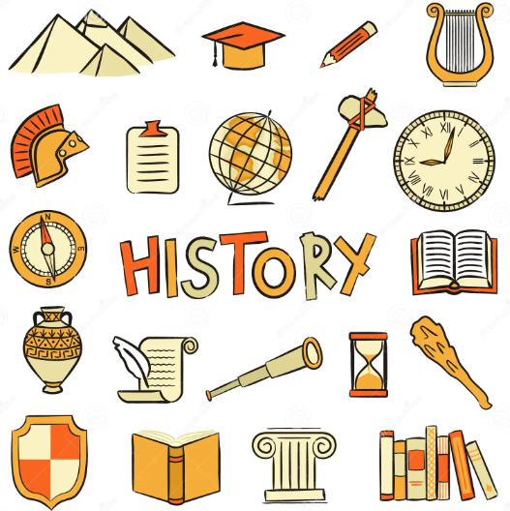 | Year 1/2 | Year 3/4 | Year 5/6
Chronological understanding | - Sequence events in their life.  - Sequence 3 or 4 artefacts from distinctly different periods of time.  - Match objects to people of different ages.  - Sequence artefacts closer together in time - check with reference book.  - Sequence photographs etc. from different periods of their life.  - Describe memories of key events in lives. | - Place the time studied on a time line  - Use dates and terms related to the study unit and passing of time  - Sequence several events or artefacts  - Place events from period studied on time line  - Use terms related to the period and begin to date events  - Understand more complex terms eg BC/AD | - Know and sequence key events of time studied  - Use relevant terms and period labels  - Make comparisons between different times in the past  - Place current study on time line in relation to other studies  - Use relevant dates and terms  - Sequence up to 10 events on a time line
Range and depth of historical knowledge | - Recognise the difference between past and present in their own and others’ lives.  - They know and recount episodes from stories about the past.  - Recognise why people did things, why events happened and what happened as a result.  - Identify differences between ways of life at different times. | - Find out about every day lives of people in time studied  - Compare with our life today  - Identify reasons for and results of people's actions  - Understand why people may have wanted to do something  - Use evidence to reconstruct life in time studied  - Identify key features and events of time studied  - Look for links and effects in time studied  - Offer a reasonable explanation for some events | - Study different aspects of different people - differences between men and women  - Examine causes and results of great events and the impact on people  - Compare life in early and late 'times' studied  - Compare an aspect of life with the same aspect in another period  - Find out about beliefs, behaviour and characteristics of people, recognising that not everyone shares the same views and feelings  - Compare beliefs and behaviour with another time studied  - Write another explanation of a past event in terms of cause and effect using evidence to support and illustrate their explanation  - Know key dates, characters and events of time studied
Interpretations of history | - Use stories to encourage children to distinguish between fact and fiction.  - Compare adults talking about the past – how reliable are their memories?  - Compare 2 versions of a past event.  - Compare pictures or photographs of people or events in the past.  - Discuss reliability of photos/ accounts/stories. | - Identify and give reasons for different ways in which the past is represented  - Distinguish between different sources – compare different versions of the same story  - Look at representations of the period – museum, cartoons etc  - Look at the evidence available  - Begin to evaluate the usefulness of different sources  - Use text books and historical knowledge | - Compare accounts of events from different sources – fact or fiction  - Offer some reasons for different versions of events  - Link sources and work out how conclusions were arrived at  - Consider ways of checking the accuracy of interpretations – fact or fiction and opinion  - Be aware that different evidence will lead to different conclusions  - Confidently use the library and internet for research
Historical enquiry | - Find answers to simple questions about the past from sources of information e.g. artefacts.  - Use a source – observe or handle sources to answer questions about the past on the basis of simple observations. | - Use a range of sources to find out about a period  - Observe small details – artefacts, pictures  - Select and record information relevant to the study  - Begin to use the library and internet for research  - Use evidence to build up a picture of a past event  - Choose relevant material to present a picture of one aspect of life in time past  - Ask a variety of questions  - Use the library and internet for research | - Begin to identify primary and secondary sources  - Use evidence to build up a picture of a past event  - Select relevant sections of information  - Use the library and internet for research with increasing confidence  - Recognise primary and secondary sources  - Use a range of sources to find out about an aspect of time past  - Suggest omissions and the means of finding out  - Bring knowledge gathered from several sources together in a fluent account
Organisation and communication | - Communicate their knowledge through discussion, drawing, pictures, drama/role play, making models, writing and using ICT | - Communicate their knowledge through discussion, drawing pictures, drama/role play, making models, writing and using ICT  - Recall, select and organise historical information  - Communicate their knowledge and understanding | - Recall, select and organise historical information  - Communicate their knowledge and understanding  - Select and organise information to produce structured work, making appropriate use of dates and terms.

EYFS Understanding the World | Nursery | Reception | Year 1
 | Talk about significant past event- often summer holiday or a birthday  Talk about what they did earlier in the day or just a few moments ago.  To be introduced to the fact that Christmas was a long long time ago no cars, phones, computers, buses and there was a time before this.  Talk about what they have done earlier in the day; learning they have done in the day; what they have had for breakfast or lunch; how they have changed since they were a baby.  To investigate past family events through family photos which they are part of. Find out about what life was like for their grandparents and parents; about family stories and memories which they are not part of.  Find out about a long time ago through the book Peepo.  Talk about significant past event- often summer holiday or a birthday  Talk about what they did earlier in the day or just a few moments ago.  To be introduced to the fact that Christmas was a long long time ago no cars, phones, computers, buses and there was a time before this.  Talk about what they have done earlier in the day; learning they have done in the day and what they have had for breakfast or lunch.  To compare old and new items and notice how they have changed or stayed the same.  To notice the difference between old and new buildings within Kidlington  Find out about a long time ago through the book Peepo. | To talk about farm vehicles a long time ago compared to farming machines today. Linking to The Little Red Hen topic and harvest.  Children will know about the past through settings and characters.  To know about my own life story and how I have changed from a baby to now.  Children will talk about past and present events in their lives and what has been read to them.  Children will talk about the past and present events in their lives.  To Talk about the lives of people around them and their roles in society | - Sequence events in their life.  - Sequence 3 or 4 artefacts from distinctly different periods of time.  - Match objects to people of different ages.  - Recognise the difference between past and present in their own and others’ lives.  - They know and recount episodes from stories about the past.  - Use stories to encourage children to distinguish between fact and fiction.  - Compare adults talking about the past – how reliable are their memories?  Find answers to simple questions about the past from sources of information e.g. artefacts.

