**Curriculum Intent**

At West Kidlington Primary School and Nursery, we aim for all pupils to:

* Become fluent in the fundamentals of mathematics so that they develop conceptual understanding and the ability to recall and apply knowledge rapidly and accurately.
* Can solve problems by applying their mathematics to a variety of problems with increasing sophistication, including in unfamiliar contexts and to model real-life scenarios.
* Can reason mathematically by following a line of enquiry and develop and present a justification, argument or proof using mathematical language.
* Have an appreciation of number and number operations, which enables mental calculations and written procedures to be performed efficiently, fluently and accurately to be successful in mathematics.

To enable our children to develop their skills in Maths, our approach is mapped out from EYFS through to Year 6. Our approach to teaching Maths ensures the teaching and learning is progressive in skills, knowledge and understanding between year groups and across the school. We have daily teacher led Maths Lessons as well as daily Maths Meeting (Fluency) sessions to rehearse or deliberately practise key skills.

MATHS

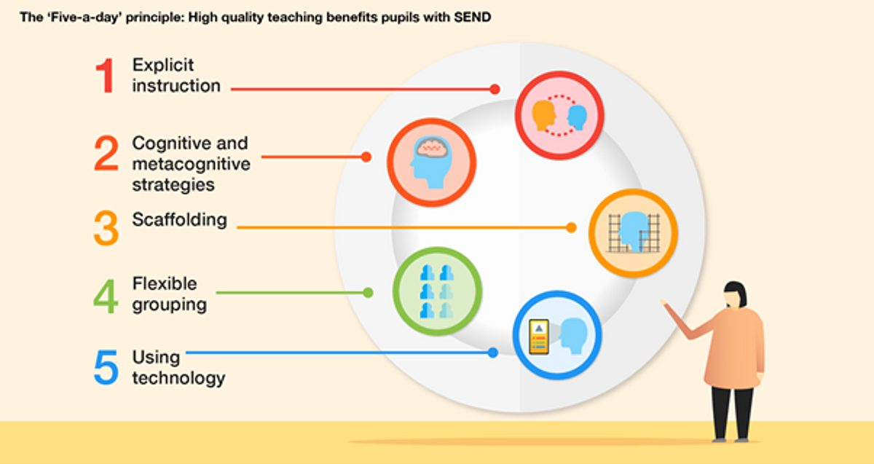

**Curriculum Implementation**

The National Curriculum is the starting point of our curriculum design. In Early Years, Maths is taught through a carefully sequenced combination of whole class input and small group adult-led activities alongside continuous provision to ensure that our youngest learners are developing a secure sense of number. The maths area in the classroom provides the children with the chance to explore their own learning with appropriate resources that they will have experienced during the whole class and small group sessions. Both EYFS and Year 1 & 2 are beginning to implement the Mastering Number Programme which will help to secure firm foundations in the development of good number sense for all children.

In Years 1 - 6, Maths learning is planned from the National Curriculum statements, which are grouped into units and divided into manageable steps using the ‘Can Do Maths’ road maps. These guarantee progression across the school and support long term planning of both the main Maths lesson and the fluency lesson. They create a coherent mathematical journey through the learning at each stage. Learning is sequences into small, manageable steps that progressively build on prior learning.

**Curriculum Impact**

Our intended impact is that by the time our pupils leave West Kidlington Primary School, they will have developed:

* Mathematical fluency based on rapid and accurate recall and conceptual understanding.
* A love of Maths, including number, geometry and reasoning and a desire to develop their mathematical knowledge and skills further in their next phase of education.
* A confidence in their ability to solve a variety of mathematical puzzles and problems that they may experience in every day life.

**Lesson Deign**

|  |  |
| --- | --- |
| **Hook It**: Introduction / real-life context  Key Learning Point  **Teach It**: Modelling new learning.  **Practise It**: All practise together – support & challenge.  **Do It**: 6 – 10 intelligently designed questions aimed to provide pupils the opportunity to practise the key learning point from the lesson. An opportunity for teachers to also ensure the new learning has been understood.  **Secure It**: opportunity to apply understanding in a range of different contexts including identifying common mistakes or misunderstandings (true or false, spot the mistake, reason and explain).  **Deepen It**: learners challenge themselves and deepen their understanding of the key learning point. Teachers plan open-ended problems that encourage children to think deeper and solve problems, including multiple solution problems. | Developing mathematical fluency through:   1. **Deliberate practice** - revisit previously taught objectives 2. **Fact fluency** (number bonds, multiplication and division facts)   No new learning takes place, this is an opportunity to rehearse previous learning. Children develop their fluency to ensure speed and accuracy. Sessions are planned following the Can Do sequence or addressing misunderstandings or gaps without impacting on the progress and coverage in the Maths Lesson. |

**Challenging Learners**

To guarantee all children are challenged appropriately in Maths, teachers ensure that challenge is provided through the 3 steps of the lesson. QLA from previous assessments and AfL during the lesson should inform future planning to ensure that Secure It and Deepen It parts of the lessons are correctly pitched to enable all learners to make progress and reach their full potential.

Our lesson design ensures that our rapid graspers and previously high attainers are challenged through depth of understanding rather than breadth; learners are not ‘accelerated’ to experience learning objectives from older year groups.

**Can Do Maths**

‘Can Do Maths’ is followed as a coverage overview and Key Learning Points for individual lessons to ensure whole school progression. From these objectives taken form the Can Do overview, teachers plan a lesson to ensure that children have the opportunity for rehearsal of the new learning as well as the opportunity to reason mathematically and solve problems in a range of difference contexts. School has a White Rose subscription and are also supported to use the NCTEM RTP exemplifications resources to ensure planning is varied and meets the needs of all pupils.

**Scaffolding/supporting SEND/lowest 20%**

To ensure we provide the right opportunities for our children that are within the lowest 20% and not on track to apply the taught objectives, we provide additional scaffolding and, in some cases, differentiate the learning objective. In order to ensure that all children are keeping up, children’s learning is sometimes scaffolded using additional resources (sentence stems, 5 and 10 frames, number lines, hundred squares etc). Using teacher judgement, where appropriate, teachers may differentiate the learning objective so that some of our lowest 20% and those children with SEND can achieve. Teachers will follow the same unit of Maths (following the road map) but will take appropriate learning objectives from previous year groups.