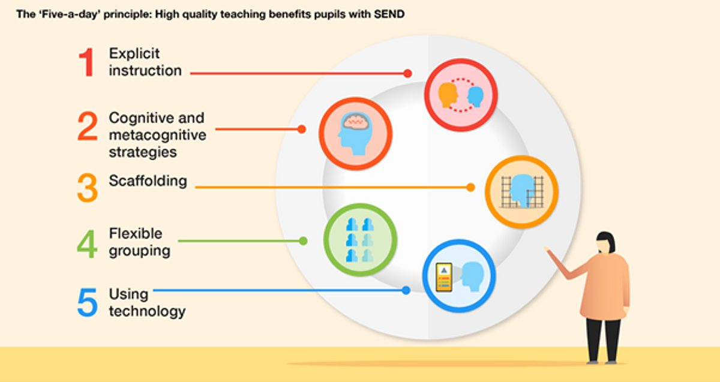

**Curriculum Intent**

At West Kidlington our languages curriculum aims to foster a vibrant, inclusive learning environment, equipping students with the linguistic tools to engage meaningfully in an interconnected world. Our intent is to cultivate a deep appreciation for cultural diversity, encouraging students to explore and celebrate different languages and traditions.

Our chosen language is French and through memorable and interactive lessons, we aspire to develop proficiency in key skills in this language: listening, speaking, reading, and writing. Communication is a fundamental pillar of our curriculum. Nurturing the ability to express thoughts and ideas with clarity and confidence makes our learning truly purposeful.

Learning a second language offers pupils the opportunity to explore relationships between language and identity, develop a deeper understanding of other cultures and the world around them with a better awareness of self, others and cultural differences. We aim to instil a lifelong love for languages, promoting curiosity both within the bounds of and extending beyond the classroom.

The intention being that they will be working towards becoming life-long language learners.

**Curriculum Impact**

We offer a relevant, broad, vibrant and ambitious foreign languages curriculum that will inspire and excite our pupils using a wide variety of topics and themes. All pupils will be expected to give their best in order to achieve their full potential. This is done by encouraging high expectations and excellent standards in their foreign language learning - the ultimate aim being that pupils will feel willing and able to study languages beyond key stage 2.

Our languages curriculum ensures that when leaving West Kidlington our pupils will:

* Have an appreciation of and passion for language learning.
* Have a strong awareness of French culture.
* Have the confidence to speak French with good pronunciation.
* Be able to read simple French texts.
* Be able to write accurately and fluently in French.
* Have an excitement about and confidence to learn other languages.

Languages

**Curriculum Implementation**

The National Curriculum is the starting point of our curriculum design. All KS2 classes have access to a very high-quality languages curriculum which will progressively develop pupil skills in foreign languages through regularly taught and well-planned weekly lessons. Careful sequencing of these helps pupils develop the skills and confidence to apply it in real-life situations and to prepare for life in the modern world.

The curriculum is designed to empower students to learn through constant practice and perfection, making and learning from mistakes along the way. Children will progressively acquire, use and apply a growing bank of vocabulary, language skills and grammatical knowledge organised around age-appropriate topics and themes - building blocks of language into more complex, fluent and authentic language.

Children will build on previous knowledge gradually and continuously as their language lessons recycle, revise and consolidate previously learnt language whilst building on all four language skills.