Music development plan summary:
West Kidlington Primary School

Overview
Detail | Information
Academic year that this summary covers | 2024-2025
Date this summary was published | September 2024
Date this summary will be reviewed | August 2025
Name of the school music lead | Daniel Pearson
Name of school leadership team member with responsibility for music (if different) | Headteacher
Name of local music hub | Oxfordshire County Music Service
Name of other music education organisation(s) (if partnership in place)

This is a summary of how our school delivers music education to all our pupils across three areas – curriculum music, co-curricular provision and musical experiences – and what changes we are planning in future years. This information is to help pupils and parents or carers understand what our school offers and who we work with to support our pupils’ music education.

Part A: Curriculum music
This is about what we teach in lesson time, how much time is spent teaching music and any music qualifications or awards that pupils can achieve.
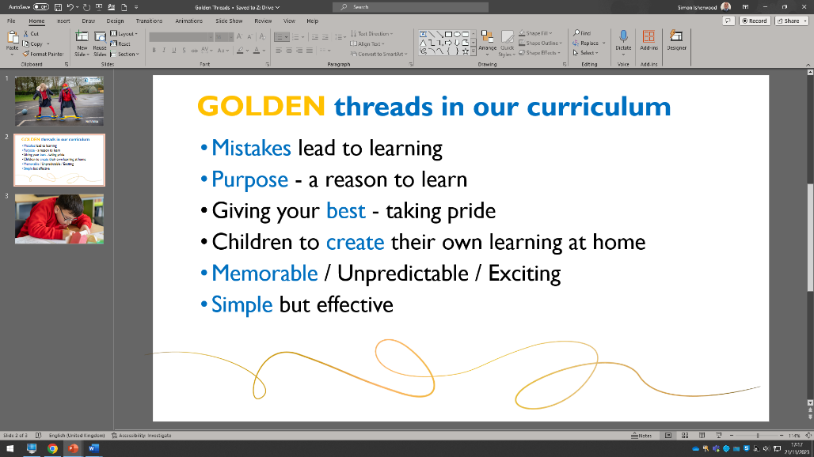
At West Kidlington Primary School, it is our intent that we make music an enjoyable and interactive learning experience. We have carefully designed a music curriculum which is underpinned by our school-wide Golden Threads.

Our Golden Threads underpin our curriculum intent enabling our pupils to achieve the following in Music:
- To be curious about different music genres and how they are composed and performed.
- To learn how to play a range of instruments.
- Use our school values to work cooperatively and persevere when activities challenge them
- To make connections in their learning and to know more, remember more and do more each year leading to academic success and enjoyment in music
- Develop skills in order to acquire, apply and transfer their knowledge ​
Students receive an hour of musical learning per week, whether that is through singing assemblies, in-class music lessons or through the listening and appreciation of a range of musical genres. Mistakes in Music are celebrated, and we use them to support learning. We further encourage children to participate in a variety of musical experiences through which we aim to build the confidence of all children, and to become the best musicians they can be.
We follow the Charanga Music Scheme, which links to the MMC (Model Music Curriculum) from YR-Y6. This school wide, interactive program teaches children to listen and to appreciate different forms of music, as well as play, improvise and compose using a range of tuned instruments and percussion. Children develop descriptive language skills in music lessons when learning about how music can represent different feelings, emotions and narratives – we give them a purpose and reason to respect Music. To develop breadth of music knowledge and appreciation, all children in school are exposed to a variety of musical artists, showcasing a variety of different genres and styles of music, both modern and classical.
KS1 and KS2 have dedicated music lessons each week, with further opportunities for cross-curricular music making included in lessons such as English, Computing and French. Within their music lessons, pupils sing weekly, play untuned percussion and listen to and appraise a variety of music. All curriculum music is delivered by the class teachers and supported by the music coordinator.
For two terms of the year, children from YR to Y6 engage in a weekly 30-minute singing assembly that is delivered specifically to their year group, taught by a highly skilled singing teacher. Children are introduced to new songs, learn musical vocabulary tailored to their year group’s curriculum requirement, and enjoy practising, rehearsing and performing together. For a further 2 terms of the year, all children participate in a whole school singing assembly for 30 minutes, allowing opportunities to practice and perform music in unison at school wide events.
The celebration of music across the school also allows pupils with SEMH to develop positive thinking strategies and increase well-being. Both listening to and creating music has been proven to have positive effects on mood and mental health. Furthermore, music can be a tool and mode of expression that allows children from disadvantaged backgrounds to thrive – PP, SEN and EAL children can all benefit from the music curriculum that we offer.
Our music curriculum, along with Long Term Plans, Progression of Skills and Intent Documents, are published on our school website and can be accessed here: Music | West Kidlington Primary & Nursery School (west-kidlington.oxon.sch.uk)

Part B: Co-curricular music
This is about opportunities for pupils to sing and play music, outside of lesson time, including choirs, ensembles and bands, and how pupils can make progress in music beyond the core curriculum.
Our school works in close partnership with the OCMS (Oxfordshire County Music Service), and this collaboration has led to West Kidlington being recognised for a ‘Music Mark Award.’ Music Mark Schools are schools that recognise the value of music education as part of a broad and balanced curriculum, engage in music development conversations with the music hub and are working on a strategy to provide a high-quality music education for all children, both inside and outside of lesson time.
Peripatetic lessons are also available for parents and carers to sign their child up to. This service is provided through OCMS and allows for additional, peripatetic music tuition for a variety of instruments, such as Guitar and Keyboard from highly skilled professionals. These lessons can take place 1:1 or as a small group depending on preference. Pupils enjoy performing music that they have learnt, and performing in front of peers is welcomed and encouraged. Further musical opportunities are provided through ‘The Rock Project’; an after-school club in which children can receive instrumental tuition and perform as part of a band. Furthermore, pupils in KS2 are provided with the opportunity to join a free afterschool Ukulele Club, which is run by the Music Coordinator, where child can learn how to play this instrument and perform in front of peers and celebration events.
Additionally, singing clubs are run at West Kidlington – Including Young Voices and a School Choir, which allow children the chance to rehearse and then perform at events in front of large audiences and celebrate music as an ensemble. Children are rewarded and celebrated when they utilise their skills outside of the classroom, and providing children with the opportunity to attend these events help to form memorable and exciting learning experiences.

Part C: Musical experiences
This is about all the other musical events and opportunities that we organise, such as singing in assembly, concerts and shows, and trips to professional concerts.
- Weekly Singing Assemblies for 30 minutes (both Year Group Specific and Whole School). Each year group is provided with opportunities for performing in front of the school during assemblies.
- Year 6 Leavers production which is performed to families and to the rest of the school.
- Year 1 and Year 2 Nativity to families and to the rest of the school.
- KS1 children attend a pantomime in December.
- KS2 Young Voices Choir, who perform each year at a large venue alongside other schools. Families can buy tickets to attend the performance and the children also share some songs with the rest of the school.
- The school choir performs for public events such as the Christmas Light Switch On, Church Services and at Summer Fayres and Christmas Fayres.
- Local school trips to neighbouring primary schools for children to celebrate music with other children in their Key Stage and Year Groups.
- Performances of musical talent by individuals or groups to their classes and/or rest of school in assemblies.

In the future
This is about what the school is planning for subsequent years.
It is our plan to:
- Engage further with the Music Hub provision of large-scale singing events for more year groups.
- Organise additional opportunities for children to engage in musical events and have more chances to perform in celebrations (e.g. talent shows, school choir, instrument clubs and more).
- Provide opportunities for children to experience a variety of high-quality live music from a range of skilled performers.
- Continue to develop our relationship with the local secondary school and nearby Primary Schools to help facilitate more opportunities to share in live performances from students.
- Secure Funding for Whole Class Ensemble Tuition (WCET) learning from a skilled professional and weave this into our Music Curriculum.

Further information (optional)
Oxfordshire County Music Service:
Centre for Music
Bayswater Road,
Oxford
OX3 9FF
music.service@oxfordshire.gov.uk
www.oxfordshire.gov.uk/music
Area Manager: Jonathon Wakefield

