Parent and Visitor Code of Conduct

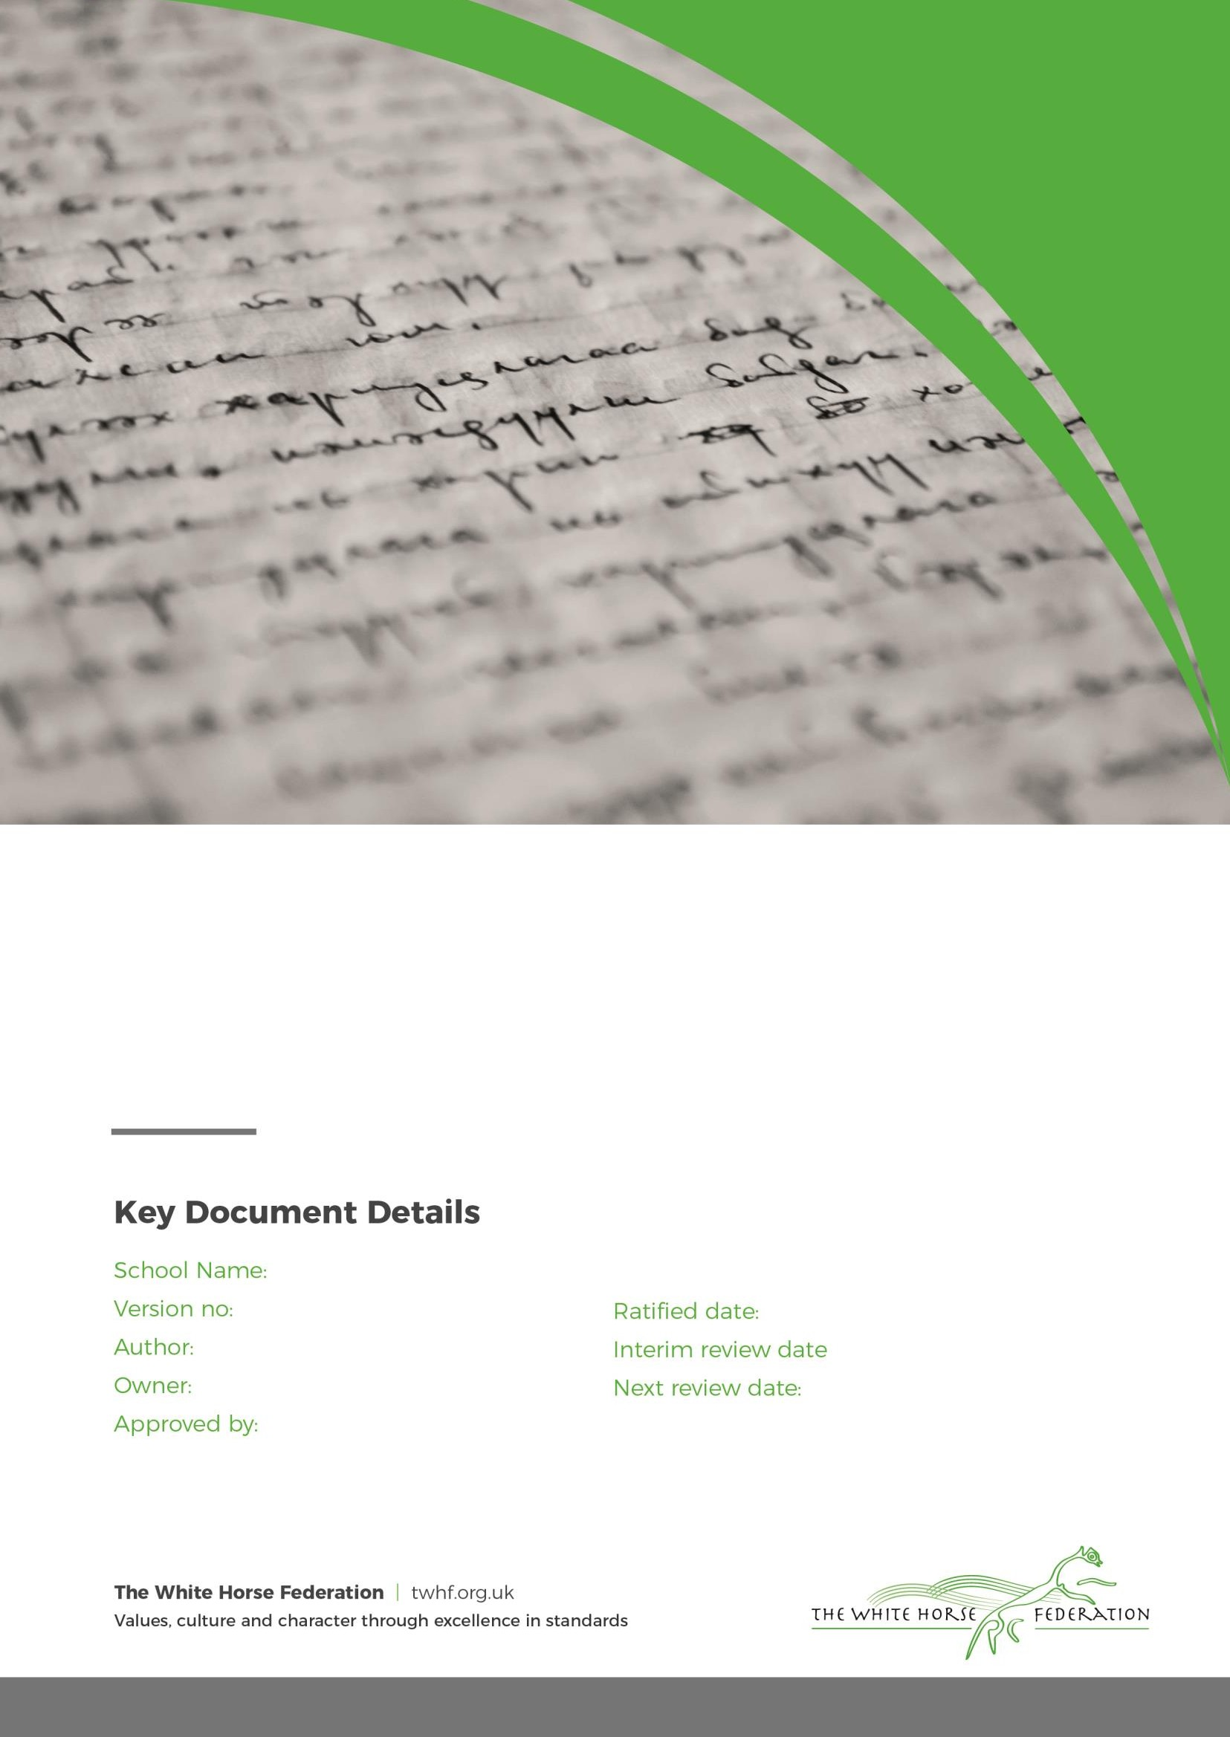
The White Horse Federation Schools 3
Simon Cowley Simon Cowley
CEO

September 2023
n/a
September 2025
Parent and Visitor Code of Conduct

- Introduction and purpose

  - The schools within The White Horse Federation are committed to a partnership between staff, parents and students to enable them to provide an outstanding education for children and young people in its academies. In order to achieve these very ambitious goals all parties must work together effectively at all times.

  - Each school aims to be an orderly, safe place where relationships between staff and visitors, especially parents, demonstrate mutual respect and shared responsibility for pupils’/students’ welfare and educational progress. Parental engagement is an important factor in educational success and in dealing with emerging problems at an early stage.

  - The purpose of this policy is to provide a reminder to parents, carers and other visitors to the schools in The White Horse Federation about expected conduct in order to maximise effective partnership working.

Legal Framework

  - This policy has due regard to statutory legislation, including, but not limited to, the following:

    - Education Act 1996

  - This policy also has due regard to guidance, including, but not limited to, the following:

    - DfE (2018) ‘Controlling access to school premises’
    - DfE (2021) ‘Best Practice Advice for academies complaints procedures 2021’

Expected behaviour and conduct

  - As well as following the guidance in each school’s Home-School Agreement, the Trust expects parents, carers and visitors to:

    - Respect the caring ethos of the school, underpinned by its core values;
    - Understand that both teachers and parents need to work together for the benefit of their children;
    - Treat all members of the school community with respect and set a good example in their own speech and behaviour;
    - Correct own child’s behaviour especially in public where it could otherwise lead to conflict, aggressive behaviour or unsafe behaviour;
    - Approach the school to help resolve any issues of concern;
    - Raise concerns about the school through the appropriate channels by contacting the relevant teacher, the Headteacher or the Chair of the Local Governing Body, so they can be dealt with fairly, appropriately and effectively for all concerned;
    - Contribute positively and constructively during meetings with school staff or governors.
    - Respect and adhere to the school safeguarding and child protection policy

Behaviour and conduct which is not tolerated

  - In order to support a peaceful and safe environment in each school, the Trust will not tolerate parents, carers and visitors exhibiting the following:
    - Disruptive behaviour which interferes or threatens to interfere with the operation of a classroom, an employee’s office, office area or any other area of the school grounds including sports pitches;
    - Using loud or offensive language, swearing, cursing, using profane language or displaying temper;
    - Threatening to do harm to a member of school staff, governor, visitor, fellow parent/carer or pupil/student regardless of whether or not the behaviour constitutes a criminal offence;
    - Damaging or destroying school property;
    - Openly displaying disrespect to any member of school staff or governor;
    - Making defamatory, offensive or derogatory comments in communication, either verbal or written (including emails, text/voicemail/phone messages or other written communication) to a member of staff or governor;
    - Making defamatory, offensive or derogatory comments regarding the school or any of the pupils/students, parents, staff or governors at the school on any social media sites (see paragraph 5);
    - Threatening a member of staff or governor either verbally or with written comments;
    - Using equipment to record conversations with members of staff and governors;
    - Using physical aggression towards another adult or child. This includes physical punishment against their own child on school premises;
    - Approaching someone else’s child in order to discuss or chastise them because of the actions of this child towards their own child (such an approach to a child may be seen to be an assault on that child and may have legal consequences);
    - Smoking and consuming alcohol or other illegal drugs whilst on school property.

  - Should any of the above behaviour occur on school premises the school may feel it is necessary to contact the appropriate authorities and if necessary, ban the offending adult from entering the school premises (see paragraph 7).

Inappropriate use of social media

  - Any concerns that parents or other community members may have about a school in the Trust must be made through the appropriate channels by contacting the relevant teacher, the Headteacher or the Chair of the Local Governing Body, so they can be dealt with fairly, appropriately and effectively for all concerned.

  - In the event that any parent/carer of a student at one of the Trust’s schools or other community member is found to be posting libellous or defamatory comments through any medium, they will be reported to the appropriate 'report abuse' section of the network site. All social media sites have clear rules about the content which can be posted on the site and they provide robust mechanisms to report contact or activity which breaches this. The Trust will also expect that any parent/carer, student or community member removes such comments immediately.

  - In serious cases the Trust will also consider its legal options to deal with any such misuse of social media and other sites.

Code of conduct during meetings

  - Meetings between staff or governors and parents/carers are an important aspect of the partnership to provide an outstanding education in The White Horse Federation’s schools. Sometimes, the focus of these meetings will be on sensitive or emotive issues; therefore, to maximise the effectiveness of the discussions, the Trust expects meetings to be conducted as follows:

    - The meeting will be held in a location which can enable confidential or sensitive issues to be discussed without undue interruptions;
    - Identify who will Chair the meeting;
    - Each party is entitled to be accompanied by a representative if they wish (for example, a parent can be accompanied by a friend or legal representative, whilst a staff member or governor can be accompanied by a professional support representative such as a senior colleague from another school in the Trust);
    - A clear understanding by all parties of the objectives of the meeting should be established at the beginning of the meeting;
    - Where appropriate, a maximum length of the meeting will be agreed by both parties at the beginning of the meeting;
    - Each party should listen to the other party without interrupting unnecessarily;
    - The use of equipment to record meetings is not permitted;
    - Each party will contribute positively to the discussions, focused at all times on reaching mutual agreement in order to seek a resolution;
    - Using intimidating or offensive language or threatening behaviour will not be tolerated; the meeting will be ended immediately should such language or behaviour occur;

Dealing with incidents

Incident report form

- All incidents of abuse, threatening behaviour, violence (verbal and physical) or any other breaches of this Code of Conduct will be recorded on the Trust’s Incident Report Form (Appendix A). A record of an incident (supported by any available photographs of injuries or damage, or relevant CCTV footage, where available or appropriate) will help in the collection of evidence where necessary (for example, for legal proceedings). Recording details of incidents also helps to inform the ongoing review and monitoring of this policy and future risk assessments.

- Any person who witnessed the incident should be asked to produce witness reports in writing as soon as possible after the incident. These should be signed and dated.

Access to school premises

- A parent/carer of a student at one of the Trust’s schools normally has implied permission to be on the school’s premises at certain times and for certain purposes. However, this permission may be withdrawn – either temporarily or permanently - in instances of breaches of this Code of Conduct, in which case the parent/carer or visitor will become a trespasser.

- Section 547 of the Education Act 1996 makes it an offence for a trespasser on school premises to cause or permit a nuisance or disturbance, and allows for the removal and prosecution of any person believed to have committed the offence. A person who persists in entering school premises and displaying unreasonable behaviour when permission has been withdrawn may be removed and prosecuted under Section 547.

Referral to external agencies

- If there is an injury to staff or governor from an assault, the Trust may need to report the injury to the Health and Safety Executive under the requirements of the Reporting of Injuries, Diseases and Dangerous Occurrences Regulations 201311. This should be discussed with the Trust’s Estates Director in the first instance.

Health and Safety Executive Guidance on reporting incidents in schools is available here: http://www.hse.gov.uk/pubns/edis1.htm
- The Trust may seek legal advice in instances of alleged harassment or libellous comments against staff members or governors. This should be discussed with the Trust’s Chief Executive Officer in the first instance.

- Serious criminal acts will be reported immediately to the Police.

  - Summary of actions in responses to breaches of the Parent and Visitor Code of Conduct

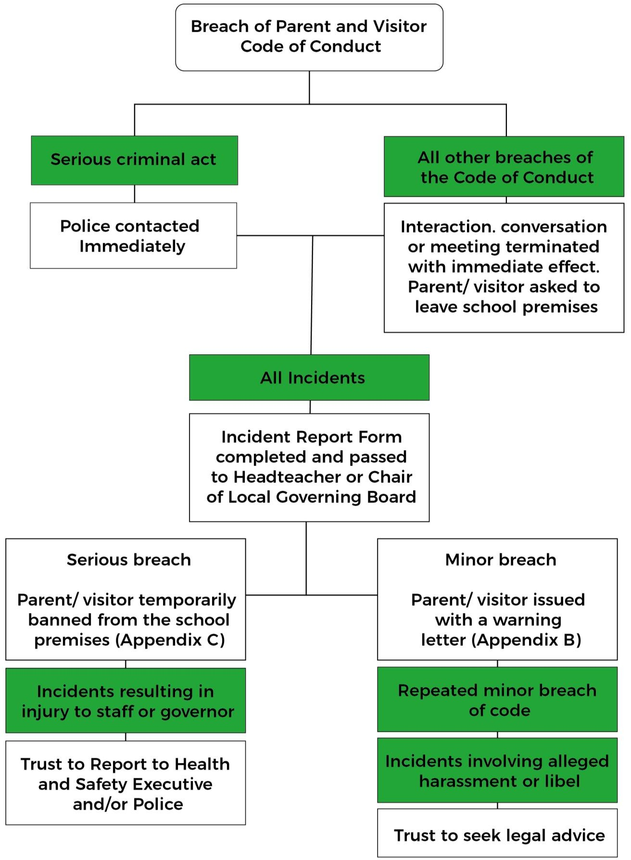

Roles and responsibilities

  - The Trust’s Board of Trustees is responsible for the approval and review of this policy, and for monitoring the appropriate implementation of this policy.

  - Each school’s Local Governing Board is responsible for monitoring the implementation of this policy in its school.

  - The Headteacher of each school is responsible for ensuring:

    - that this policy is fully implemented in their school;
    - that all parents/carers, visitors and staff members are aware of and familiar with this policy;
    - that an assessment of risk to staff and others from abusive or violent visitors is conducted where necessary;
    - that personal safety training is available to staff.

  - All parents/carers, visitors, staff members and local governing board members are responsible for familiarising themselves with this policy.

Monitoring, evaluation and review

  - The Board of Trustees, will keep this policy under review and ensure that each school’s practices are in line with this policy.

