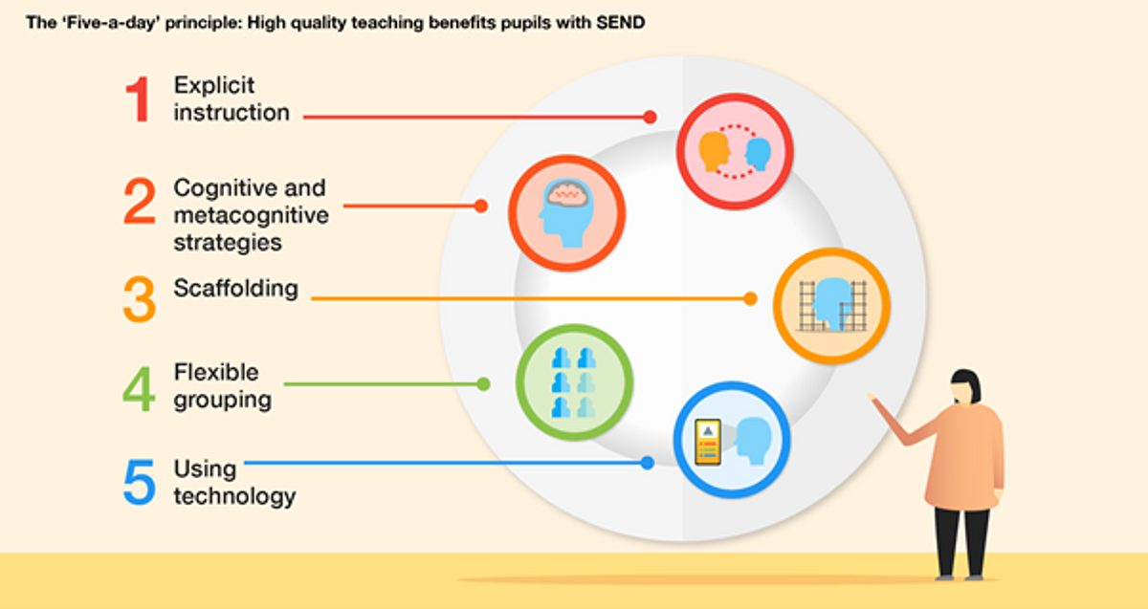

**Curriculum Implementation**

We deliver a language-rich, engaging curriculum through high quality texts in our reading lessons, as well as taking every opportunity to learn through reading in other areas of the curriculum. In EYFS and Key Stage One, phonics is taught daily alongside general comprehension skills. By making mistakes and learning from them, fluency and prosody is encouraged, allowing children to access a wide range of books.

In Key Stage Two, two or three novels are read across the year. This develops stamina and encourages rich book talk discussions. Teachers read these novels to the children, modelling a fluency of reading and prosody (the rhythm and ‘tunefulness’ of reading) that the children can then emulate themselves. The children are also asked to read sections of the novels out loud, which helps teachers track individuals’ reading speed and accuracy. Books are carefully chosen to ensure progression across the key stage, to engage all children, to provide exposure to rich vocabulary and, where appropriate in Upper KS2, different forms of narrative.

Reading in KS2 is taught four times per week. When doing a novel study, two to three lessons per week will focus on the book: reading a section or chapter, discussing unknown vocabulary, modelling high-quality book talk around what has been read, and answering questions based on the text. The remaining lessons in the week are linked either to the writing sequence, where applicable, or focus on accessing different types of text, such as information texts, and how to apply our reading skills to get the most out of them.

Each classroom has a well-stocked library with suitable and engaging books for the children to choose from for independent reading. Children experience the purpose of a great range of non-fiction text types through use of the school library which offers books suitable for the range of topics taught across the school, and is being added to regularly as new elements of curriculum, and interests of the children, arise.

**Curriculum Impact**

Continuous assessment takes place, which then informs future planning. All outcomes are measured through both formative and summative assessments, ensuring fluency and accuracy of reading is measured alongside understanding of the text itself, and by the end of their time at West Kidlington, all children will have made progress in their reading, no matter what their starting point was. Children will demonstrate a love of reading, talking about their reading both in and out of school with enthusiasm. Pupils will acquire a varied vocabulary and will want to challenge themselves.

**Curriculum Intent**

At West Kidlington Primary School and Nursery, we believe that a love of reading opens doors for every child and gives them the chance to become life-long learners. Developing a love of reading is at the heart of what we do at West Kidlington: it is vital to us that every child is excited to and takes pride in sharing what they are reading either independently or in class, and is keen to read outside of school as well.

By helping children develop a love of reading, they see its purpose as not just reading for the sake of it, but to open up their imaginations, to provide comfort as well as challenges, and to broaden their own horizons.



READING

