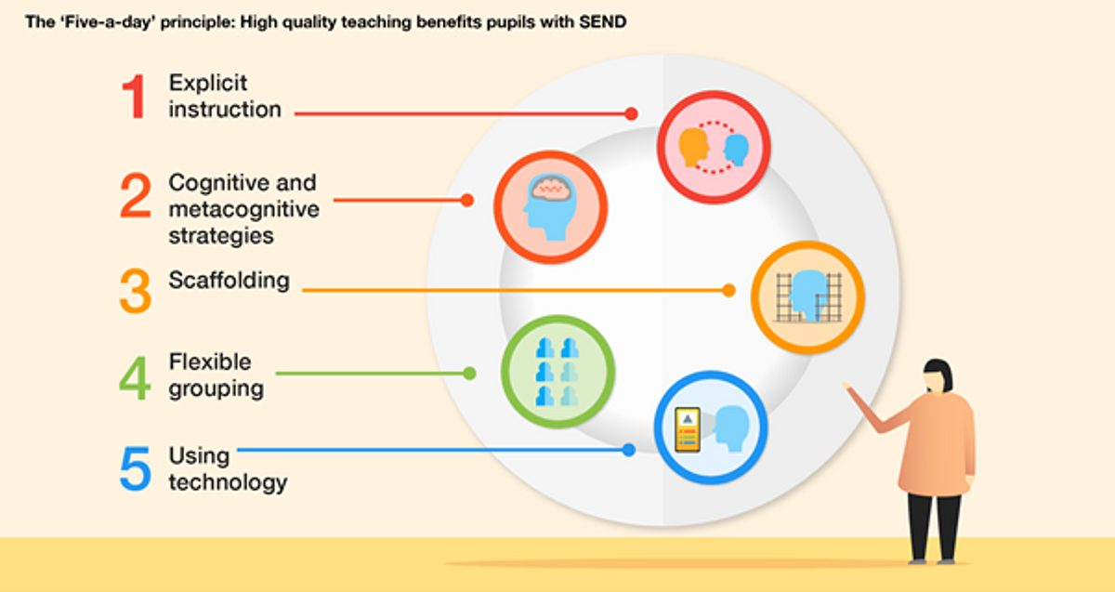

**Curriculum Implementation**

Our teaching follows a purposeful progression through the careful sequencing of units to allow our learners to draw on their knowledge across the curriculum. Where appropriate, Science learning is matched and complemented by the knowledge of other curriculum areas to allow this to further support children. Teaching is seen as a supportive tool, providing explanations of critical scientific concepts, to enable all children to question, test, explore and experiment with the real world through a collaborative approach. Children are encouraged to struggle, fail, reinvent, and scaffold the learning for themselves and those around them, creating a positive attitude towards science and reinforcing our belief of high achievement for all. The progressive nature of our curriculum encourages automaticity of scientific knowledge through the application of science skills and vocabulary. Children will be taught with a focus on both subject-specific vocabulary that links to each module of learning and vocabulary that supports their skills of Working Scientifically. Our model of teaching encourages children to revisit and build upon previous learning to help embed and extend their understandingacross the Science curriculum.

**Curriculum Intent**

At West Kidlington Primary School, our goal is to provide a dynamic and immersive Science curriculum for all children, fostering a confident exploration of the world. We aim to instil a lasting curiosity that extends beyond their school years. Aligned with the National Curriculum, our science education equips pupils with essential knowledge, enabling them to comprehend complex concepts and apply them through hands-on, Working Scientifically activities. We prioritize the continual development of scientific skills, encouraging students to inquire, experiment, and pose meaningful questions. Our approach involves using equipment, conducting experiments, and building arguments to cultivate a deep understanding of scientific principles. Embracing the inherent learning process in making mistakes, our practical curriculum sparks joy in discovering solutions. Our overarching intent is to impart Science skills that children can carry into adulthood, ensuring they become confident, lifelong learners who relish curiosity and exploration.

Science

**Curriculum Impact**

The implementation of this curriculum ensures that when all children leave West Kidlington Primary School, they have gained a rich understanding of Primary Science that they can draw upon in future learning.

In addition, they will also be able to:

* Develop scientific knowledge and conceptual understanding through the disciplines of biology, chemistry, and physics.
* Think scientifically by finding different ways to answer questions.
* Generate their own ideas on how best to answer Scientific enquiries.
* Gather and record their own evidence from practical Science opportunities.
* Ask meaningful questions to further their own understanding of Science as a core subject.
* Understand the uses and implications of science, today and in the future.
* Appreciate rational explanations and have a keen interest in explaining natural phenomena.