**Curriculum Implementation**

Writing skills in EYFS are covered through four key areas of learning: communication and language; physical development; literacy; and expressive arts and design. Through Nursery and Reception, this includes developing fine and gross motor skills using a range of tools, writing simple phrases which built to simple sentences and then on to longer sentences to express themselves.

From Years 1 to 6, the writing each term is based around a specific text and/or film that offers interesting vocabulary, sentence structure, story structure, and/or creative inspiration. Even a simple text can provide a great deal of learning opportunities!

For children in Year 1/2, key writing skills are taught, opportunities are given to apply those key skills, and then a longer piece of writing is completed. This usually takes place across one week, with four writing lessons per week, as well as opportunities for writing available through the continuous provision offer. Colourful Semantics is used to teach sentence structure. Writing is also a regular element of the Read Write Inc SSP scheme.

Writing is taught daily in Key Stage 2. The engaging texts chosen for each term support the teaching of key skills that are needed to enable children to become competent writers with a good understanding of audience (who we write for) and purpose (why we are writing).

KS2 use a 3-phase planning and teaching approach that follows a clear sequence of skills that are both progressive and sequential, and involve explicit links between the skills of writing and reading. As well as teaching children new skills appropriate for their year group, we also revisit prior learning in order to embed these skills.

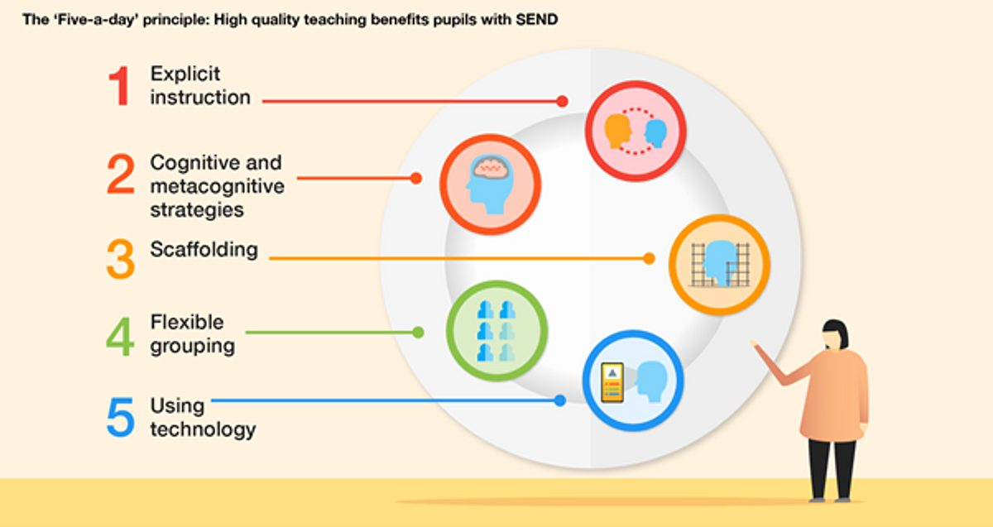

**Curriculum Impact**

Regular verbal feedback is given to the children throughout lessons so that they understand what they need to focus on next. Formative assessment is used to develop future planning, giving children opportunities to revisit areas where mistakes have occurred and learn from them. Through this process, pupils become confident in their understanding of key writing skills, and take pride in applying that knowledge to their writing. Regular moderation sessions take place in phases and across the school, ensuring teachers are confident in their assessment of pupils and in planning next steps.

**Curriculum Intent**

At West Kidlington Primary School and Nursery, we believe that securing skills and confidence as a writer sets children up for success as they move through school, as well as for success in their life beyond education. We intend to deliver a language-rich, engaging curriculum through high quality texts and visual stimuli, creating fascinating and memorable ways to develop the fundamentals of becoming a good writer. This will enable children to be completely immersed in their learning, to develop a wider vocabulary and stimulate their imagination, allowing children to create high-quality and creative written and oral outcomes.



WRITING

