Lunch In Unit 2.3.21

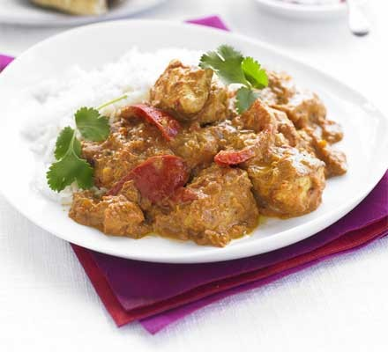
Chicken Tikka Masala

Ingredients
- 4 tbsp vegetable oil
- 25g butter
- 4 onions roughly chopped
- 6 tbsp chicken tikka masala paste
- 2 red peppers deseeded and cut into chunks
- 8 chicken breasts chopped into chunks
- 2 x 400g cans chopped tomatoes
- 4 tbsp tomato purée
- 150ml double cream
- 150ml natural yoghurt
- chopped coriander leaves, to serve
- Boiled rice

Method
STEP 1 - Heat the vegetable oil and butter in a large, lidded pan the hob, then add the onions and a pinch of salt. Cook for 15-20 mins until soft and golden.
STEP 2 - Add the tikka masala paste and peppers, then cook for 5 mins more to cook out the rawness of the spices.
STEP 3 - Add the chicken breasts and stir well to coat in the paste. Cook for 2 mins, then tip in the chopped tomatoes, tomato purée and 200ml water. Cover with a lid and gently simmer for 15 mins, stirring occasionally, until the chicken is cooked through.
STEP 4 - Remove the lid, stir through the double cream and natural yogurt, then gently warm through.
STEP 5 – Cook the rice and season, then serve the chicken tikka masala and rice in a bowl.

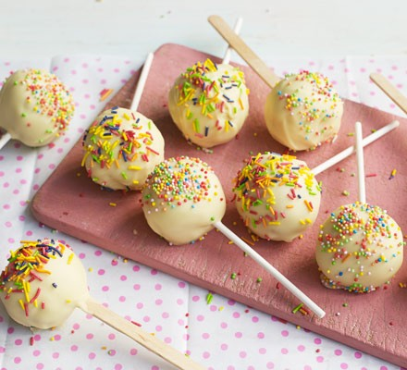
Cake Pops
Ingredients for the cake100g butter
- 100g caster sugar
- ½ tsp vanilla extract
- 2 eggs
- 100g self raising flour

Ingredients for the buttercream
- 75g butter
- 150g icing sugar
- ½ tsp vanilla extract
- 1 tbsp milk
- 200g white chocolate melted, to dip
- sprinkles, to dip
- Lollipop stick or straws

Method
STEP 1- First make the cake. Heat oven to 190C/170C fan/gas 5. Grease and line the base of a 20cm sandwich tin. Place the butter, sugar and vanilla extract into a bowl and beat well to a creamy consistency. Slowly beat in the eggs, one by one, then fold in the flour and mix well. Tip into the cake tin and bake for about 20 mins until risen and golden brown. Set aside to cool completely.
STEP 2 - While the cakes are cooling, make the buttercream. In a large bowl or the bowl of stand mixer, beat the butter and icing sugar together until smooth, add the vanilla extract and milk and beat again. Once the cake is cooled, crumble into large crumbs. Add the butter cream and stir together. Take chunks of the cake mixture and roll into balls, transferring each ball to a lined tray or plate, push a lollypop stick or straw into each, then put into the fridge for 30mins to set.
STEP 3 - Melt the white chocolate in the microwave, blasting it and stirring at 10 seconds intervals until smooth. Tip the sprinkles into another bowl. Take each of the chilled cake pops and dip into the white chocolate, allowing it to drip off a little over the bowl. Dip into the sprinkles, then stand upright in a mug to dry at room temperature for an hour, or in the fridge for 30 mins.

