Mains and pudding recipe for Tuesday 23rd February 2021

Mains

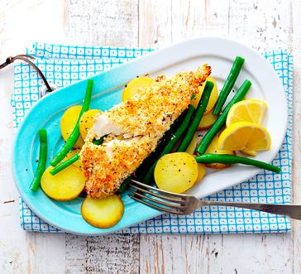
Crispy Topped Fish with New Potatoes and Green Beans.

Ingredients
- 150ml double cream
- 15ml vegetable oil
- 1 packets of plain crisps
- 2 haddock or cod fillets
- Pinch of black pepper
- 1 packet of green beans
- 8 baby potatoes
- ¼ spoon of ground coriander
- ¼ spoon garlic powder

Method

- Wash and dry your hands.
- Turn oven to 200.
- Chop the ends off the green beans.
- Put 15ml of oil into the oven proof dish and brush the dish with the oil.
- Put the 2 pieces of fish into the oven proof dish.
- Pour the cream into the measuring jug and add a pinch of black pepper.
- Put ¼ spoon of garlic powder and coriander into the measuring jug.
- Set the timer for 1 minute.
- Stir everything in the jug until the timer beeps.
- Pour all the contents of the jug over the fish in the oven proof dish.
- Open the crisp packet and crush the crisps into small pieces.
- Put the crisps on top of the fish.
- Put the 8 potatoes into the colander and wash the potatoes under the tap.
- Put the potatoes into the pan.
- Fill up the kettle and pour the boiled water into the pan with the potatoes.
- Turn on the hob and put the pan on the hob to boil the potatoes.
- Place the dish into the oven and set the timer for 20 minutes.
- Place the green beans into the collider and rinse under the tap and leave to one side.
- Sit back and wait for the 20 minute timer to end.
- When the timer has finished put the green beans into the pan with the potatoes and set a 5 minute timer.
- When the timer ends turn off the hob and the oven.
- Take the dish out of the oven and the potatoes off the hob.
- Place the colander into the sink and drain the water from the potatoes and green beans.
- Put the green beans and potatoes onto a plate and then place a piece of fish onto the plate and serve.

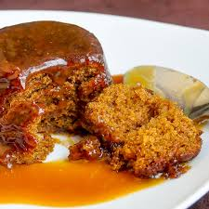
Pudding
Sticky toffee pudding

Ingredients
For the sponge
- 75g softened butter
- 50g light brown soft sugar
- 2 eggs
- 1 teaspoon vanilla extract
- 140g self raising flour
- 1 teaspoon baking powder
For the sauce
- 150ml double cream
- 75g light brown soft sugar
- 25g butter

Method

- Heat the oven to 180 degrees/160 degrees fan/ gas mark 4.
- Grease and line the bases of a tin or moulds.
- Cream the butter and sugar together until pale and fluffy.
- Add each egg individually to the mix.
- Add vanilla extract and then fold in the flour and baking powder.
- Once mixed pour mixture into baking tin or moulds.
- Cover tin with foil and cook in the oven for 25 minutes.
- Whilst the sponge is cooking you can make the sauce.
- Pour half the cream and all of the sugar and butter into a small pan.
- Heat whilst stirring gently until the sugar has dissolved.
- Turn up the heat and bubble for 3 minutes until the sauce is glossy and thick.
- Once the sauce is thick stir in the remaining cream.
- Once mixed take the sauce off the heat.
- Once 25 minute timer has ended take the puddings out of the oven and place on a plate and serve with the sauce.

