Recognise the equivalence of $\frac{1}{2}$ and $\frac{2}{4}$ | Component 3 | Entry 2.5

1 Look at the shapes.

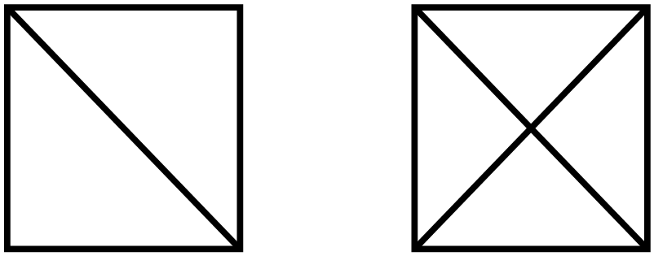

a) Shade in $\frac{1}{2}$of each shape.

b) Fill in the missing number.

$\frac{1}{2}$ = $\frac{}{4}$

2 Decide which of the following are true/false.
Circle your answer.

a)
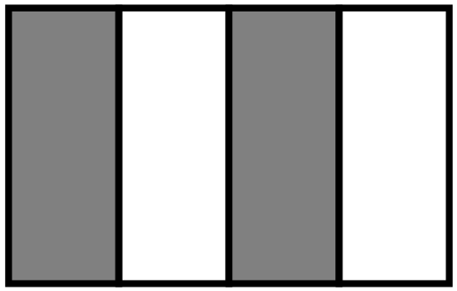
one half of this shape is shaded TRUE / FALSE

b)
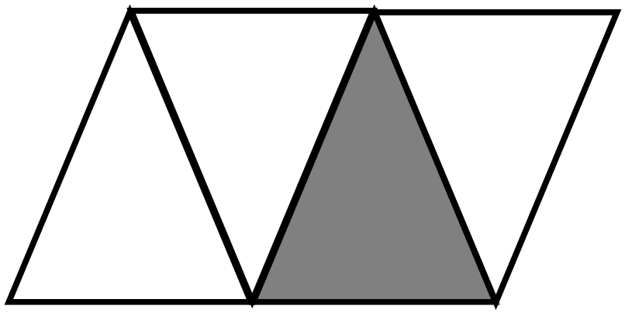
one half of this shape is shaded TRUE / FALSE

3 Jen and Dari want to share some games equally.

Jen takes $\frac{2}{4}$ of the games and Dari takes $\frac{1}{2}$ of the games.

Is this a fair way to share the games?
Show how you decide.

……………………………………………………………………………………………………………

……………………………………………………………………………………………………………

2.5 |  | 1.1

