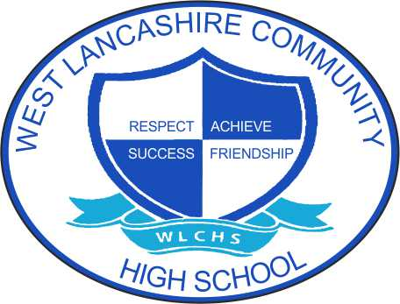 Supporting Students and Parents and Carers with staying safe online.

These symbols may help Parent’s Carer’s to support their children with symbols relating to Online Safety.
We have assembled these symbols with the support of Kidsmart. Please remember that we are always here to offer help and advice to support you with your child and help to try and keep them safe.
These symbols can be printed off and stuck on your fridge door or similar. If you would like school to produce some laminated versions of these symbols, or any other symbols to support your child please just email any of the contact numbers at the end of this document and we will endeavour to support you in any way possible.

This is document broken down into :
- Emails
- Meeting people
- Reporting

Emails:
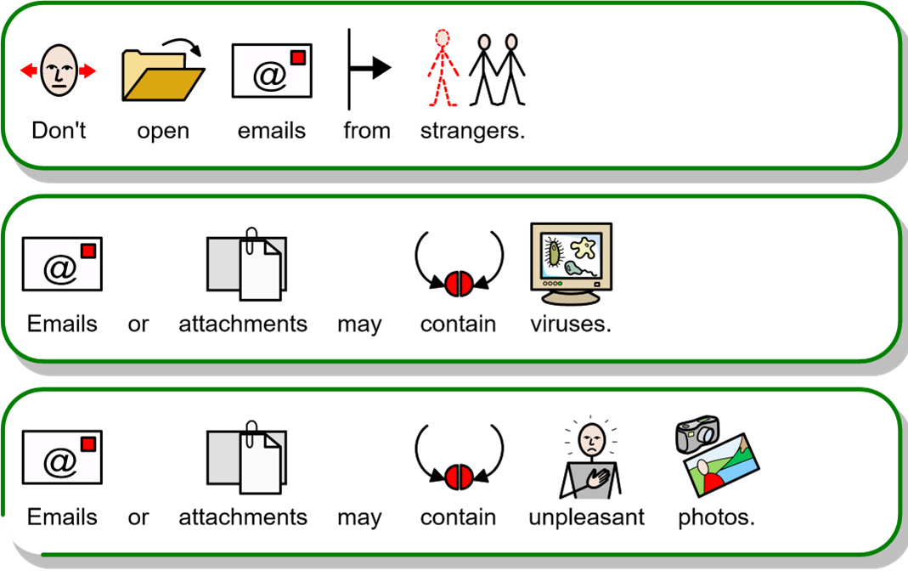

Meeting People:
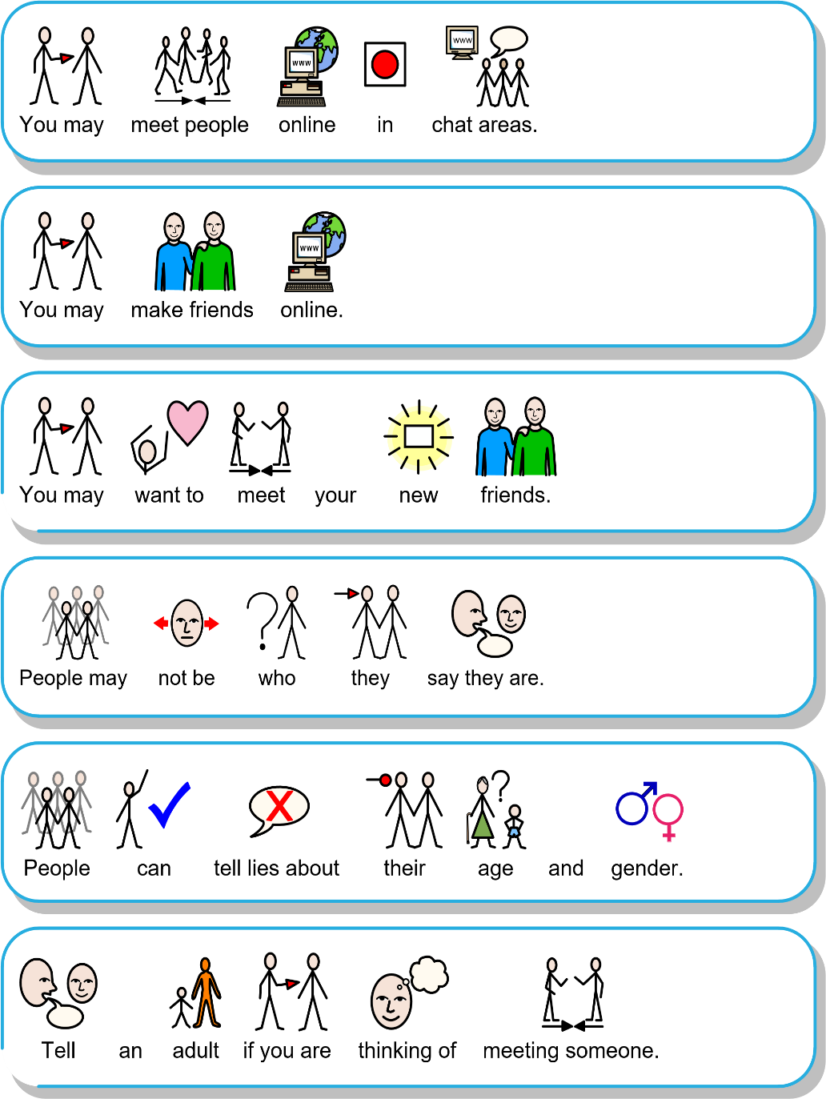

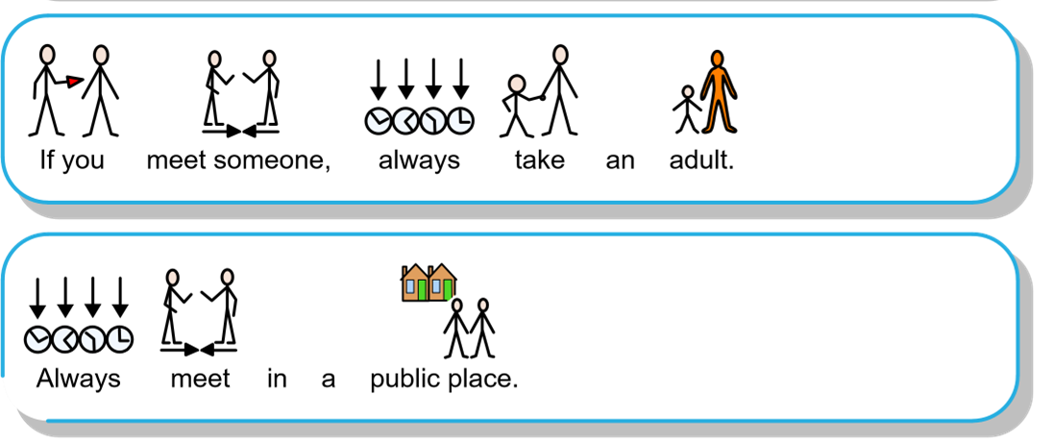

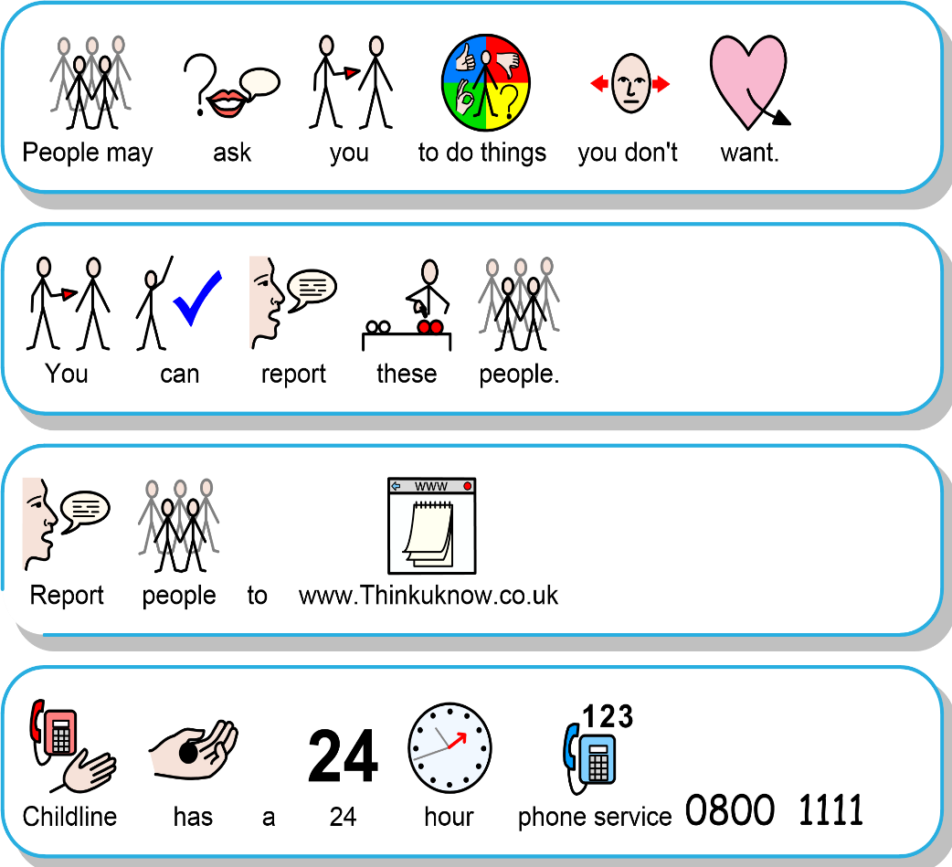
Reporting

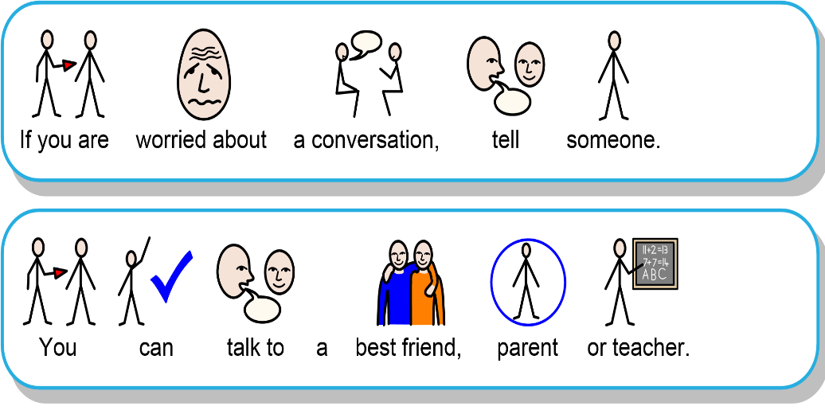

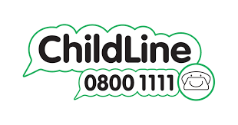
Where can I get help?
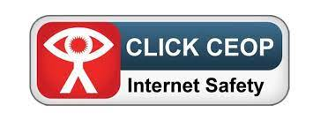
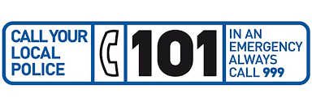


deputy@westlancs.lancs.sch.uk

mullen@westlancs.lancs.sch.uk

head@westlancs.lancs.sch.uk
We are ALL responsible for keeping our children safe, healthy and happy.

