

Admission arrangements

Document Control
Document name (inc version number, if applicable) | Admission arrangements (v1)
Date adopted by governing body | 27/1/2026
Next review | 27/1/2027
Owner | LCC
Approved on behalf of the governing body | Jeff Seddon (Chair of Governors)
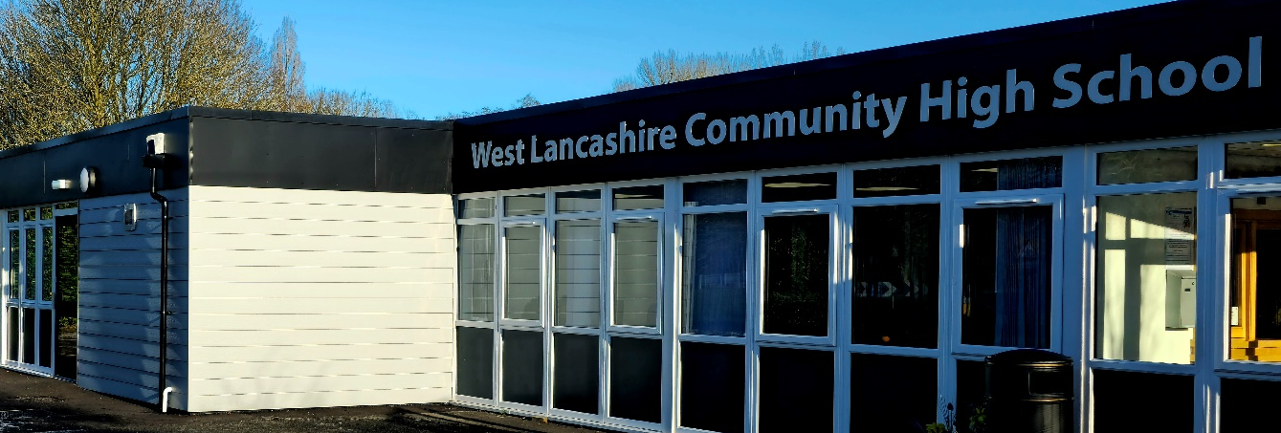

Policy for Admissions
In the processes relating to admissions and transfers, the school should have due regard to the SEN Code of Practice (Sept 2014) drawn up by the Secretary of State for Education under the terms of the Education Act 1996 plus The Equality Act 2010 (SEN). In addition, the ability to offer a place to a child will relate not only to the interests of that child but also to the interests of the children already attending West Lancashire Community High School. It is considered to be extremely important that parents/guardians are fully consulted and kept informed as to the status of any referral.

In all cases, children should have been identified as experiencing learning difficulties, which might be moderate, severe, profound and multiple or the student may be on the ASD continuum. Where students have been identified as experiencing additional special educational needs, learning difficulties should have been identified as the primary difficulty inhibiting the ability to access the curriculum. The child should already have an Education, Health and Care Plan in place.

Admissions Procedure
Students can be admitted to West Lancashire Community High at any time during their secondary school career (this will normally be initiated during Y6 for a student transferring from Primary school.) However, in terms of special educational needs under the Education Act, they may also enter at different levels:

1. Students who have an Education, Health and Care Plan;

2. Students with an Education, Health & Care Plan which requires modification;

The availability of a place at WLCHS will always be determined by the number of vacancies in year groups and the social dynamics of the group into which the student is to enter. Such considerations serve to protect the interests of the students already attending the school.

As part of the consultative process, parents/guardians of respective students who are under consideration will be offered a visit the school (a without-prejudice visit – WPV). During the visit, they will have opportunity to ask questions and discuss the appropriateness of the placement. In most cases, the prospective student will also be given the opportunity to visit and join a class. Such visits are not necessarily binding on either the parents/guardians or the school.
After a formal request for placement has been received from the LA an Admissions/Referrals form will be used to indicate the procedures which are taking place. The ability to offer a place will be determined by the status of the referral defined by the Special Educational Needs District Officer (SENDO).

1. Students who have an EHCP
These students will have undergone assessment under the Code of Practice. Upon the completion of this process, the SENDO will consider the advice from the different agencies involved with the children. If a special school placement is identified, the SENDO will send copies of the advice to WLCHS and the Headteacher will indicate whether there is a place available at the school, whether their needs can be met and whether a place can be offered.

Where a student moves into the catchment area from a special school in another area, a place, if available, can be offered without a reassessment being necessary provided he or she has a statement as identified above and the interests of the students already attending WLCHS are not at risk.

2. Students with an EHCP which requires modification
Attempts to meet the needs of students may have been made through the use of another school rather than at a SEN day school. Where a place is sought under such circumstances, an Annual Review/Interim Review should take place and there should be a common agreement that the student's needs are likely to be met. This will be reflected in the recommendations of the Review from the sending school. The procedure is then as per above 1.

Under these circumstances the student would normally be admitted to the school on a trial basis for one term and, at the end of such a period, a reassessment should take place. If the results of such an assessment are that the child's placement is appropriate, then the child will be admitted on a permanent basis and have his or her needs reassessed annually under the Annual Review Process.

Transfers Policy
In the circumstances of alternative educational provision for a child is under consideration, it important that parents/guardians are consulted and kept fully informed as to the procedures taking place. Such considerations must take into account the interests of the child and will also be the result of discussion with the SENDO and the Schools Psychological Service and, where applicable, other agencies may also be consulted. This consultation process will normally take place through the recommendations of an Annual Review and may result in a transfer into another school more appropriate to the needs of the child.

Procedures for Transfers
The educational provision for a student may need to be modified during his/her school career. This could require a transfer to or from:

1. A mainstream school.

2. A special school which has another designation.

3. A special school of the same designation.

1. Transfer to a Mainstream School
In certain cases, it may be appropriate that students transfer to a mainstream school. Before this procedure can take place, there must have been close discussion with the parents and an Annual Review which recommends such a placement. This will require the involvement of the Schools Psychological Services and any other agencies which have an input with the child and may result in the modification of the child's statement. Additionally, the parents of the student may wish to declare a preferred mainstream school.

The SENDO should be informed and, if a place is to be sought, contact made with the Headteacher of the preferred school. The opportunity for a trial period would be offered, this would normally be two terms.

The procedure which then follows is subject to the admissions policy of the receiving school and would normally involve liaison with its Special Educational Needs Coordinator (SENCO). Any special concerns relating to the child would be shared and, occasionally, define the success or failure of the transfer. The Inclusion Leader /Inclusion Manager would assist in passing necessary information between schools.

At the end of two terms, one of three decisions can be made:

- The student stays in the mainstream school and the place reserved for him/her at WLCHS is removed.

(ii) The trial period is extended for another fixed period pending a consideration of the success/failure of the integration.

(iii) The student returns to WLCHS as the inclusion has not been a success.

The decision made at the end of the trial period does not preclude the student from returning to WLCHS at a later date. However, such moves would require the processes identified in the Admissions section of this document to take place.

Transfer to another Special School of a different designation
Occasionally, it may be considered that a placement at a day school for students with learning difficulties may not be appropriate. Decisions regarding the appropriateness of places can only be made following an Annual Review and will involve parents and other agencies including the Schools Psychological Service.

The recommendations of the review can then be followed and the SENDO may wish to seek a place in an alternative school. Procedures which then follow rely upon the admissions procedure in the receiving school. However, an invitation will be made for a teacher from the receiving school to visit and the necessary processes discussed.

Transfer to another Day Special School for students with learning difficulties
Such requirements would normally be the result of the family of the child concerned moving out of the area. The course followed again will rely on the admissions procedure of the receiving school and liaison will be offered through visits and/or exchange of school records.

In all cases the interests of the student should be paramount. If necessary, the above procedures may be modified in the interests of the children concerned. It is desirable that, wherever possible, there be no time delay in the transfer process.

