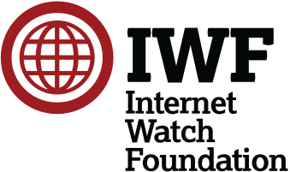

Annual Report 2022 - Internet Watch Foundation
What is the IWF?

We exist to stop child sexual abuse online
We want to see a world where no child is ever sexually abused and then forced to face the very real possibility that a record of their terrible abuse will be shared online. All too often, victims and survivors are traumatised long after the physical suffering has ended. We call it re-victimisation. It’s just another way offenders torture their victims.
No child should ever face this horror. No child should ever face this repeated abuse. It’s our job to stop this. We exist to hunt down and remove any online record of child sexual abuse. The criminals responsible for making, sharing and even selling these illegal images are totally ruthless. The images our analysts remove range from the abuse of babies, to grooming of teenagers, young people just trying to form relationships in a digital world. Sometimes they don’t even realise that they’re being trapped, until it’s too late.
It’s a tough job. But because of our work the internet is a safer place for all children. When we started, over twenty-five years ago, 18 per cent of the world’s known child sexual abuse imagery was hosted in the UK. Today, it’s less than 0.2 per cent. This means we’ve helped make the UK one of the most difficult places on the planet to host illegal images of children. We’re proud of that.
Sadly, it’s estimated that in the UK alone there are over 800,000* men who pose a sexual risk to children. That includes regularly viewing child sexual abuse online. We won’t rest until every single criminal image and video has been removed.
But we’re not dealing with a UK problem. The internet doesn’t respect borders. Neither can we. Because of our experience, we’re in a unique position to understand the challenge of stopping child sexual abuse imagery. And working in partnership with the tech community, governments, law enforcement agencies, charities and other hotlines. We’re pushing the boundaries to create new Tech for Good and to support our team of world-class analysts.
* National Crime Agency.

https://annualreport2022.iwf.org.uk/

