

CANDIDATE INFORMATION – TEACHING ASSISTANT 2B VACANCY
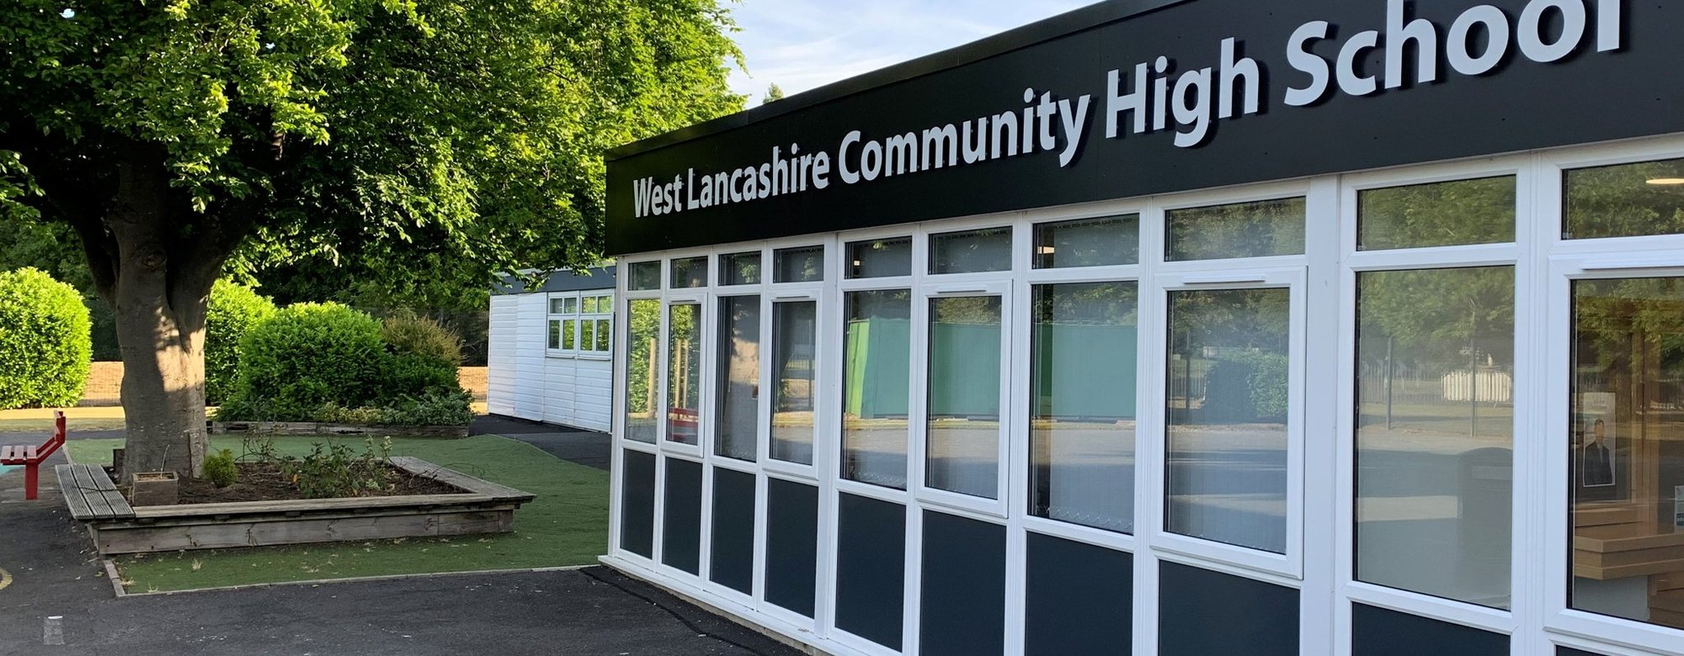
School Lane, Skelmersdale WN8 8EH
01695 721487
Welcome

Thank you for expressing an interest in the post of Teaching Assistant Level 2B.
The Governing Body and Headteacher of West Lancashire Community High School are currently inviting applications to fill Teaching Assistant, Level 2 vacancies.
The hours are 32.5 per week, term time (38 teaching weeks plus one week for INSET training). These are permanent posts.
The Teaching Assistant level 2B is a Grade 5 post, Scale points 6-11, £25,989 to £28,142 per annum (full time equivalent). If successful the salary received will be paid on a pro-rata basis which equates to a salary range of £19,864 to £21,510 per annum.
The role involves supporting students with generic learning difficulties, within a specialised environment. As a Teaching Assistant you will be expected to support the class teacher in delivering structured learning activities to individuals or groups of students. You will also assist in monitoring student progress and supporting them in their social, emotional and personal needs.
We are looking for individuals who;
• are enthusiastic and committed with a ‘can do’ attitude
• can work as part of a team
• can work effectively with students, parents and other school stakeholders.
• have the ability to motivate and inspire students to achieve
• are willing to promote our school values of respect, achieve, success and friendship.
The post is covered by the Rehabilitation of Offenders (Exceptions) Act 1975. If successful, you will be required to apply to the Disclosure and Barring Service for an Enhanced Disclosure. References will be sought for all applicants. We will always consider your references before confirming a job offer in writing.

The closing date for the post is Wednesday 15th October at 9.00 am. Ideally, we would like the successful candidate to start in the Autumn term 2025.
If you decide to apply for the post, please return the application form and letter by email to the School Business and Premises Manager: Business.manager@westlancs.lancs.sch.uk
We look forward to hearing from you in the near future.

Lee Fazackerley,
Headteacher
About us

West Lancashire Community High School is a vibrant generic learning difficulties school and has previously been inspected by Ofsted and rated good. Our students all have an Education Health Care Plan. We currently have 160 students on roll with numbers increasing, students are aged between 11 and 19 years. Our school is organised into three key stages/departments Key Stage 3, Key Stage 4, Key Stage 5.

At West Lancashire Community High School, we want our students and young adults to be the best they can be within an environment which challenges and supports. We focus upon academic, social and emotional development and progress but equally important to us is the development of independence skills to enable all to achieve, stand out as valued member of their communities and successfully meet the varying demands of an ever-changing society.

It is our dedication to achieving three core principles that allow us to develop students and young adults that are resourceful, resilient and that approach challenges with a ‘can do’, ‘nothing is impossible’ attitude. These are:

- Providing the highest quality of specialist teaching and learning experiences for all students and young adults
- Providing a curriculum that meets the needs and aspirations of all students and young adults
- Providing the highest standard of care, support and guidance to allow every student to achieve their aspirations.

We aim to provide an educational experience focused on improving education experiences and outcomes for all by:

- Developing well rounded individuals, that demonstrate greater resilience, determination and strength of character to succeed
- Equipping students and young adults with the skills to access increased opportunities and enhance their life chances
- Insisting on high expectations and challenge
- Developing an aspirational school community
- Engaging all parents and carers.

If you want to find out more about our school, please visit our website www.westlancs.lancs.sch.uk or contact the School Business and Premises Manager to arrange a visit: business.manager@westlancs.lancs.sch.uk

Job Description

JOB TITLE Teaching Assistant Level 2B
GRADE Grade 5
RESPONSIBLE TO Classroom Teacher/Department Lead
STAFF RESPONSIBLE FOR N/A

PURPOSE
Under the teacher’s clear guidance to establish positive relationships with students and support the education, personal and social development of students in the class, within an establishment catering for children with special educational needs.

CORE TASKS
In addition to the following duties, the postholder may be required to undertake any of the duties normally associated with a lower graded Teaching Assistant post.

Support for Students
Under the clear guidance of the class teacher to implement structured learning activities and to assist individual/groups of students to complete tasks.
To undertake activities to assist in monitoring the personal, social and emotional needs of students.
To develop positive relationships with students to assist student progress and attainment.
To assist in the devising of student's individual targets, their monitoring and review.
Support students as part of a planned inclusion programme
To assist in the development of varying skills that support students' learning.
To assist in the specific medical/care needs of students following relevant training.

Support for the Teacher
To assist in the monitoring/recording of student progress, problems and developmental needs.
To assist in the production of teaching aids and resources.
To undertake routine classroom administrative tasks.
To assist in student supervision and in the management of student behaviour.
To provide information to the class teacher to assist in the planning of work programmes
To liaise with the school's nominated person in respect of student absence.
To assist with the arrangements for administering student work experience.
To provide clerical and administrative support including the collection and recording of money.
Administer routine tests, assist in the invigilation of exams and undertake routine marking of students work

Support for the School
To assist in providing an atmosphere in which effective learning can take place.
To support the promotion of positive relationships with parents and outside agencies.
To work within school policies and procedures.
To attend staff training as appropriate.
To take care for their own and other people's health and safety.
To be aware of the confidential nature of issues related to home/student/teacher/school work.

Support for the Curriculum
To assist the delivery of educational and developmental work programmes.
To support the use of ICT in learning activities

OTHER DUTIES AND RESPONSIBILITIES
Undertake other duties in line with the role, as appropriate.

Equal Opportunities
We are committed to achieving equal opportunities in the way we deliver services to the community and in our employment arrangements. We expect all employees to understand and promote this policy in their work.

Health and Safety
All employees have a responsibility for their own health and safety and that of others when carrying out their duties and must help us to apply our general statement of health and safety policy.

Safeguarding Commitment
This school is committed to safeguarding and protecting the welfare of children and young people and expects all staff and volunteers to share this commitment.

Person Specification

Note: Candidates failing to meet any of the essential criteria will
automatically be excluded

- TRAINING AND QUALIFICATIONS
 | Essential or Desirable | Evidence
NVQ level 2 or above qualification –appropriate to the post (or equivalent) | D | A/I
Level 2 or equivalent qualification in English/Literacy and Mathematics/Numeracy | D | A

- EXPERIENCE
 | Essential or Desirable | Evidence
Experience of working with or caring for children of relevant age | E | A/I/R
Experience of working in a similar classroom/service environment | D | A/I/R
Experience of Administrative work | D | A
Experience of supporting pupils with challenging behaviour | D | A/I/R

- KNOWLEDGE, SKILLS AND ABILITIES
 | Essential or Desirable | Evidence
Ability to operate at a level of understanding and competence equivalent to NVQ Level 2 standard | E | A/O
Ability to relate well to children | E | A//I/R/O
Ability to work as part of a team | E | I/R
Good communication skills relevant to target audience | E | I/R/O
Ability to supervise and assist pupils | E | A/R
Time management skills | D | R
Organisational skills | D | R
Knowledge of classroom roles and responsibilities | D | A/I/R
Knowledge of the concept of confidentiality | E | A/I/R
First Aid Certificate | D | A
Administrative skills | D | A
Good numeracy and literacy skills | E | A/R
Ability to make effective use of ICT | D | A/R
Flexible attitude to work | E | A/I/R

- OTHER
 | Essential or Desirable | Evidence
Commitment to undertake in-service development | E | A/R
Commitment to safeguarding and protecting the welfare of children and young people | E | A/I/R
Commitment to equality and diversity | E | A/I/R
Commitment to health and safety | E | A/I/R
Commitment to sustaining regular attendance at work | E | I/R

- APPLICATION FORM
The Application Form should be fully completed, addressing the criteria as outlined on the person specification and free from errors.

- CONFIDENTIAL REFERENCES AND REPORTS
References should provide a strong level of support for relevant professional/personal knowledge, skills and abilities referred to above. | Essential
Positive recommendation from current employer | Essential

EVIDENCE CODES
Application form- A, Interview- I, Observation- O, Reference- R

