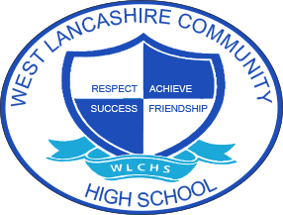

3 Year Long Term Overview
Subject | Autumn Term Theme | Spring Term  Theme | Summer Term Theme
Year 1 | Fair Trade  Exploring and experiencing the use of colour/mark making and tonal work.  Developing skills in using paint/pencil/pen/charcoal and graphite  Explore the works of Harriet Powers and Sayaka Ganz | My Environment  Students will work together to express themselves through artwork inspired by Andy Goldsworthy and based around the story ‘The Dot’. They will use their artwork to promote mental health week by displaying their work around their local community (home, school, local businesses, and places within the environment). | Space  To develop pupils’ awareness of surrealism, use a range of materials and methods to record ideas. Choose a favoured medium giving reason where possible. Research artist Tang Yau Hoong and use their work to influence their own work. Create a final piece of work.
Year 2 | Around the World  Exploring and experiencing the use of colour/mark making and tonal work.  Developing skills in using paint/pencil/pen/charcoal and graphite  European Art – Mondrian  (Colour, Pattern and Shape) | Farm to Fork  3D Sculpture (Clay) and Printing  Still Life – Paul Cezanne  (Drawing) | Lights Camera Action  Film Art (stencil)  (Drawing and colour skills including digital media)
Year 3 | Best of British  Exploring and experiencing the use of colour/mark making and tonal work.  Developing skills in using paint/pencil/pen/charcoal and graphite  David Hockney (Painting)  LS Lowry  (Drawing and Sketching) | Looking After Me  Picasso and Henri Matisse – self portraiture  (Drawing) | Animal Kingdom  Steve Brown (Oil Pastels)  Alan M Hunt (Pencil and Water Colour  Animals Masks (Modelling and Sculpture)

