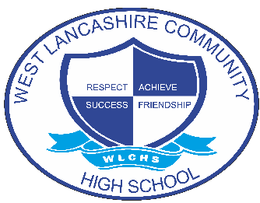
INTERVENTION OVERVIEW

NAME OF INTERVENTION
Art & Design
AREA OF FOCUS (PLEASE HIGHLIGHT)
COGNITION AND LEARNING | COMMUNICATION AND INTERACTION | SOCIAL, EMOTIONAL AND MENTAL HEALTH | PHYSICAL AND SENSORY | SELF-HELP AND INDEPENDENCE
INTENT
The focus of the intervention is to develop skills and techniques within the 7 elements of art. This is done over a two-year period to help develop self confidence in individual abilities with the aim of this transferring into the art sessions and projects chosen as part of KS4 ‘options’.
Students will develop skills to strengthen their art knowledge through the development of art vocabulary, study artists and applying this to their own pieces of work
The intent is to upskill to improve art outcomes at GCSE for those who are entered.
IMPLEMENTATION
Weekly sessions which cover all the elements if art.
Students are provided with an interventions sketch book which compliments the work that they already do in class.
Students are provided teacher demonstration time and 1:1 support to help develop skills and techniques.
Students watch tutorials and can further experiment with mediums and materials.
Students can research artists of choice and work in a themed area and medium that they prefer, further strengthen skills and students becoming more aware of their own individual style.
Students develop self-reflection skills.
Student also develop knowledge organiser linked to GCSE Art to help prepare for further studies.
IMPACT
Developing confidence in the use of mediums
Developing confidence in recognising the elements of art and using these appropriately in individual pieces of work.
Developing a greater awareness of AO1 – AO4 linked to the GCSE art assessment outcomes.
Developing skills in critically analysing their own work and the work of others
Overall – sustained learning at GCSE level

