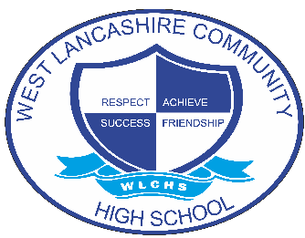
INTERVENTION OVERVIEW

NAME OF INTERVENTION
Autism and Me
AREA OF FOCUS (PLEASE HIGHLIGHT)
COGNITION AND LEARNING | COMMUNICATION AND INTERACTION | SOCIAL, EMOTIONAL AND MENTAL HEALTH | PHYSICAL AND SENSORY | SELF-HELP AND INDEPENDENCE
INTENT
The aim of Autism and Me is;
- To begin to recognise how autism makes them unique on both the inside and out.
- To be able to explain what their autism looks like to themselves and others.
- To be purposefully engaged and contribute to discussions or group activities.
- To explain how autism can affect daily life in different contexts and situations and be able to give clear explanations for suggestions.
- To fully understand the term disability and to be able to link this with their Autism.
Autism and Me is an intervention course for students who have an ASC diagnosis either longstanding or new. The sessions involve group discussions, activities and individual tasks. Over the course we encourage our students to recognise their uniqueness and take ownership of it by developing their own understanding of how they process and see the world around them. The course of work is drawn from the text and research of Peter Vermeulen in ‘I am Special’ (2013) Jessica Kingsley Publishers, London.
IMPLEMENTATION
Students engage in weekly sessions and complete a programme of study that explores;
- Being Unique
- Recognising likes and dislikes, personal strengths and areas for development
- How the body develops
- How the brain works
- Understanding the term disorder and disability and how this relates to their autism
- Adapting and changing with our disabilities
- Understanding and overcoming barriers.
The intervention is supported by a lead who is also leading on NAS (National Autistic Society) Accreditation and teaching assistants to support the delivery of the curriculum.
Resources are designed appropriately and are drawn from the text ‘I am Special’ (2013) by Peter Vermeulen.
IMPACT
Students will be able to communicate facts about their autism and their uniqueness.
Students will be able to communicate about how their autism impacts them and how they can overcome the barriers.
Students take ownership of their autism and overcome the challenges and barriers to engage positively with the world around them both in school and in the wider community.
Students complete weekly reflections and end of term reflections.
Completed portfolio of evidence produced by students.
Progress of students with specific PLG (Personal Learning Goals) outcomes are monitored on Evidence for Learning.
Future Development – All student progress in ‘Autism and Me’ will be tracked and recorded on Evidence for Learning and bespoke reports produced to communicate impact.

