Autumnal Adjectives

Write 3 adjectives next to the pictures to describe the objects. Then come up with a sentence underneath which includes your adjective.

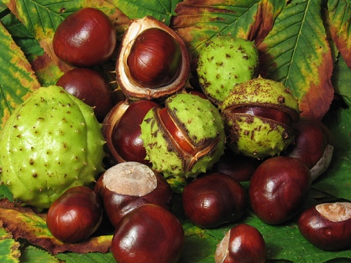
___________________________________________________

_________________________________________________________________________________________________________
___________________________________________________
_________________________________________________________________________________________________________

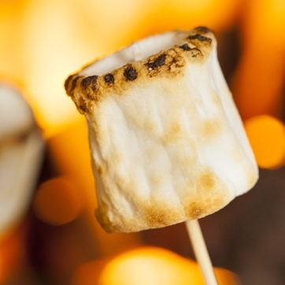
___________________________________________________

_________________________________________________________________________________________________________

Challenge

Write a sentence about something autumnal that includes adjectives.
_________________________________________________________________________________________________________

