

Billing and Debtors Policy

Document Control
Document name (inc version number, if applicable) | Billing and Debtors Policy (v1)
Date adopted by governing body | 27/1/2026
Next review | 27/1/2027
Owner | Darby Harrison
Approved on behalf of the governing body | Jeff Seddon (Chair of Governors)
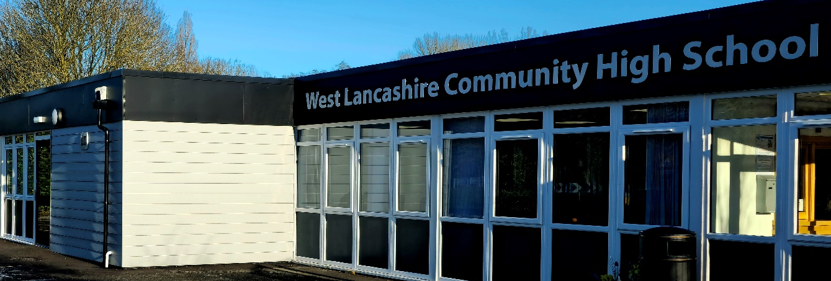

1.0 Introduction

1.1 Under the Scheme for Financing Schools in Lancashire, schools have the power to issue their own invoices and determine their own policy for debt recovery including the issue of reminders, authorisation for write-off of debt etc.

1.2 There are three options available to schools relating to raising bills on debtors. These are:

- Schools may use their FMS accounts receivable module to raise their own bills. Any school requiring training should contact Lancashire Education Digital Services (LEDS).

- Schools may raise bills locally by using alternative computerised/manual systems. If a school elects to set up their own system, they need to be aware of the key controls which need to be established with any system of debt management. These are described in paragraph 2 below.

- Schools may request the Business Support Team to raise bills on their behalf.

1.3 Where the value of goods and services is relatively small, payment should be obtained as and when the goods or services are provided wherever possible. This will help to minimise administrative costs and prevent default on debts.

1.4 Schools should have a Debt Management Policy agreed by the Governors for the management of any debt. A draft policy is included at Appendix A with suggested amounts and time periods for follow up. Schools can determine their own policy to suit their own particular circumstances.

2.0 Debt Management - Key Controls

2.1 The following key controls need to be established within any system of debt management:

The amounts due are correctly calculated

- charges are in accordance with the charging policy of the governing body which should be reviewed annually

- source documents are in sufficient detail to enable the correct charge to be levied

- VAT is charged where appropriate by raising a VAT invoice (VAT Guidance can be found at https://schoolsportal.lancsngfl.ac.uk/view_sp.asp?siteid=733&pageid=1006&e=e)

There is a clear link between source document and bill

- bills are cross-referenced to source document which records bill number and date. This should prevent duplication of bills.

- all source documents relating to the debtor and associated debt are retained.

- under the Limitation Act 1980 no legal recovery action can take place six years after the date of the debt became known to the claimant. For practical purposes this is regarded as six years from the date of the invoice. Schools should therefore retain all documentation relating to the debtor for six years from the date of the invoice.

Prompt and effective recovery action is taken for all unpaid bills

- reminders are issued in accordance with the policy of the governing body and any action taken is noted.

NB: For any bills raised on behalf of schools by the Authority (https://schoolsportal.lancsngfl.ac.uk/corporate/web/viewdoc.asp?id=116577), the Authority's Debt Management Policy is applied. This is currently:
Individual debtors

- debtors are expected to pay invoices immediately

- first reminder is issued after 21 days

- final reminder is issued after a further 14 days

- a follow up call to the debtor is made by the Income and Debt
Management Team prior to consideration of referral for legal action.

Other debtors e.g. commercial, groups.
- debtors are expected to pay invoices immediately
- final reminder is issued after 28 days
- a follow up call to the debtor is made by the Income and Debt
Management Team prior to consideration of referral for legal action.

Payments received from debtors are properly accounted for

- wherever possible there should be adequate separation of duties, ie the person raising the bill and collecting and receipting the income should be different

- all payments relating to bills raised should be acknowledged by the prompt issue of an official receipt

- the school records/copy bill should be noted with the date and receipt number relating to the payment

The issue, amendment, cancellation or write-off of bills are properly controlled

- bills are raised promptly, pre-numbered sequentially and dated

- any VAT invoice must include Lancashire County Council's VAT registration number (GB 155 7121 74)

- bills should require cheques to be made payable to Lancashire County Council (or for bank account schools the school bank account)

- a control record of all bills is maintained

- school records/copy bills are retained for all bills raised

- invoices must only be cancelled (in part or fully) when the original invoice is subsequently found to be incorrect or should not have been raised. Cancellations should not be made to invoices due to the debt not being recovered. In these instances, debt should be written off subject to appropriate approval.

- copies of any cancelled bills are retained on file and authorised in writing by a nominated person

- all write-off of bills after appropriate reminders/recovery action has been taken is properly authorised in accordance with policy approved by the governing body and recorded in the school records/on the copy bill

- all income received is banked promptly and bill number(s) recorded on payment into bank books.

DEBT MANAGEMENT POLICY

1.0 | INTRODUCTION
1.1 | The Governing Body is responsible for ensuring that procedures are in place for the recovery of any outstanding debt.
1.2 | This policy sets out procedures for debt recovery and for the write-off of any debt which is deemed to be irrecoverable.
2.0 | POLICY
2.1 | Payment should be obtained as and when goods and services are provided wherever possible; in particular where the value of the goods and services is relatively small, i.e. less than £100.
2.2 | Where payment is not received at the time when the goods or services are delivered an invoice must be raised as soon as possible but normally within 10 working days after a debt becomes due.
2.3 | Invoices should require immediate payment.
2.4 | Final reminders should be issued if no payment is received within 28 days. The final reminder should make it clear that legal action will be considered if payment is not received within a further 14 days.
2.5 | At each Governing Body/Finance Committee meeting, the headteacher is required to inform the governors of any debt which is still outstanding after the 14-day period following the final reminder together with any proposed action. This may be a referral to a debt collection agency, to solicitors for legal action or to write-off the debt if there is no realistic prospect of debt recovery being successful or if further action is not cost-effective.
2.6 | Outstanding debt of up to £200 may be written-off by the headteacher provided that the appropriate follow-up action outlined above has been taken and the details of the debtor, amount of write-off and reason for no further action being taken is reported to the Finance Committee for information at their next meeting.
2.7 | Write-off of outstanding debt in excess of £200 must be approved by the Finance Committee following submission of details of the debt by the headteacher together with reasons for no further action being taken.

