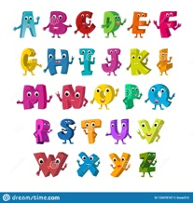
Capital Letters and Full Stops
Spot the mistakes in the sentences and rewrite them, with the correct punctuation, underneath.

- on monday I Went to spain
______________________________________________________________________________
- i was born in. march
______________________________________________________________________________
- A man Called sam was born in may
______________________________________________________________________________
- The Boys Went to liverpool on Thursday
______________________________________________________________________________
- layla was born on A wednesday in april
______________________________________________________________________________
