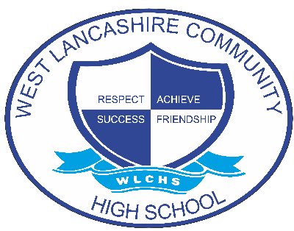

Careers Policy

Document Control
Document name (inc version number, if applicable) | Careers Policy (v1)
Date adopted by governing body | 27/1/2026
Next review | 27/1/2027
Owner | Louise Holcroft
Approved on behalf of the governing body | Jeff Seddon (Chair of Governors)
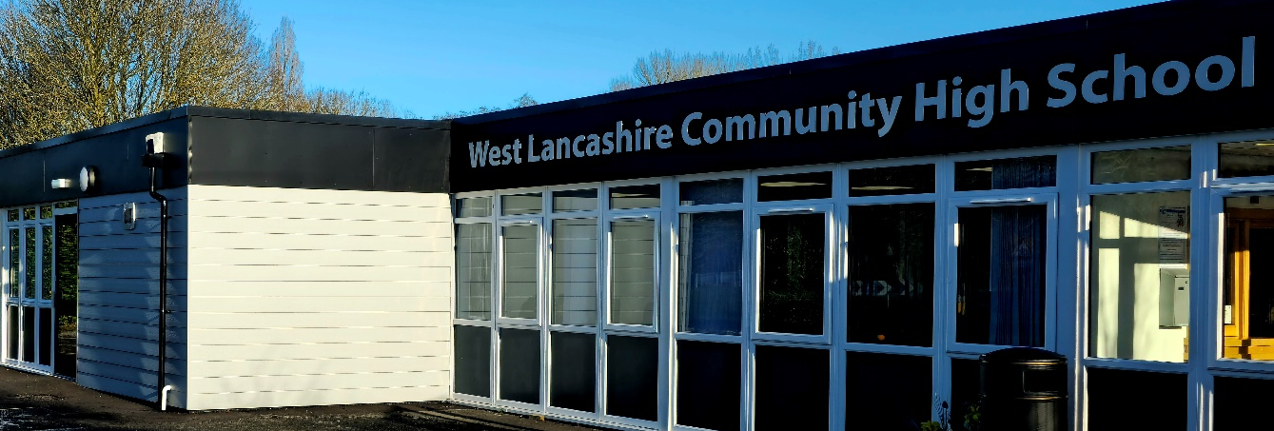

Careers Policy

Introduction
West Lancashire Community High School provides a relevant and engaging careers curriculum that meets the differing needs and requirements of our students. This is developed throughout a student’s time at the school and is always supportive of their abilities, strengths, and skills.

Aims and purpose
- Prepare students for the transition to life after West Lancashire Community High School through curriculum and career learning.
- Support students in making informed decisions that are appropriate for them, learning from information provided including Labour Market Intelligence.
- Provide students with well-rounded experiences through a stable careers programme.
- Develop personal characteristics such as social skills, communication, independence and resilience through the implementation of Skills Builder and encounters with employers and employees.
- Inspire and motivate students to develop themselves as individuals and live as independently as possible.
- To provide students with the experiences of the workplace through work-related learning.
- To provide students with the opportunity to receive CEIAG and encounter career opportunities appropriate to their needs.

This policy summarises the statutory guidance and recommendations. It then outlines the provision of careers education, work experience and provider access including a commitment to careers education, information, advice and guidance.

Statutory requirements and recommendations
From 2012, section 29 of the Education Act 2011, places schools under a duty to secure access to independent careers guidance for their students in school years 8-13. Careers guidance under the new duty must;

- be impartial
- include information on a range of pathways, including apprenticeships
- be adapted to the needs and interests of the students
- careers provision will be tailored around the Gatsby Benchmarks

In addition, the school is compliant with the careers guidance that the government set out for delivery from 5 January 2018: ‘Careers Guidance and Inspiration for young people in schools.’ This states that all schools must give education and training providers the opportunity to talk to students about approved technical qualifications and apprenticeships. Further information relating to this is set out later in this document, under Provider Access.

West Lancashire Community High School is also compliant in demonstrating meeting the 8 benchmarks of Gatsby Framework introduced in December 2017. West Lancashire Community High provides education for students with SEND and continuously monitors its programme to ensure that the needs of the students are met when it comes to CEIAG.

Careers Provision at West Lancashire Community High School
All students have access to the following:
- West Lancashire Community High School programmes of study involving careers are ASDAN Personal Development Plan, Transition Challenge, Towards Independence, ASDAN Raising Aspirations. West Lancashire Community High School also use the CDI framework to organise and plan their career delivery at KS4.
- Careers and preparing for life after West Lancashire Community High School is a fundamental aspect of the schemes of work and programmes of study followed which incorporates Skill Builder and the development of the eight essential skills.
- Visitors to school and offsite visits support students in developing their understanding of a range of different P16 and P19 pathways.
- All students throughout school have access to a Careers programme to help raise aspirations for their future.
- All students from Year 9 have access to careers advice and guidance from the school careers adviser.
All students in Y7, Y9 and Y11 and Y12 will complete their vocational profile in relation to their aspirations and goals
- All students in KS4 to access a meeting with the school careers advisor to explore future pathways.
- Pathways and future planning are also discussed as part of every student’s annual review.
- All students will be encouraged to participate in meetings about their future through ‘student voice’
- Students have access, through the Lancashire Partnership, to relevant careers events hosted at Lancashire schools, local P16 and P19 providers.
- All students will participate in career events including National Careers Week.

Key Stage 3
- Student pathways planned and prepared for in KS3. All students follow and complete modules which are a part of ASDAN Raising Aspirations. Modules include; Healthy Lifestyles, People in my Community and Being Independent.
- Students take part in Enterprise projects across the school year.
- STEM events and projects are a key part of the KS3 curriculum.
- One to one meetings with families and supporting agencies to help prepare for transition to Key Stage 4.
- Year 7 and Year 9 vocational profiling to support transition, subject options and raising awareness of future ambitions.
- Students in Key Stage 3 to take part in Employer and Employee engagement sessions.
- Students to have the opportunity to take part in work related learning linked to community projects and supported by local employers.
- Students will have the opportunity to take part in 1 day team building activities to further develop skills.
Key Stage 4
- One-to-one meetings with families and the school Careers Leader and Adviser in Y10 and Y11 informs individual routes into Post 16 provision and appropriate and meaningful work experience opportunities
- Students will have the opportunity to take part in the 2 nights/ 3 day residential
- Students in Key Stage 4 undertake Work Experience and work-based placements and opportunities of up to 2 weeks.
- Students in Y11 have a transition support plan to support the process at the end of KS4.
- Students have access to college experiences through planned activities linked to the curriculum.
- Students participate in enterprise projects.
- Student learn within the 6 areas of the CDI Framework.
- Students in Key Stage 4 to take part in Employer and Employee engagement sessions.

The overall organisation of work experience is undertaken by the Careers Leader who liaises with the internal and external teams/colleagues to ensure the most relevant and engaging opportunities are taken.
Families are informed and communicated with throughout the process and a work experience agreement form and work experience information form are completed.
All students on placement are covered by the employers’ insurance and places of work are risk assessed by the Careers leader and Lancashire Education Partnership Northwest work experience database.

Key Stage 5
- One-to-one meetings with families and the school Careers Lead in KS5 inform individual routes into Post 19 provision and appropriate and meaningful work experience opportunities.
- The majority of KS5 students take part in the Duke of Edinburgh Award.
- The majority of KS5 students will take part in the King’s Trust Programme.
- Students in KS5 undertake weekly work-based placements and opportunities linked to their aspirations and future goals.
- Students will have access to The Hub as additional work placement opportunities.
- Regular 1:1 meetings in their transition year.
- Transition support sessions for both students and families
- All students have a transition support plan to further support the transition process
- Support sessions at external providers as part of a robust transition support programme
- Links with local businesses, employers and employees
- Discreet weekly careers sessions through identified ASDAN challenges from Towards Independence, Personal Development Programme and ASDAN short course.

West Lancashire Community High School is committed to working with students and families’ Post 19 who are members of the Alumni group.

Monitoring & Evaluation

The implementation of the careers programme will be monitored and reviewed by the Careers Lead and those involved in the delivery of the careers programme on an annual basis ensuring that it is fit for its purpose.
Evaluations will be drawn from destination data and feedback from stakeholders. We will evaluate and report on the programme, the level of engagement, the successes, and any identified areas for improvement.

Providers Access Policy Statement
Introduction
This policy statement sets out the school’s arrangements for managing the access of providers to students at the school for the purpose of giving them information about the provider’s education or training offer. This complies with the school’s legal obligations under Section 42B of the Education Act 1997.

Student & Parent entitlement
All students in years 8-14 are entitled:
- To find out about technical qualifications and apprenticeships opportunities, as part of a careers programme this provides information on the full range of education and training options available at each transition point;
- To hear from a range of local providers about the opportunities they offer through options events, assemblies and group discussions and taster events;
- To understand how to make applications for the full range of academic and technical courses.
- To be provided with impartial careers education, information, advice and guidance.

Management of provider access requests
Procedure:
A provider wishing to request access should contact Louise Holcroft, Assistant Headteacher for Preparation for Adulthood and Careers Programme Lead, Telephone: 01695 721487; Email: holcroft@Westlancs.lancs.sch.uk

Opportunities for access
A number of events, integrated into the school careers programme, will offer providers an opportunity to come into school to speak to students and/or their parents/carers:
 | Autumn term | Spring term | Summer term
Year 7* | - STEM Hub link with local college  - Partnership with local schools  - Life Skills and Functional Skills through Personal Learning Goals, careers and PSD curriculum – assembly and class group opportunities  - EHCP annual review meeting  - ASDAN Raising Aspirations Programme  - Employee and Employer encounter sessions  - Vocational Profiles  - Community Project Work
Year 8 | - STEM Hub link with local schools and colleges  - Partnership with local schools  - Life Skills and Functional Skills through Personal Learning Goals, careers and PSD curriculum – assembly and class group opportunities  - EHCP annual review meeting  - ASDAN Raising Aspirations Programme  - Employee and Employer encounter sessions  - Community Project Work
Year 9 | - STEM Hub link with local schools and colleges  - Partnership with local schools  - Life Skills and Functional Skills through Personal Learning Goals, careers and PSD curriculum – assembly and class group opportunities  - EHCP annual review meeting  - Options pathways in line with aspirations and goals.  - Transition support to KS4 – Transition Support Plans  - ASDAN Raising Aspirations Programme  - Student and parent support meetings  - Employee and Employer encounter sessions  - Vocational Profiles  - Community Project Work
Year 10 | - Link with local Colleges and social care providers where applicable  - Partnerships with local centres and business  - Partnerships with WATC  - STEM Hub link with local schools and Colleges  - Bespoke College taster programme opportunities linked to careers programme  - KS4 attend careers event  - Open Doors events with local colleges including open evenings  - Transition Coffee Mornings for families  - EHCP annual review meeting  - CDI Framework
Year 11 | - Careers advisor working alongside young person and family  - KS4 attend a careers event  - STEM Hub link with local schools and colleges  - Bespoke Post 16 taster programme opportunities  - Open Doors events with Post 16 provision  - Transition Coffee Mornings for families  - 1:1 transition support meetings  - Two-week work experience programme  - Links with businesses  - Interview day  - Transition programme  - EHCP annual review meeting  - CDI Framework  - Vocational Profiling
Y12-Y14 | - Careers advisor working alongside young person and family  - KS5 attend careers event  - Partnerships with Preston North End  - links with local Post 16 providers and colleges  - Bespoke Post 19 taster programme opportunities  - Open Door events with Post 16/Post 19 provision  - Transition Information Events for families  - One day a week work placement programme  - Links with businesses (employer and employee engagement encounters)  - Interview day  - Transition programme including support plan for students and families  - EHCP annual review meeting  - ASDAN Towards Independence and Personal Development Programme  - ASDAN Careers and Experiencing Work Short Course  - Enterprise events  - Community Project Work  - Vocational Profiles
*not a legal requirement at Year 7 but at West Lancashire Community High School Year 7 students are part of our Careers Programme:

Premises and facilities
The school will make the main hall, classrooms or meeting spaces available for discussions between the provider and students, as appropriate to the activity. The school will also make available AV and other specialist equipment to support provider presentations. This will all be discussed and agreed in advance of the visit with the Careers Leader or a member of their team.
Providers are welcome to leave a copy of their prospectus or other relevant course literature with the Careers Lead. This will be made available to students and families as appropriate.

