Column Method Addition

Remember to start with the Units column, use a number line or objects to help you.

T U
3 2

Extension
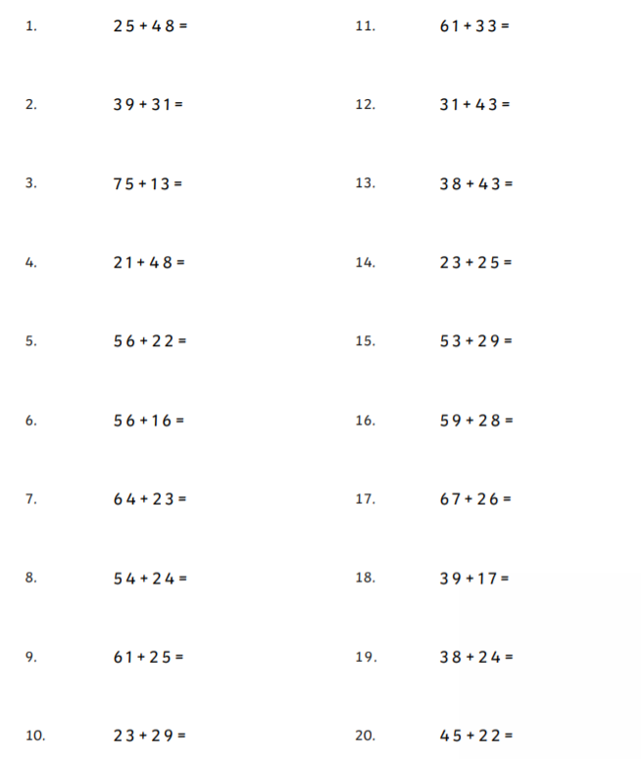
Use the column method to find the answer to these sums.

