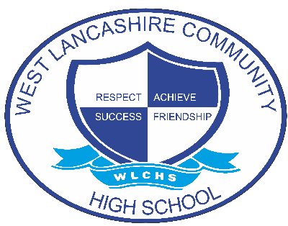

Curriculum Policy

Document Control
Document name (inc version number, if applicable) | Curriculum Policy (v1)
Date adopted by governing body | 27/1/2026
Next review | 27/1/2027
Owner | Dave Mullen
Approved on behalf of the governing body | Jeff Seddon (Chair of Governors)
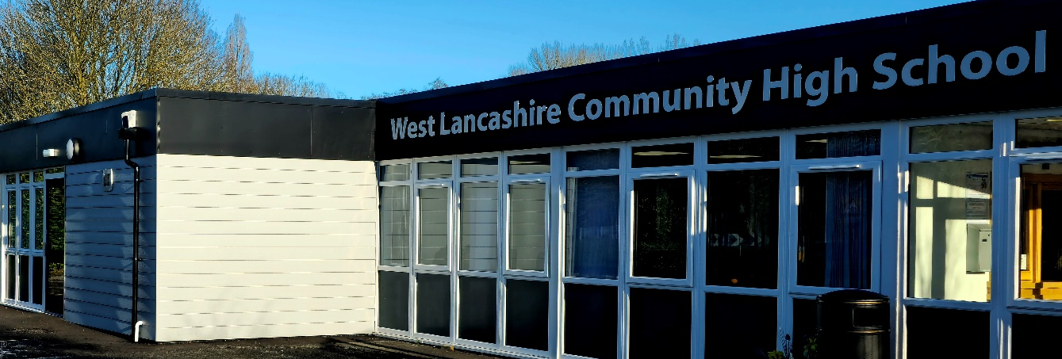

Aim
The curriculum is individualised, creative, innovative and flexible allowing for the needs of each student to be met. It aims to promote the social, moral, spiritual and cultural development of the students as well as their intellectual and physical development.
The school is committed to providing a broad and balanced curriculum, based on the National Curriculum for those students of compulsory school age. This is blended with opportunities for students to develop functional skills, independence skills and skills for working life as appropriate.

The curriculum will take a student-centred approach and will value diversity. A strong ethos of marking and assessment will ensure continuity, progression, differentiation and evaluation to better enable our practice and the success of our learners.

To this end we endeavour to ensure:

- That students make progress against personal targets
- That students acknowledge their achievements and have a sense of pride
- That students have opportunities to participate in a range of enrichment activities within and beyond the curriculum via working with professionals within the community and by visiting places of interest.
- That students develop social and communication skills including the use of symbols, signing and objects of reference
- That students develop reading and writing skills through a robust English curriculum that engages students in functional aspects and also immerses them in a wide range of literature.
- That through functional and practical activities both in school and in the wider community students develop skills for independence.
- That students’ use of ICT equipment is encouraged to develop independence and support their learning and that they can link with the wider world of knowledge in a safe and secure way.
- That students develop a greater awareness of their local community and make a positive contribution.
- That students learn a range of skills for life beyond school.

School Organisation
The Curriculum is co-ordinated throughout the school through Subject Co-ordinators and staff who teach that subject. These are overseen by the Deputy. The roles of the subject leaders include:

- ensuring continuity and progression of teaching throughout the school in respective curriculum areas and adopting school initiative to further develop learning opportunities for all students
- moderate and assess progress within their subject area.
- Quality assure theirs and others planning to ensure high quality teaching and learning.
- Develop, implement and measure impact of accredited routes that may be applicable to their subject area.
- the bidding for, and provision of appropriate resources as part of the annual school budget based on their Subject Improvement Plan.
- Each Subject Improvement Plan should contribute to the school development plan.

Each class group has its own Teacher and access to qualified Teaching Assistants (TA's) who work under the supervision of the Teacher to support the needs of the students.

Class teachers are responsible for:
- Planning their subject or sessions for subjects they teach.
- Differentiation to meet the individual needs of students
- Summative and formative assessment
- Using a range of teaching and learning strategies, techniques and resources that are student centred.
- Directing the work of Teaching Assistants to be the most effective in the classroom
- Attending and contributing to training and meetings on a whole school level and wider through networking.
- Maintaining their Staff Professional Logbook in accordance with school requirements to inform CPD and continually develop their learning spaces to best meet the needs of the current students.
- Attending and contributing to subject Moderation within school or externally.
- Keeping up to date on relevant research for their subject area or in the world of education and SEND.
- Contribute to the development of the curriculum and implement any whole school initiatives that improve teaching and learning for all students.

Student Individuality and Worth
The curriculum of West Lancashire Community High School will recognise the individuality of students by:

- identifying and building on each student's existing skills, knowledge and character development
- creating a learning environment which focuses on individual need, interest and concern, yet recognises the need for students to work collaboratively
- establishing high personal and school expectations and clear targets within the capabilities of each student
- requiring students to accept responsibilities and develop qualities of initiative and persistence
- encouraging critical self-evaluation and the development of self-esteem
- providing opportunities for success through systematic encouragement and recording of achievement of each student.

Opportunity and Access
Within the framework of the curriculum, every student, regardless of sex, race, religion and special educational needs, will have access to educational opportunity and a full curriculum based on their needs. Student access to educational resources will be determined by individual need.

Breadth and Balance
Breadth and balance are achieved not only through the National Curriculum, cross-curricular provision, Religious Education and Sex and Relationship Education but also through a wide range of learning experiences that include interventions, speech and language provision, occupational therapy provision and other lifelong learning opportunities. This provision will take place throughout the student's school career. Learning experiences and methodology will be linked to the individual's social and emotional development. The content of the curriculum will reflect the new expectations of the OfSTED Inspection Framework 2019 and ensure the curriculum is developed in a student-centred way.

Continuity and Progression
To ensure continuity of learning and planned progression careful liaison will take place between staff at all levels. There will be detailed record keeping and evidence of planning.

Relevance and Adaptability
The relationship between the curriculum and the needs, aspirations and interests of students should be flexible enough to help students successfully meet and contribute to the demands of a changing society. In addition, it should relate to their maturity and provide enjoyment and fulfilment. As the students move towards leaving school, a greater emphasis will be placed on the life skills necessary for social independence.

Adaptive learning
The presentation and content of the curriculum will identify and meet the varying needs and ability levels of all students. There will be enough adaptive learning in the teaching strategies for challenging but realistic goals to be set and for the motivation of each student to be established and maintained.

The timetable and Curriculum are reviewed annually to ensure compliance with current legislation and guidance and consider best practice within our learning environment.

Partnership with Parents
West Lancashire Community High School will help parents understand the curriculum and its implementation and will encourage parental involvement in student learning and individual progress. All information regarding the curriculum will be shared via the website and through the Curriculum Handbook.

Planning
Planning will be informed by discussion and collaboration through curriculum meetings and will ensure that clear methods of communication are used using the systems put in place by the school. It will be explicit, systematic and collaborative whilst also being subject to regular review.

Assessment and Recording
Assessment, marking and recording will follow the whole school policy which enables students to evaluate and develop their own work, track their own advances, discuss and participate in setting their own learning objectives and next steps and recognise ‘value added’ elements of their work where extra learning has occurred beyond the original expectations. For English and Maths, B Squared will be used to gain quantitative data to indicate student progress. All other subjects will be tracked through assessment and moderation meetings and all evidence of progress will be saved electronically on the school system. Some outcomes and learning will be monitored and assessed through Evidence for Learning.

Safeguarding
All staff attend training on an annual basis on safeguarding and online safety.
Annually all students learn about online safety across the school year through their Computing sessions. This is differentiated depending on their age and ability.

Health and Hygiene
Students are taught through the curriculum about health and hygiene and personal, social and health education.

Monitoring and Evaluation
The Senior Leadership Team will co-ordinate the monitoring of teaching and learning by:
- moderating assessment data
- analysing progress data
- observing lessons
- learning walks
- work scrutiny
- curriculum development and planning
- initiating training/workshop opportunities with specific focus.

