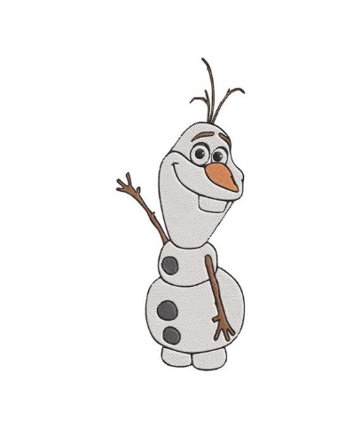
Disney Movie Quiz

- What is the name of Anna and Elsa's kingdom in Frozen?

- "Pull the lever Kronk" is a line from which film released in 2000?

- What is the address of the dentist office in which Nemo is kept in Finding Nemo?

- What is the name of the prince Ariel falls in love with in The Little Mermaid?

- Which Disney princess appeared on our screens first? Cinderella, Snow White, or Aurora?

- Who played the iconic role of Genie in the 2019 live-action remake of Aladdin?

- Where is Lilo & Stitch set?

- In Wreck It Ralph, what is the name of the 'good guy' in Ralph's game?

- In The Aristocats what is the name of the streetcat who befriends Duchess and her kittens?
- What is the name of Andy's little sister in the Toy Story franchis?

- What kind of animal is Louis in The Princess and the Frog?

- What is the name of the villain in Tarzan?

- In Zootopia, what kind of animal is Flash?

- What is the name of the demoted guardian spirit of Mulan's family who accompanies her on her adventures in the place of the Great Stone Dragon?

- In the original 1994 version of The Lion King, which characters distract the hyenas with a Hawaiian luau?
