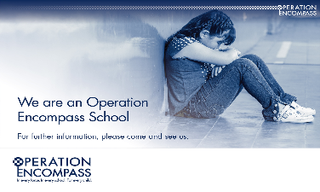

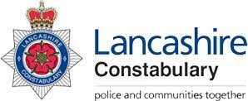

West Lancashire Community High School is part of Operation Encompass which is a national scheme that operates jointly between schools and police forces.
Operation Encompass is the reporting to schools, prior to the start of the next school day, when a child or young person has experienced domestic abuse.
As a school our Designated Safeguarding Lead Mr Grant has been trained in the Operation Encompass procedures allowing us to then use the information that has been shared, in confidence, to support the child/ren in our care.
The Domestic Abuse Act 2021 identifies children who experience domestic abuse as victims of domestic abuse in their own right.
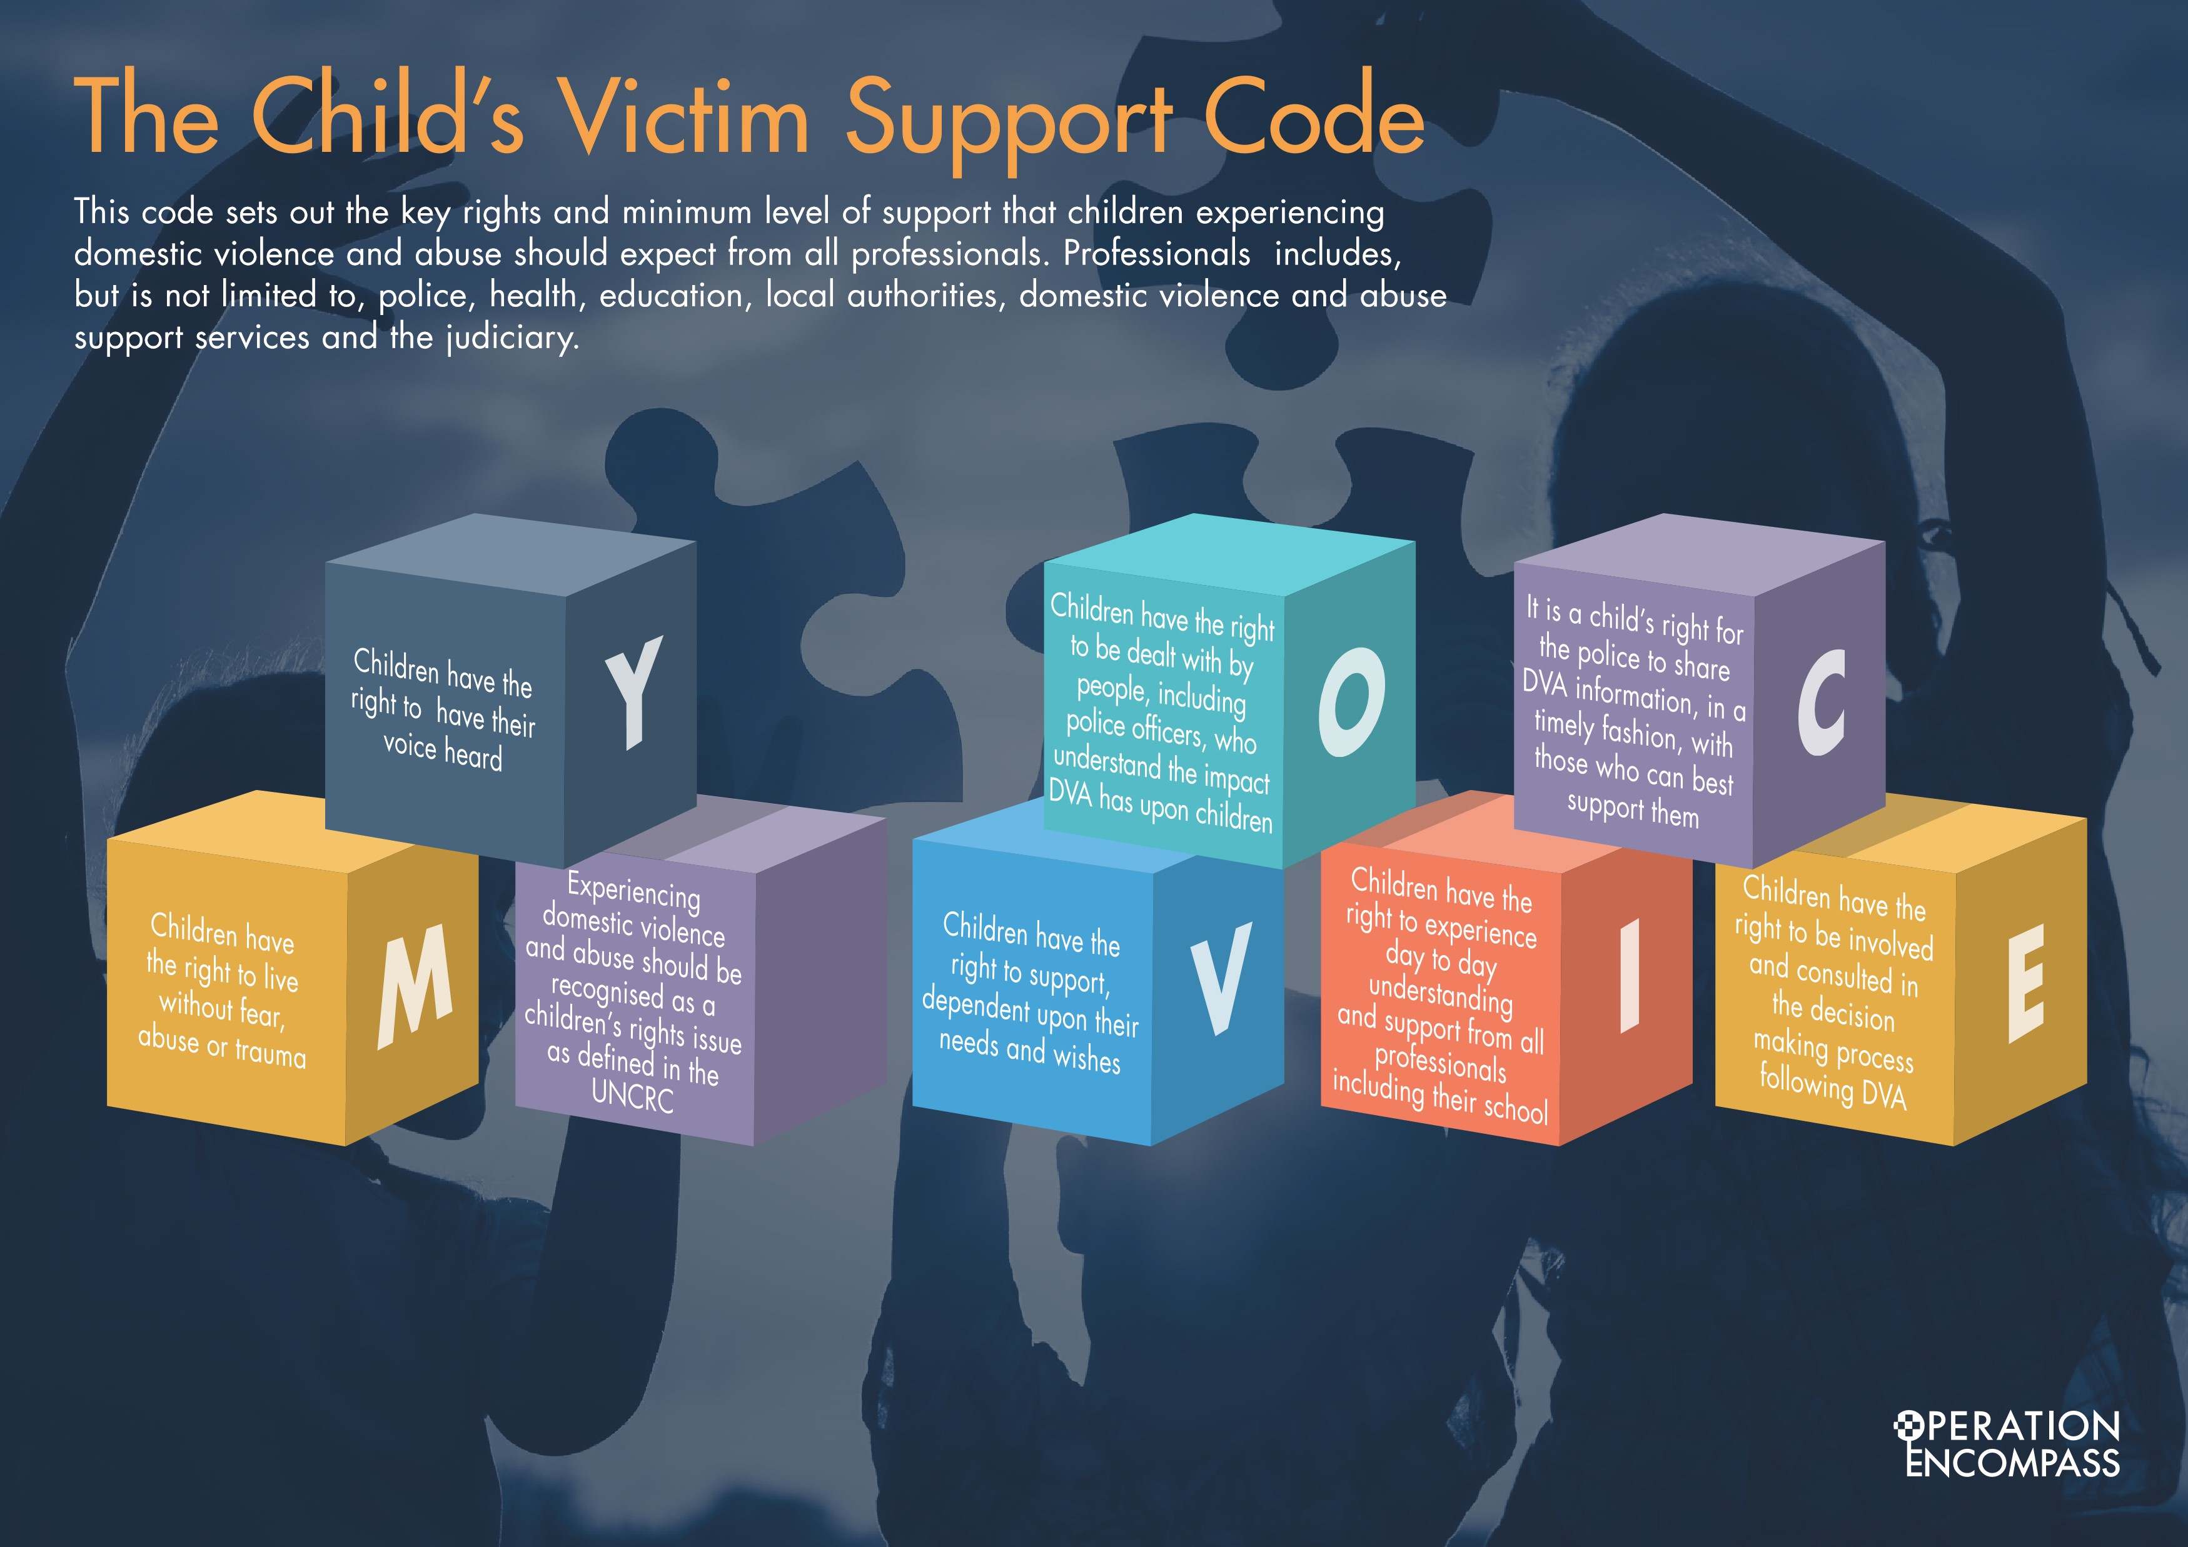

Supporting Parents and Carers with additional free training opportunities.
For Parents who would like an opportunity to learn more there is a free accredited training option here. Please follow this Link.
http://operationencompass.vc-enable.co.uk/Login/Login

Self-register by entering the following details:
- First Name
- Last Name
- Email address
- Job Title
- School Name. Please include the school's postcode WN8 8EH

Finally, please ensure that you select the Group titled Key Adult Briefing.
Once you’ve completed the registration form it will say ‘registration successful’ and your request will be sent to an administrator to approve.
A welcome email will be sent from donotreply@vc-enable.co.uk with a temporary password to login in with. Please note, the welcome email will direct you to update your password to something new.
Once logged in you will be able to access the content via the learning tile under ‘Active Learning’.
If you are having trouble logging in please contact Virtual College on 01943 885095 or via email customersupport@virtual-college.co.uk.

If you have any concerns regarding your child please inform Mr Grant, Mr Mullen or Mr Fazackerley on 01695-721887

