English

Home Learning Pack
Contents

SPaG
Spelling 1 ………………………………………………………………………………………………………. 3
Spelling 2 ……………………………………………………………………………………………………… 4
Spelling 3 ……………………………………………………………………………………………………… 5
Spelling 4 ……………………………………………………………………………………………………… 6
Spelling 5 ……………………………………………………………………………………………………… 7
Capital Letters and Full Stops ………………………………………………………………… 8
Commas …………………………………………………………………………………………………………. 9
Adjectives ………………………………………………………………………………………………….. 10
Adverbs ………………………………………………………………………………………………………. 11
Question Mark or Exclamation Mark? …………………………………………………. 12
Speech Marks ……………………………………………………………………………………………. 13

Reading Skills
Comprehension – Charlie and the Chocolate Factory .………………………. 14
Comprehension – Poetry (The Eagle - Alfred Tennyson) .………………… 21

Writing Skills
Responding to a Picture ………………………………………………………………………….. 23
Write a Newspaper …………………………………………………………………………………. 25

Extras Section
Wordsearch ………………………………………………………………………………………………. 27
Design a Book Cover ………………………………………………………………………………… 28
Design a Bookmark …………………………………………………………………………………… 29
Make Your Own Comic …………………………………………………………………………….. 30

Spelling 1

In the following sentences, there are some spelling mistakes.

Write the sentence out with your corrections on the lines underneath.

- Sally arived at school by bicicle.

……………………………………………………………………………………………………………

- Polly cort the wrong train by acident.

……………………………………………………………………………………………………………

- You should increse the amount of exersize you do ocasionaly.

……………………………………………………………………………………………………………

- He didn’t have the right lengf of matereal.

……………………………………………………………………………………………………………

- A quarter of the bisness centre was empty.

……………………………………………………………………………………………………………

Spelling 2

In the following sentences, there are some spelling mistakes.

Write the sentence out with your corrections on the lines underneath.

- She was buzy and under preshure.

……………………………………………………………………………………………………………

- The guyde showed us around the iland.

……………………………………………………………………………………………………………

- Henry the Eigth’s reyn lasted 38 years.

……………………………………………………………………………………………………………

- If you want to improve your knowledge, you could always go to the liebrary.

……………………………………………………………………………………………………………

……………………………………………………………………………………………………………

- Lily was poppular but ocasionaly naghty.

……………………………………………………………………………………………………………
Spelling 3

In the following sentences, there are some spelling mistakes.

Write the sentence out with your corrections on the lines underneath.

- Arthur had been known to disappear often.

……………………………………………………………………………………………………………

- Meddicine has changed thru the sentury.

……………………………………………………………………………………………………………

- We will continu to lern grammer.

……………………………………………………………………………………………………………

- He made a prommise it would be a suprise.

……………………………………………………………………………………………………………

- They did not knowtice it was diferent.

……………………………………………………………………………………………………………

Spelling 4

In the following sentences, there are some spelling mistakes.

Write the sentence out with your corrections on the lines underneath.

- Mo looked for the Febuery on the calander.

……………………………………………………………………………………………………………

- Max was the best gard dog in historry.

……………………………………………………………………………………………………………

- I couldn’t remmember what the womman said.

……………………………………………………………………………………………………………

- Various fameous people have performed here.

……………………………………………………………………………………………………………

- Humans brethe up to twenty times a minite.

……………………………………………………………………………………………………………

Spelling 5

In the following sentences, there are some spelling mistakes.

Write the sentence out with your corrections on the lines underneath.

- The cook prepped the frute and the potaytos.

……………………………………………………………………………………………………………

- Just take some ordinnary breths.

……………………………………………………………………………………………………………

- We had to draw strate lines and sercles.

……………………………………………………………………………………………………………

- She found it hard to imajun it was possibble.

……………………………………………………………………………………………………………

- The experimment was dificult.

……………………………………………………………………………………………………………

Capital Letters and Full Stops

Read the paragraph and put a circle around where there should be a full stop or a capital letter.

i went to see my friend on saturday his dad cooked us some pasta and then we went outside to play football we excitedly grabbed our coats to go outside for the first time in ages it had been raining non-stop in manchester we got to the park and set our coats on the ground because there were no goals all of a sudden, the heavens opened and we were pelted with the hardest, coldest hailstones we’d ever seen we ran over to pick up our coats to put them back on, I bundled our ball under my arm and we ran back as fast as we could the disappointment hit us as soon as we walked in dripping wet and frozen to the bone, we miserably trudged back into the warm kitchen my friend’s dad took one look at us and laughed “anyone for a hot chocolate?” he asked us we soon felt better after that

Comma Practice

Commas are really important. They separate items in a list, separate extra information in a sentence and tell us when we need to stop for a pause.

Can you put in the missing commas in the list below?

- We packed sandwiches crisps and apples for lunch.

- I went to the shops with my friends Joe Anja and Malik.

- The cat had scratchy sharp claws.

- Spaghetti a long type of pasta is delicious with tomato sauce.

- I made sure I packed my phone charger socks and toothbrush this time!

- Effy gave up running for the train as she knew she wouldn’t make it on time.

- I woke up brushed my teeth and had a wash before school.

- Miguel Arteta who played for the club in his younger years has now taken on the role of manager.
Awesome Adjectives

Adjectives are words used to describe, e.g. beautiful, calm, spooky, hungry, noisy…etc.

Look at the pictures below and write three adjectives to describe each one. Use a thesaurus (you can find one online) if you get stuck or want to find extra ambitious adjectives!

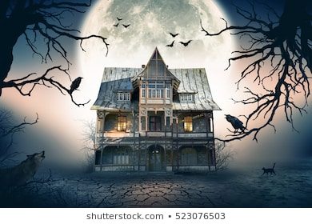
…………………………………………………………………………………………

…………………………………………………………………………………………

…………………………………………………………………………………………

…………………………………………………………………………………………

…………………………………………………………………………………………

…………………………………………………………………………………………

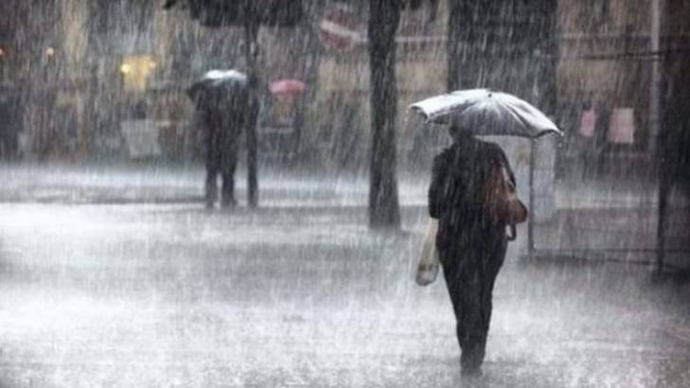
…………………………………………………………………………………………

…………………………………………………………………………………………

…………………………………………………………………………………………

…………………………………………………………………………………………

…………………………………………………………………………………………

…………………………………………………………………………………………

Adverbs

A verb is a doing (action) word. An adverb is a word put before or after the verb to tell you how that action is being done. They make our writing sound much more exciting.

For example: She kindly helped the old lady safely cross the road.

Write a sentence for each of the adverbs listed.

- Cautiously

………………………………………………………………………………………………………………………………………………….

- Nastily

………………………………………………………………………………………………………………………………………………….

- Speedily

………………………………………………………………………………………………………………………………………………….

- Anxiously

………………………………………………………………………………………………………………………………………………….

- Softly

………………………………………………………………………………………………………………………………………………….

- Gracefully

………………………………………………………………………………………………………………………………………………….

- Sorrowfully

………………………………………………………………………………………………………………………………………………….

Question Mark or Exclamation Mark?

Adding a question mark (?) or an exclamation mark (!) is important when you need to let someone know whether you are asking a question or putting more emphasis on something.

Task 1: Add the right punctuation mark to the end of each sentence.

- I told you I don’t know
- Where is the jam
- Are you alright
- Stop doing that
- I couldn’t believe it
- Can you pass me that

Task 2: Write your own sentences using exclamation marks and question marks.

Exclamation mark:

- ………………………………………………………………………………………………………………………………………

- ……………………………………………………………………………………………………………………………………….

- …………………………………………………………………………………………………………………………………….

Question mark:

- ………………………………………………………………………………………………………………………………………

- ……………………………………………………………………………………………………………………………………….

- …………………………………………………………………………………………………………………………………….

Speech Marks

Speech marks are used to show when direct speech starts and ends. For example: The football fan shouted “Goal!” as loudly as he could.

Task 1: Add the speech marks to the following sentences.

- What time are you going there asked Sarah.
- The police officer shouted Freeze! when he saw the thief.
- Where are my glasses? demanded Tom.
- I don’t know, his friend shrugged. Have you checked the top of your head?
- What is important, the teacher said, Is not to rush your work.
Task 2: Write three examples of your own speech sentences.
- …………………………………………………………………………………………………………………………………….

…………………………………………………………………………………………………………………………………….

- …………………………………………………………………………………………………………………………………….

…………………………………………………………………………………………………………………………………….

- …………………………………………………………………………………………………………………………………….

…………………………………………………………………………………………………………………………………….
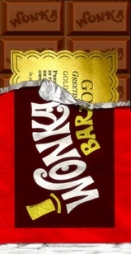

Comprehension – Fiction

Read the following extract from Charlie and the Chocolate Factory by Roald Dahl and answer the questions about it.
Only once a year, on his birthday, did Charlie Bucket ever get to taste a bit of chocolate. The whole family saved up their money for that special occasion, and when the great day arrived, Charlie was always presented with one small chocolate bar to eat all by himself. And each time he received it, on those marvellous birthday mornings, he would place it carefully in a small wooden box that he owned, and treasure it as though it were a bar of solid gold; and for the next few days, he would allow himself only to look at it, but never to touch it. Then at last, when he could stand it no longer, he would peel back a tiny bit of the paper wrapping at one corner to expose a tiny bit of chocolate, and then he would take a tiny nibble – just enough to allow the lovely sweet taste to spread out slowly over his tongue. The next day, he would take another tiny nibble, and so on, and so on. And in this way, Charlie would make his sixpenny bar of birthday chocolate last him for more than a month.
But I haven’t yet told you about the one awful thing that tortured little Charlie, the lover of chocolate, more than anything else. This thing, for him, was far, far worse than seeing slabs of chocolate in the shop windows or watching other children munching bars of creamy chocolate right in front of him. It was the most terrible torturing thing you could imagine, and it was this:
In the town itself, actually within sight of the house in which Charlie lived, there was an ENORMOUS CHOCOLATE FACTORY!
Just imagine that!
And it wasn’t simply an ordinary enormous chocolate factory, either. It was the largest and most famous in the whole world! It was WONKA’S FACTORY, owned by a man called Mr Willy Wonka, the greatest inventor and maker of chocolates that there has ever been. And what a tremendous, marvellous place it was! It had huge iron gates leading into it, and a high wall surrounding it, and smoke belching from its chimneys, and strange whizzing sounds coming from deep inside it. And outside the walls, for half a mile around in every direction, the air was scented with the heavy rich smell of melting chocolate!
Twice a day, on his way to and from school, little Charlie Bucket had to walk right past the gates of the factory. And every time he went by, he would begin to walk very, very slowly, and he would hold his nose high in the air and take long deep sniffs of the gorgeous chocolatey smell all around him.
Oh, how he loved that smell!
And oh, how he wished he could go inside the factory and see what it was like!

- Does Charlie’s family have lots of money? Give a reason for your answer.

…………………………………………………………………………………………………………………………………….

…………………………………………………………………………………………………………………………………….

- What do we learn about Charlie?

…………………………………………………………………………………………………………………………………….

…………………………………………………………………………………………………………………………………….

- Name two ways Roald Dahl puts some words in all capital letters. To show…

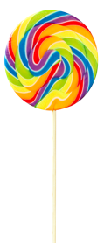
…………………………………………………………………………………………………………………………………….

…………………………………………………………………………………………………………………………………….

- How does Roald Dahl describe the chocolate factory?

…………………………………………………………………………………………………………………………………….

…………………………………………………………………………………………………………………………………….

- How do you think Charlie feels when he walks past the factory?

…………………………………………………………………………………………………………………………………….

…………………………………………………………………………………………………………………………………….

- Why does Roald Dahl use a lot of exclamation marks in the passage?

…………………………………………………………………………………………………………………………………….

…………………………………………………………………………………………………………………………………….

- Imagine you are Charlie. Write a short paragraph to describe the experience of walking past the factory.

…………………………………………………………………………………………………………………………………….

…………………………………………………………………………………………………………………………………….

…………………………………………………………………………………………………………………………………….

…………………………………………………………………………………………………………………………………….

…………………………………………………………………………………………………………………………………….

- Would you like to visit the factory? Give a reason why.

…………………………………………………………………………………………………………………………………….

…………………………………………………………………………………………………………………………………….

Comprehension – Poetry

Read the poem and answer the questions at the end

The Eagle
Alfred Lord Tennyson

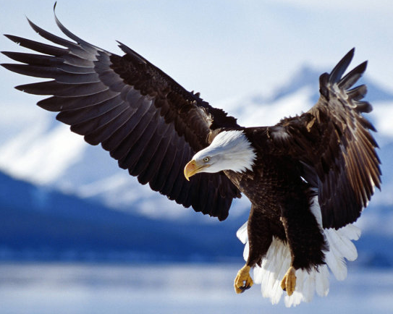
He clasps the crag with crooked hands;
Close to the sun in lonely lands,
Ring’d with the azure world, he stands.

The wrinkled sea beneath him crawls;
He watches from his mountain walls,
And like a thunderbolt he falls.

Clasps: holds tightly Azure: bright blue

- What is the eagle doing in the first stanza (verse)?

…………………………………………………………………………………………………………………………………….

…………………………………………………………………………………………………………………………………….

- How does this change?

…………………………………………………………………………………………………………………………………….

…………………………………………………………………………………………………………………………………….

- Can you find a simile?

…………………………………………………………………………………………………………………………………….

…………………………………………………………………………………………………………………………………….

- Can you find an example of personification (when something not human is given human qualities)?

…………………………………………………………………………………………………………………………………….

…………………………………………………………………………………………………………………………………….

- Is there an image that you find powerful in the poem? Give a reason why.

…………………………………………………………………………………………………………………………………….

…………………………………………………………………………………………………………………………………….

- Where is the eagle?

…………………………………………………………………………………………………………………………………….

…………………………………………………………………………………………………………………………………….

- What does the poem give you a sense of?

…………………………………………………………………………………………………………………………………….

…………………………………………………………………………………………………………………………………….

- Describe the eagle in three words.

…………………………………………………………………………………………………………………………………….

…………………………………………………………………………………………………………………………………….
Creative Response to a Picture

Task: Imagine you are in this picture.

Describe:
- What you can see, hear, smell, touch and taste.
- Why you are there
- How you are feeling
- What is happening that you can’t see in the picture.

………………………………………………………………………………………………………………………………………………….

………………………………………………………………………………………………………………………………………………….

………………………………………………………………………………………………………………………………………………….

………………………………………………………………………………………………………………………………………………….

………………………………………………………………………………………………………………………………………………….

………………………………………………………………………………………………………………………………………………….

………………………………………………………………………………………………………………………………………………….

………………………………………………………………………………………………………………………………………………….

………………………………………………………………………………………………………………………………………………….

………………………………………………………………………………………………………………………………………………….

………………………………………………………………………………………………………………………………………………….

………………………………………………………………………………………………………………………………………………….

………………………………………………………………………………………………………………………………………………….

………………………………………………………………………………………………………………………………………………….

………………………………………………………………………………………………………………………………………………….

………………………………………………………………………………………………………………………………………………….

………………………………………………………………………………………………………………………………………………….

………………………………………………………………………………………………………………………………………………….

………………………………………………………………………………………………………………………………………………….

………………………………………………………………………………………………………………………………………………….

………………………………………………………………………………………………………………………………………………….

………………………………………………………………………………………………………………………………………………….

………………………………………………………………………………………………………………………………………………….

………………………………………………………………………………………………………………………………………………….

………………………………………………………………………………………………………………………………………………….

Create a Newspaper

Task: Write a newspaper report based on this picture.

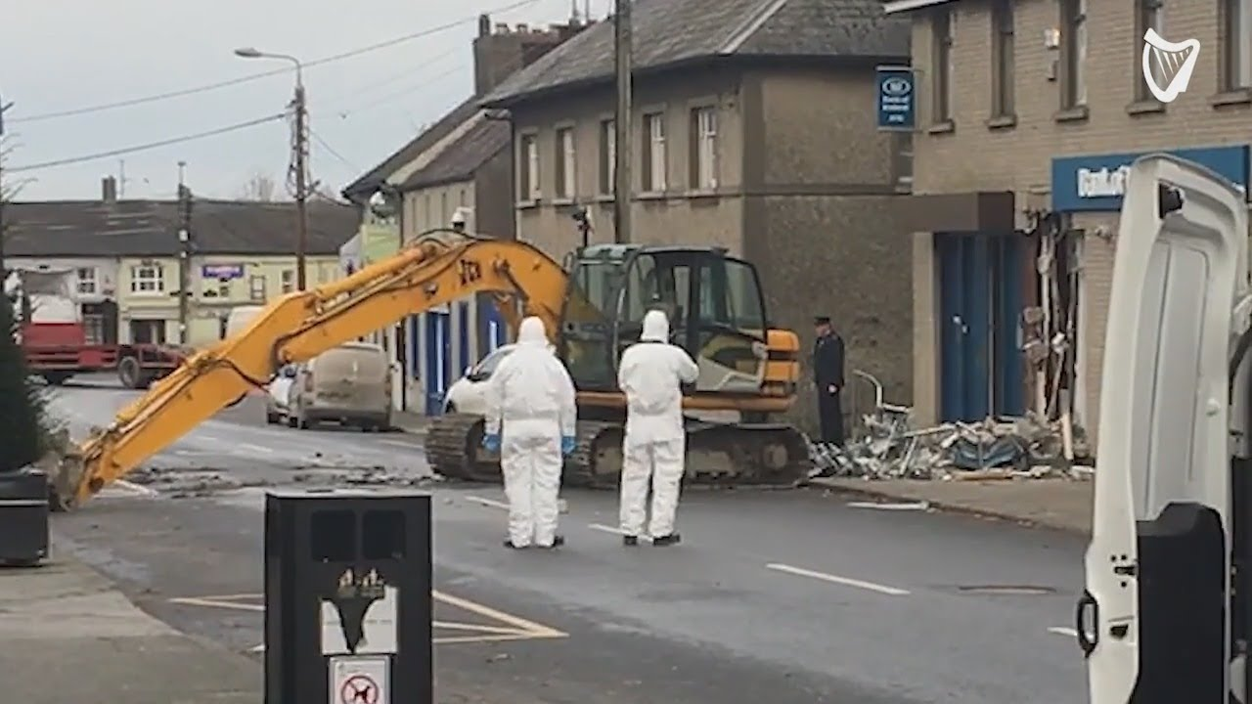

Make sure to include:

- A catchy headline
- The 5 Ws (what happened, where it happened, when it happened, who was there, why it happened)
- A quote from a witness who was there or a person discovering it when they came to work
- The nice-to-knows (what happened next, what is being done, what advice police are giving)
The Daily News

Price Date:

……………………………………………….

……………………………………………….

……………………………………………….

……………………………………………….

……………………………………………….

……………………………………………….

……………………………………………….

……………………………………………….

……………………………………………….

……………………………………………….

……………………………………………….

……………………………………………….

……………………………………………….

……………………………………………….

……………………………………………….

……………………………………………….

……………………………………………….

……………………………………………….

……………………………………………….

……………………………………………….

……………………………………………….

……………………………………………….

……………………………………………….

……………………………………………….

……………………………………………….

……………………………………………….

……………………………………………….

……………………………………………….

……………………………………………….

……………………………………………….

……………………………………………….

……………………………………………….

English Wordsearch
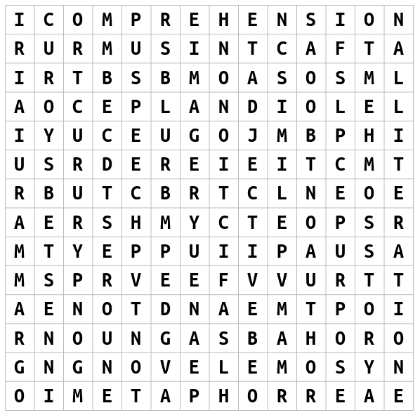
WORDS: Imagery Speech
Suspense Comprehension Metaphor
Grammar Alliteration Author
Story Simile Blurb
Adjective Tone Fact
Fiction Adverb Purpose
Novel Noun Poem

Design a Book Cover

Make sure to include the author name, title and make it bright and colourful! It can be an alternative cover for an existing book or better yet, make your own one up!

Design a Bookmark
Make sure it is bright and colourful. You could base it on your favourite book or superhero!

Create Your Own Comic

