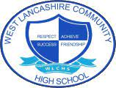
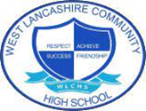

English Long Term Planning
KEY STAGE FOUR - 2022-2023 Cycle 2
Step up to English & AQA Unit Awards

 |  | Cycle 1 | Cycle 2
Autumn | 1 | Myths and Legends  Component 2  Reading & Writing | Heroism  Component 2  Reading & Writing
 | 2 | Myths and Legends  Component 2  Reading & Writing | Heroism  Component 2  Reading & Writing
Spring | 1 | Music  Component 1  Spoken Language | The Next Step  Component 1  Spoken Language
 | 2 | Detectives  Component 1  Reading & Writing | Hobbies  Component 1  Reading & Writing
Summer | 1 | Fashion  Component 2  Reading & Writing | Exploring  Component 2  Reading & Writing
 | 2 | Fashion  Component 2  Reading & Writing | Exploring  Component 2  Reading & Writing

