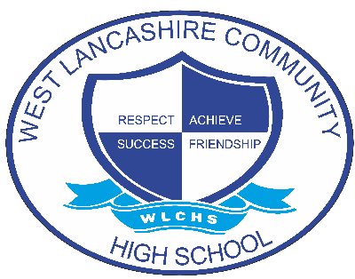

Equalities Policy

Document Control
Document name (inc version number, if applicable) | Equalities Policy (v1)
Date adopted by governing body | 27/1/2026
Next review | 27/1/2027
Owner | Andrew Grant
Approved on behalf of the governing body | Jeff Seddon (Chair of Governors)
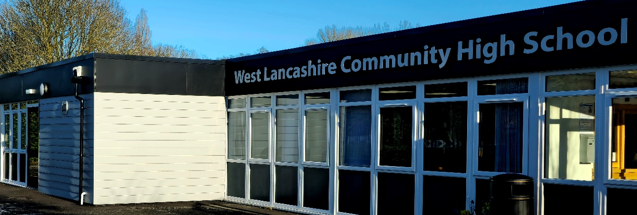

STATEMENT OF PRINCIPLES

The policy outlines the commitment of the staff, students and governors of West Lancashire Community High School to ensure that equality of opportunity is available to all members of the school community. For our school this means not simply treating everybody the same but understanding and tackling the different barriers which could lead to unequal outcomes for different groups of students in school, whilst celebrating and valuing the achievements and strengths of all members of the school community.

These include:
- Students
- Staff
- Parents, carers
- The Governing Body
- Multi-agency staff linked to the school
- Visitors to the school
- Students & Volunteers on placement

We believe that equality at our school should permeate all aspects of school life and is the responsibility of every member of the school and wider community. Every member of the school community should feel safe, secure, valued and of equal worth.

At West Lancashire Community High School, equality is a key principle for treating all people fairly and creating a society in which everyone has the opportunity to fulfil their potential-irrespective of their gender, ethnicity, disability, religion or belief, sexual orientation, age or any other recognised area of discrimination.

Our logo is:
- Achieve
- Respect
- Friendship
- Success

This logo was designed by the students to best reflect what we do here. It is essential that Equality is a theme that permeates all of these aims.
As a secondary special school for students with a wide range (generic) of needs it is paramount that we are able to recognise differences in need and address them appropriate, regardless of what the differences are.

ETHOS AND ATMOSPHERE

West Lancashire is predominantly a white British area with few people from ethnic backgrounds. School works hard to address this issue to ensure that our students are able to value and understand people from a wide range of backgrounds. We visit other groups from more varied ethnic areas in the county and reflect on visits made by staff to other areas of the world in our assemblies.

- At West Lancashire Community High School, the leadership of the school community will demonstrate mutual respect between all members of the school community.
- There is an openness of atmosphere which welcomes everyone to the school.
- All within the school community will challenge any type of discriminatory and/or bullying behaviour, eg. through unwanted attentions (verbal or physical) and unwelcome or offensive remarks or suggestions.
- All students and staff are encouraged to greet visitors to the school with friendliness and respect.
- The displays around the school are of high quality and reflect diversity across all aspects of equality of opportunity and are frequently monitored.
- Provision is made to cater for the spiritual needs of all the children through planning of assemblies, classroom based and externally based activities.

POLICY DEVELOPMENT

This policy applies to the whole school.

MONITORING AND REVIEW

West Lancashire Community High School is an inclusive school, working towards greater equality in the whole school community. We use the curriculum and teaching to enhance the self-esteem of all those it serves and to provide a learning environment in which each individual is encouraged to fulfil his or her potential.

We collect and analyse a range of equality information for our students by:

- Chronological age group.
- Male/female
- Children Looked after
- Special need types (as per statement)
- Level of ability cohort
- Free school meals

This information can be found in the LSIP report (Lancashire School Information Profile) which assists in self-evaluation. We make regular assessments of student’s learning and use this information to track student’s progress, as they move through the school. As part of this process, we regularly monitor the performance of different groups, to ensure that all groups of students are making the best possible progress. We use this information to adjust future teaching and learning plans, as necessary.
Resources are available to support groups of students where the information suggests that progress is not as good as it should be. The governing body receives regular updates on student performance information.
School performance information is compared to national data and local authority data to ensure that all students are making appropriate progress when compared to all schools, and to schools in similar circumstances.
As well as monitoring student performance information, we regularly monitor a range of other information. This relates to:
- Attendance
- Exclusions and truancy
- Racism
- Disability
- Sexism
- Homophobia and all forms of bullying
- Parental Involvement
- Participation in extended learning opportunities

Our monitoring activities enable us to identify any differences in student performance and provide specific support as required, including pastoral support. This allows us to take appropriate action to meet the needs of specific groups in order to make necessary improvements.
West Lancashire Community High School is also committed to providing a working environment free from discrimination, bullying harassment and victimisation. We aim to recruit an appropriately qualified workforce and establish a governing body that is representative of all sections of the community in order to respect and respond to the diverse needs of our population.
We already collect and analyse a range of profile information on our staff and governors including:
- Applicants for employment
- Staff profile
- Governing body profile
- Attendance at training events
- Disciplinary and grievance cases
- Staff performance management
- Exit interviews.

This data is of course confidential and is not collected by name.

Due regard is given to the promotion of equality in the School Development Plan. The person responsible for the monitoring and evaluation of the policy and action plan is the Headteacher.
Their role is:
- Lead discussions, organise training, update staff in staff meetings, support discussions.
- Work with the governing body on matters relating to equality
- Support evaluation activities that moderate the impact and success of this policy.

DEVELOPING BEST PRACTISE

Learning and Teaching
We aim to provide all our students with the opportunity to succeed, and to reach the highest level of personal achievement. To do this, teaching and learning will:
- Provide equality of access for all students and prepare them for life in a diverse society
- Use materials that reflect a range of cultural backgrounds, without stereotyping
- Use materials to promote a positive image of and attitude towards disability and disabled people
- Promote attitudes and values that will challenge discriminatory behaviour
- Provide opportunities for students to appreciate their own culture and religions and celebrate the diversity of other cultures.
- Use a wide range of sensitive teaching strategies when teaching about different cultural and religious traditions.
- Develop student advocacy skills so that they can detect bias, challenge discrimination, leading to justice and equality.
- Ensure that the whole curriculum covers issues of equality and diversity
- All subject leaders, where appropriate will promote and celebrate the contribution of different cultures to the subject matter.
- Seek to involve all parents in supporting their child’s education
- Provide educational visits and extended learning opportunities that involve all student groups
- Take account of the performance of all students when planning for future learning and setting challenging targets
- Make best use of all available resources to support the learning of all groups of students
- Identify resources and training that support staff development

Learning Environment
We have consistently high expectations for all of our students regardless of their starting point. This is also regardless of gender, ethnicity, disability, religion of belief, sexual orientation, age or any other recognised area of discrimination. All students are encouraged to improve on their own achievements and not to measure themselves against others. Parents are also encouraged to view their own children’s achievements in this light.
- Teacher enthusiasm is a vital factor in achieving a high level of motivation and good results from all students
- Adults in the school will provide good, positive role models in their approach to all issues relating to equality of opportunity.
- The school places a high priority on the provision for special educational needs and provides an environment in which all students have equal access to all facilities and resources
- All students are encouraged to be actively involved in their own learning
- A range of teaching methods are used throughout the school to engage and encourage students
- We ensure that the learning is effective by monitoring lessons
- Displays and signage are appropriate to the users.

Curriculum
At West Lancashire Community High School, we aim to ensure that:
- Planning reflects our commitment to equality in all subject areas and cross curricular themes promoting positive attitudes to equality and diversity
- Students will have opportunities to explore concepts and issues relating to identity and equality
- Steps are taken to ensure that all students have access to the mainstream curriculum by taking into account their cultural, backgrounds, linguistic needs and learning styles
- All students have access to qualifications which recognise attainment and achievement and promote progression.

Resources and materials.
The provision of good quality resources and materials within West Lancashire Community High School is a high priority. These resources should:
- Reflect the reality of an ethnically, culturally and sexually diverse society
- Reflect a variety of viewpoints
- Show positive images of males and females in society
- Include non-stereotypical images of all groups in a global context
- Be accessible to all members of the school community

Language
We recognise that it is important at West Lancashire Community High School that all members of the school community use appropriate language which:
- Does not transmit or confirm stereotypes
- Does not offend
- Creates and enhances positive images of particular groups identified at the beginning of this document
- Creates the conditions for all people to develop their self esteem
- Uses accurate language in referring to particular groups or individuals and challenges in instances where this is not the case

Extended Learning Opportunities
It is the policy of the school to provide equal access to all activities.
We undertake responsibility for making contributions to extended learning opportunities and are aware of the school’s commitment to equality of opportunity (eg. sports, escorts, coach drivers) by providing them with written guidelines drawn from the policy.
Our after-school clubs are open to all students.
We try to ensure all our students have access to college links and work experience.
We try to ensure that all such non-teaching staff members who have contact with children adhere to these guidelines.

Provision for Bi-lingual students.
We undertake at WLCHS to make appropriate provision for all EAL/Bi-lingual students to ensure access to the whole curriculum. Any students who require this type of provision will access it on arrival. These groups may include:
- Students for whom English is an additional language
- Students who are new to the UK
- Gypsy, Roma and Traveller Children

Personal Development and Pastoral Guidance.
- Staff take account of gender, ethnicity, disability, religion or belief, sexual orientation, age or any other recognised area of discrimination and the experience and needs of particular groups such as Gypsy, Roma and Traveller, refugee and asylum seeker students.
- All students are encouraged to consider the full range of career opportunities available to them with no discriminatory boundaries placed on them due to their disability, gender, race or sexual orientation( whilst acknowledging that a disability may impose some practical boundaries to some career aspirations)
- All students/staff/carers are given support, as appropriate, when they experience discrimination.
- We recognise that perpetrators may also be victims and require support.
- Positive role models are used throughout the school to ensure that different groups can see themselves reflected in the school community
- Emphasis is placed on the value that diversity brings to the school community rather than the challenges.

Staffing and staff development.
We recognise the need for positive role models and distribution of responsibility among staff.
- This must include students’ access to a balance of male and female staff at all key stages where possible.
- We encourage the career development and aspirations of all school staff
- It is our policy to provide staff with training and development, which will increase awareness of the needs of different groups of students.
- Access to opportunities for professional development is monitored on equality grounds.

Staff Recruitment.
- All those involved in recruitment and selection are trained and aware of what they should do to avoid discrimination and ensure equality good practice through the recruitment and selection process.
- Equalities policies and practices are covered in all staff inductions
- All temporary staff are made aware of policies and practices through an induction programme.
- Employment policy and procedures are reviewed regularly to check conformity with legislation and impact.

Partnerships with parents/Carers/families and the wider community.
We will work with parents/carers to help all students to achieve their potential.
- All parents/carers are encouraged to participate in the full life of the school
- Setting up, as part of the schools’ commitment to equality and diversity, a group made up of all stakeholders of the school community. This will be developed to support the school with matters related to its equality duties.
- Members of the local community are encouraged to join in school activities.
- Exploring the possibility of the school having a role to play in supporting new and settled communities.

Roles and responsibilities.
Our governing body will ensure that the school complies with statutory requirements in respect of this policy and action plan.
- The Headteacher is responsible for the implementation of this policy, and will ensure that staff are aware of their responsibilities, that they are given necessary training and support and report progress to the governing body.
- The Headteacher has day to day responsibility for co-ordinating the implementation of this policy.
- Our staff will promote an inclusive and collaborative ethos in the school, challenge inappropriate language and behaviour, respond appropriately to incidents of discrimination and harassment, ensure appropriate support for students with additional needs and maintain a good level of awareness of equalities issues.
- All members of the school community have a responsibility to treat each other and staff with respect, to feel valued, and to speak out if they witness or are subject to any inappropriate language or behaviour.
- We will take steps to ensure that all visitors to the school adhere to our commitment to equality.

COMMISSIONING AND PROCUREMENT

WLCHS will ensure that we buy services from organisations that comply with equality legislation. This will be a significant factor in any tendering process.

THE MEASUREMENT OF IMPACT OF THE POLICY

This policy will be evaluated and monitored for its impact on students, staff, parents and Carers from the different groups that make up our school. An Action plan will be published to enable an impact assessment to be undertaken at the appropriate time within a given timescale.

PUBLICISING THE POLICY AND PLAN

This policy will be available on the school website and copies available from the school office if required.

ANNUAL REVIEW OF PROGRESS

Report annually on progress and performance in respect of your policy covering ethnicity, disability and gender and to report annually on your progress to improve access for disabled students, including access to the curriculum, physical access and access to info.

