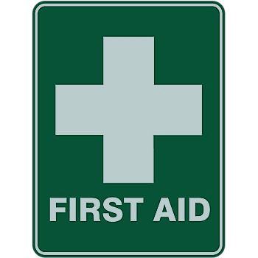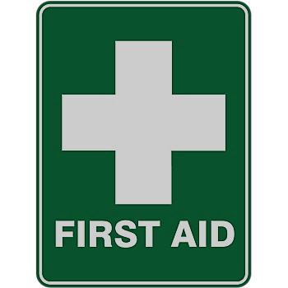WE ARE A SAFE SCHOOL 2023-24

First Aid Lead Person Offsite First Aiders Medicines Lead Emergency First Aiders at Work:

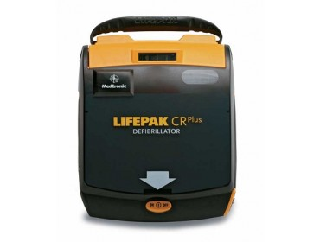

There is a First Aid box in every classroom _______________

First Aid packs for Transport are on School Minibuses

The Defibrillator is located on the wall in the school Foyer

ALL OTHER TEACHING STAFF ARE ‘SCHOOLS FIRST AID’ TRAINED