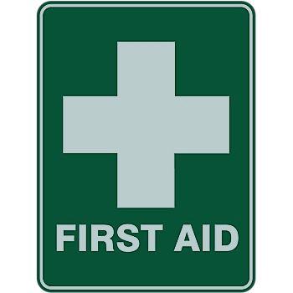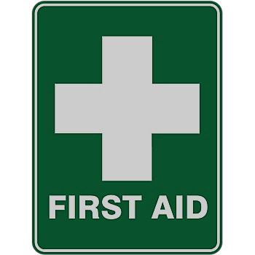WE ARE A SAFE SCHOOL 2025-27

First Aid & Medicines Lead Offsite First Aiders Emergency First Aiders at Work

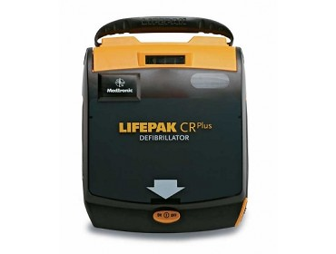

There is a First Aid box in every classroom _______________

First Aid packs for Transport are on School Minibuses

The Defibrillator is located on the wall in the school Foyer

ALL OTHER TEACHING STAFF ARE ‘SCHOOLS FIRST AID’ TRAINED