Goldilocks’



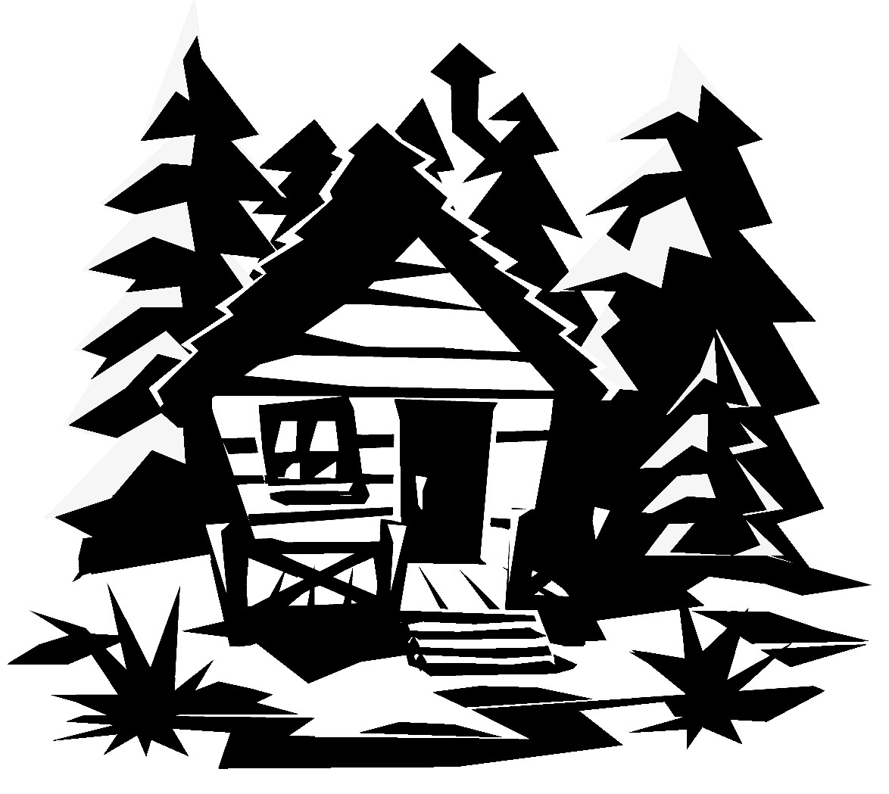

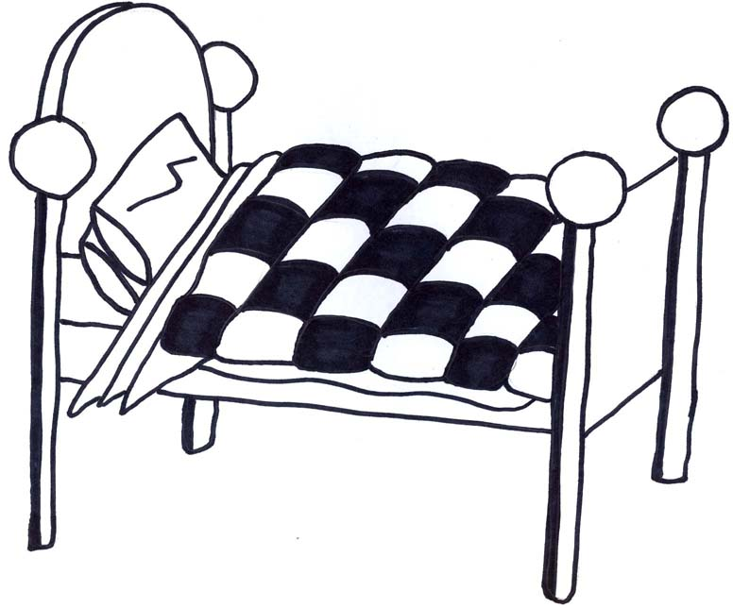

Extension question:

Do you think Goldilocks should be found guilty? Why?

________________________________________________________________________________________________________________________________

Check your work.

Have you included:

* Adjectives
* Adverbs
* Connectives

Explain what you did in the morning:

________________________________________________________________________________________________________________________________________________________________________________________________________________________________________________________________________________________________________________________________________________________________________________________________________________________________________________________________

Describe what happened in the cottage:

________________________________________________________________________________________________________________________________________________________________________________________________________________________________________________________________________________________________________________________________________________________________________________________________________________________________________________________________

Describe the bear’s reaction and how you felt:

________________________________________________________________________________________________________________________________________________________________________________________________________________________________________________________________________________________________________________________________________________________________________________________________________________________________________________________________

