Baby Bear’s



Check your work.

Have you included:

* Adjectives
* Adverbs
* Connectives

Extension question:

Do you think Goldilocks should be found guilty? Why?

________________________________________________________________________________________________________________________________

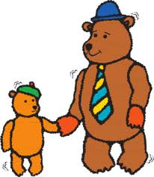



Morning:

________________________________________________________________________________________________________________________________________________________________________________________________________________________________________________________________________________________________________________________________________________________________________________________________

________________________________________________________________

Arriving home:

________________________________________________________________________________________________________________________________________________________________________________________________________________________________________________________________________________________________________________________________________________________________________________________________________________________________________________________________

How you feel:

________________________________________________________________________________________________________________________________________________________________________________________________________________________________________________________________________________________________________________________________________________________________________________________________

________________________________________________________________

