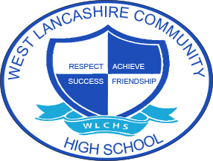
3 Year Long Term Overview
Subject:  Humanities | Autumn Term  Theme | Spring Term  Theme | Summer Term  Theme
Year 1 | Fair Trade  History focus: Transatlantic Slave Trade, Liverpool docks.  Geography focus: Map Skills Africa, Location, Weather – Food Production, Farming, UK Comparison (COCOA/BANANA) and Fair Trade | My Environment  Local study – How our environment has changed overtime  Geography Focus: Local Environment – Compare to Overseas, Population and Settlements | Space  History Focus: Skills – Story of the Landing on the Moon Chronology, Source Information, Ordering, How Technology Has Changed Overtime  Geography Focus: Comparison of 2 Space Race Countries (USA AND RUSSIA) Location, Physical, Tectonics, Weathering, Climate (Polar and Deserts)
Year 2 | Around the World  Natural disasters  Volcanoes, Tsunami, Earthquakes | Lights Camera Action  History – comparing film with validated sources of real events | Farm to Fork  British farming v Global  Vegetation belts  Shopping in settlements  History of how farming has changed over time
Year 3 | Best of British  Significant people in British history  Industrial revolution  British Tourism Country/Seaside/City | Looking After Me  Study of the school. History of the school, how the school has progressed over time. Map skills, plan of school, map work, keys, symbols etc | Animal Kingdom  Aquatic, Tundra, Grasslands  How animals have adapted over time  Exploration through time

