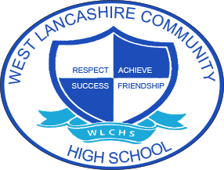
3 Year Long Term Overview
 | Autumn Term Theme | Spring Term  Theme | Summer Term Theme
Year 1 | Fair Trade  SMSC- African culture and its influences on the UK.  Why should we buy Fair trade products?  Language- French food and drink | My Environment  SMSC- cultural diversity within Skelmersdale.  Language- Ma ville, ma maison | Space  SMSC-  Language- maps and directions
Year 2 | Around the World  SMSC- respecting a diverse world, appreciating different cultures and celebrations.  Language- holidays | Farm to Fork  SMSC- developing understanding of where our food comes from, how it is produced and harvested.  Language- seasons | Lights Camera Action  SMSC –  Language- hobbies, French cinema
Year 3 | Best of British  SMSC- what are British traditions?  Language- jobs and transport | Looking After Me  SMSC- understanding of different families and homes.  Language- my family and body | Animal Kingdom  SMSC- life in  Language- animals

