Key Stage 3C – Learning Beyond the Classroom
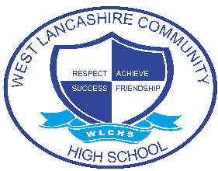

Read a short story, magazine article etc. discuss with an adult what it is about. | Use your knowledge of money to pay for items at the shop with a trusted adult to help. | Can you practice telling the time on the clocks in your house at least once a day | Can you go home and explain something you have learned to a family member (from any subject)
Make yourself a snack at home. | Can you complete 1 chore for the week e.g. make your bed. | Follow a simple recipe and make a snack for family members. | Set the table, put the dishes away
With an adult go for a walk in your local area. | In school join in a game of football or tag. | Play outside with someone at home in the nice weather in the garden or on the field. | Visit the local park with friends or an adult
At club or break time play or talk to someone who you don’t normally speak to. | With a trusted adult can you order something to eat in a café or ask for an item in the shop. | Can you check on an elderly relative and see if they are ok? Do they need any help or shopping? Work with an adult | When you are sat with your family ask everyone what they highlight of their day was.
Tell someone at home something that you have done that has made you proud today. | Take part in a mindfulness activity for at least 15mins (meditation, colouring etc). | Take a check in home with you. Tell your family what the check in is use it morning and night for a week. | Play a game with the people who you live with. eye spy, snakes and ladders.

