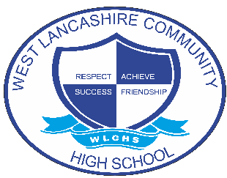
Key Stage 3S – Learning Beyond the Classroom

Count out how many cups or plates are needed to set the table at your home. | Read or listen to a story with an adult and then talk about what happened in it. | Go on a shape hunt around your home or in the community. | Pay for items in a shop or café, making sure that you wait for any change.
Order/request something in a café or over the phone. | Help to tidy a room or area in your home. | Put your clothes away into your wardrobe and drawers after they have been washed and dried. | Show that you can care for a living thing in your home, such as a pet or a plant.
Go for a walk outside. | Complete a kids yoga session by following a video on YouTube. | Find a quiet and comfortable space to sit and listen to some music when you are feeling stressed, angry, or sad. | Organise yourself for a bath or shower. Get your towel, clothes and toiletries ready.
Play a ball game or board game with your family. | Do something kind for someone in your family such as making them a card or picking a flower to give to them. | Help a family member or friend with a job. | Help to sort the washing and then put a wash on in your home.
Make a snack or drink without any help from adults at home. | Follow a shopping list to do the weekly shopping with help from an adult. | Show that you can be safe around cars whilst out in the community with an adult. | Choose clothes you want to wear and get dressed into them by yourself.

