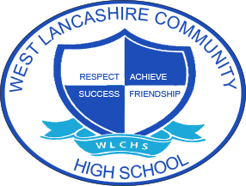
WEST LANCASHIRE COMMUNITY HIGH SCHOOL CURRICULUM AIMS
KEY STAGE 3 CURRICULUM STATEMENT
CONTEXT
Students in Key Stage 3 will access a broad and balanced curriculum that is based on the acquisition of knowledge and the application of skill in functional and meaningful activities. All students will access a curriculum that supports their cognitive development but also their communication and interaction skills, their social and emotional development, and their physical development. They will have opportunities to develop their character through activities that develop each students’ resilience. Students in Key Stage 3 will prepare themselves for their future accreditation studies.
The learning in the curriculum will take place in school
Key Stage 3
INTENT | IMPLEMENTATION | IMPACT
What is the intention of teaching and learning?  To develop a secure foundation of self-regulation and self-management so that each student can develop a strong resilient ethos to learning and life.  To develop literacy and numeracy skills through  To identify student learning journeys and potential accreditation routes and final destinations. | How will it be implemented?  Students are based within Pastoral learning groups based on Boxall Profiling.  Foundation subject learning will support the delivery of diagnostic and development outcomes to support each students’ character development and attitude to learning.  Students will be ability based for core learning (English and Maths).  English groups are ability based using reading assessments to allow better targeted approaches to improve SPaG, reading and writing.  All subjects will be planned with a focus on acquisition of knowledge, application of knowledge and skills and character development.  Students will apply skills functionally both in school and in the wider community.  Use of assessments and collaborative working through ASKL’s to track individual student journey’s and predict and plan for specific destinations. | How will we measure or monitor impact of teaching and learning?  Evidence for Learning and PLG’s will be used measure progress of EHC Outcomes.  B Squared Profiles will be used to measure the impact of core subject teaching and learning.  Boxall assessment reviews will measure the impact of social and emotional development.  Review of behaviour incidents to measure the impacts of pastoral groupings.  Annual review process and provision maps will be used to measure the impact of interventions and support strategies on students’ access to learning.

