

Transition weeks

Baselining Maths/English

Review paperwork

DofE Award Approvals

Work Experience placements identified

Risk Assessments submitted

Baselining Thrive

Accreditation Pathways identified

Review paperwork

DofE registrations, programmes, assessors identified

Autumn IEPs

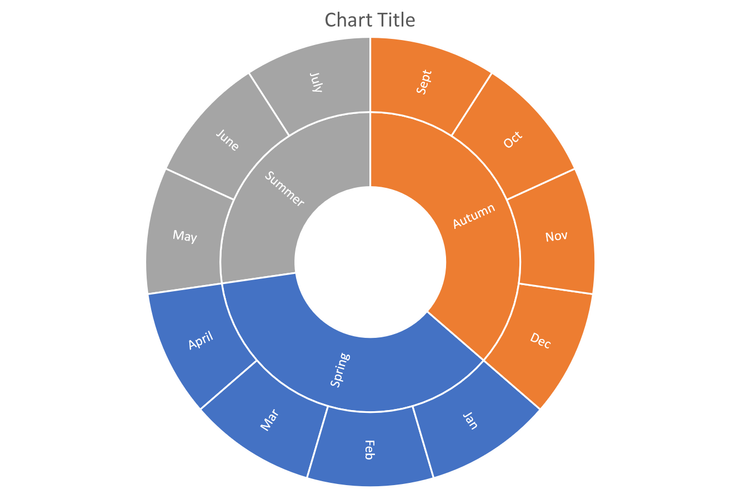

**EfL updates ongoing throughout year**

Report writing

Entry Level Assessments

Functional Skills Assessments

Summer IEPs

ELC & FS Speaking & Listening Assessments

DofE – eDofE programme update

ASDAN folder/student book update

Spring IEPs

Moderation

Functional Skills mock exams

EfL moderation (assessment week)

Autumn IEP review

ASDAN Internal Moderation

DofE – eDofE programme update

Leavers’ Assembly

Review paperwork

ASDAN folder & student book update

DofE expeditions, assessor reports

Practice Speaking & Listening ELC &FS

ASDAN Internal moderation

Assessment & Moderation

Assessment & Moderation Maths & English

Report writing

ASDAN folder/student book update

Assessment & Moderation

Spring IEP review

**KS5**

**Annual**

**Cycle**