**Skilled areas - Writing**

E1.12 W Use a capital letter for the personal pronoun ‘I’ and the first letter of proper nouns

* Identify common nouns, proper nouns
* give simple definitions of each word class
* Use capital letters for proper nouns including ‘I’.

E1.15 W Spell correctly words designated for Entry Level 1

E1.16 W Communicate information in words, phrases and simple sentences

* write simple sentences using capital letters and full stops

Ongoing:

E1.11 W Punctuate simple sentences with a capital letter and a full stop

* Identify when to use capital letters and full stops
* Add capital letters and full stops to a short piece of text

E1.13 W Use lower-case letters when there is no reason to use capital letters.

**Skilled areas – Reading**

E1.8 R Read correctly words designated for Entry Level 1

E1.9 R Read simple sentences containing one clause

* read simple sentences containing common Entry Level 1 words

E1.10 R Understand a short piece of text on a simple subject

* Read simple sentences
* Read simple texts and locate information to answer questions
* identify the main information from the text
* say what a short piece of text is about

**Skilled areas** **- Speaking and Listening**

E1.2 SLC Identify and extract the main information from short statements and explanations

E1.6 SLC Make clear statements about basic information and communicate feelings and opinions on straightforward topics

E1.7 SLC Understand and participate in simple discussions or exchanges with another person about a straightforward topic

Cycle 2

Autumn 2 – News & Media (Reporting) E1

**Activity Ideas – Writing**

* Highlight the nouns and verbs in a given list/text, or sort words into categories. Create simple definitions for each of the word classes with examples. For example: Noun – a thing: girl, boy, person; Verb – an action: walk, play
* Colourful semantics to form sentences e.g. who, doing, what. Using images as prompts, spell common verbs e.g. run, sleep, swim, play/ match picture to word. Verb bingo.
* Spell words in the past tense where the root word stays the same, e.g. ‘wanted’, ‘opened’, ‘jumped’. Write simple sentences using past tense, using a word bank to support.
* Write a simple report e.g. an article for a Newsletter or blog. Perhaps about what they’ve done in a lesson/work experience.

**Learning Outside the Classroom**

* Reporting on a visit/LOtC experience
* Visiting a Newsagent

**Activity Ideas - Reading**

Read simple sentences e.g. ‘Tim played football’; ‘I saw litter’.

Read texts e.g. simple news/magazine articles/blogs and locate information to answer questions e.g. if reading a report on a football match; which football team won? What day was the match?

**Wider Reading**

Non-fiction texts e.g. Newspapers, magazines, articles, websites/blogs.

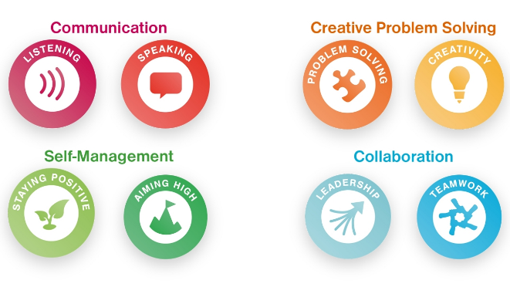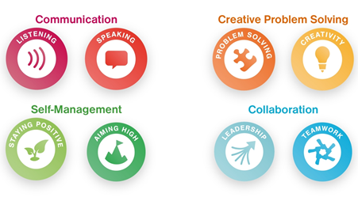

**Resources**

Texts, Newspapers/magazines. Mini whiteboards and pens, laptops/i-pads.

**Activity Ideas - Speaking & Listening**

* Watch short news clips or look at simple news articles and say how a situation makes them feel. For example, ‘sad’, ‘happy’, ‘angry’.
* Discuss what seen on a Newsround clip
* Talk about what did at the weekend
* Talk about an event e.g. a school visit, work experience
* Roleplay giving a news report for an event such as above, or a fictional event

**Skilled areas - Writing**

E2.16 W Spell correctly words designated for Entry Level 2

* identify common prefixes
* spell words with prefixes where the root word is unchanged
* spell words correctly that use the prefixes ill-, im-, ir

E2.17 W Communicate information in words, phrases and simple sentences

* identify how to begin and end an informal email/letter
* write an informal email/letter

E2.19 W Write in compound sentences, using common conjunctions (e.g. or, and, but) to connect clauses

* identify simple conjunctions
* select the correct conjunction
* use conjunctions in their writing

**Skilled areas – Speaking and Listening**

E2.1 SLC Identify and extract the main information and detail from short explanations

E2.4 SLC Follow the gist of discussions

E2.3 SLC Respond appropriately to straightforward questions

* answer simple verbal questions

E2.5 SLC Clearly express straightforward information and communicate feelings and opinions on a range of straightforward topics

* contribute to a group discussion
* share their opinion with the group
* say what they feel
* listen to the views of others

**Skilled areas - Reading**

E2.7 R Read correctly words designated for Entry Level 2

E2.8 R Understand the main points in texts

* discuss the main points in the text
* answer questions on a text

E2.11 R Read and understand sentences with more than one clause

* identify simple conjunctions
* read compound sentences

E2.12 R Use illustrations, images and captions to locate information

Cycle 2

Autumn 2 – News & Media (Reporting) E2





**Wider Reading**

Non-fiction texts e.g. Newspapers, magazines, articles, websites/blogs.

**Activity Ideas – Reading**

* Match headlines to short texts.
* Read texts e.g. simple article/blog and locate information to answer comprehension questions.
* Match written captions to images.
* Use images and captions in the text to locate information. For example, an image of the celebrity winning an award may be captioned to say what the award was for.

**Learning Outside the Classroom**

* Reporting on a visit/LOtC experience
* Visiting a Newsagent
* Community visit e.g. mile walk to explore local issues

**Activity Ideas – Writing**

* Spell words with prefixes from the Entry Level 2 specification (Annexe C). For example: ‘disappoint’, ‘return’, ‘illegal’, ‘immoral’, ‘irreversible’, . Gap-filling exercise. Select the correct spelling of words with prefixes from a given list.
* Write captions for images.
* Write an informal email/letter e.g. to a local MP about a local issue e.g. graffiti/litter
* Write a simple report e.g. an article for a Newsletter or blog. Perhaps about what they’ve done in a lesson/work experience/school visit.

**Activity Ideas - Speaking & Listening**

- Discuss the main points in a text/news clip and answer verbal questions.

- Take part in discussions and be ask and answer straightforward questions. For example, asking what did you do at the weekend?

- Watch short news clips or look at simple news articles and say how a situation makes them feel.

- Talk about an event e.g. a school visit, work experience

- Discuss an issue e.g. graffiti/litter locally and say how it makes them feel.

**Resources**

Texts, Newspapers/magazines, mini whiteboards and pens, laptops/i-pads.

**Resources**

Texts, Newspapers/magazines, mini whiteboards and pens, laptops/i-pads.

**Learning Outside the Classroom**

* Reporting on a visit/LOtC experience
* Visiting a Newsagent
* Community visit e.g. mile walk to explore local issues

**Activity Ideas – Writing**

* Introduce past tense. Spell common verbs in past tense. Sort verbs into past or present tense.
* Re-arrange sentences into a logical sequence to write a paragraph.
* Write a straightforward text in a logical sequence. For example, learners could write a report about an event e.g. a school visit, work experience, a weekend
* Write a formal email/letter about a local or further afield issue e.g. writing to an MP about litter/graffiti in the local area.
* Write a blog about a hobby/interest or interview a peer/staff about a hobby/interest and write an article about this.



**Wider Reading**

Non-fiction texts e.g. Newspapers, magazines, articles, websites/blogs.

**Activity Ideas - Reading**

* Read and answer comprehension questions on texts e.g. simple newspaper or magazine articles, blogs, a story about a celebrity.
* Explore newspapers and magazine and identify different purposes e.g. to inform, to advertise, to entertain, to educate, to persuade. Compare formal/informal.
* Sequence events from a news clip/article.

**Skilled areas - Writing**

E3.15 W Use mostly correct grammar, (e.g. consistent use of tense)

E3.18 W Communicate information, ideas and opinions clearly and in a logical sequence (e.g. chronologically, by task)

E3.17 W Spell correctly words designated for Entry Level 3

E3.21 W Write in compound sentences and paragraphs where appropriate

* know how to write a compound sentence and when to use a paragraph

**Skilled areas – Speaking and Listening**

E3.1 SLC Identify and extract relevant information and detail in straightforward explanations

* identify the main points and information
* say what the discussion was about.

E3.2 SLC Make requests and ask concise questions using appropriate language in different contexts

* ask questions and listen to the reply

E3.3 SLC Communicate information and opinions clearly on a range of topics

* share ideas about the topic with their group.

E3.5 SLC Follow and understand the main points of discussions

* demonstrate listening skills such as making eye contact, nodding, and waiting for a gap before speaking
* focus on the topic of the discussion and stick to the subject
* identify the main points and information

**Activity Ideas - Speaking & Listening**

- Discuss the main points in a text/news clip and answer verbal questions.

- Take part in discussions and be ask and answer straightforward questions. For example, asking what did you do at the weekend?

- Watch short news clips or look at simple news articles and say how a situation makes them feel.

- Talk about an event e.g. a school visit, work experience

- Discuss an issue e.g. graffiti/litter locally or wider issue of recycling and say how it makes them feel.

Cycle 2

Autumn 2 – News & Media (Reporting) E3

**Skilled areas - Reading**

E3.8 R Read correctly words designated for Entry Level 3

E3.9 R Identify, understand and extract the main points and ideas in and from texts

* read and identify the main points and ideas in a text
* answer comprehension questions about the text

E3.10 R Identify different purposes of straightforward texts

* say some key purposes of writing
* read and identify the purpose of a text