 | 1 | 2 | 3 | 4 | 5 | 6
 |   Miss Chisnall | 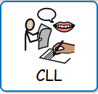  Miss Chisnall | 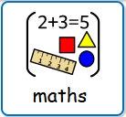  Miss Chisnall | 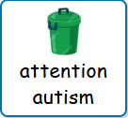  Miss Dickinson | 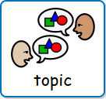  Mr Mullen | Mr Mullen
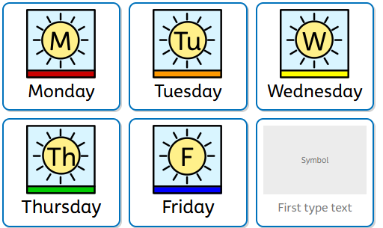 | Miss Chisnall | Miss Chisnall |   Miss Chisnall | Miss Chisnall | Miss Chisnall | Miss Chisnall
 | Miss Chisnall | Miss Chisnall | Miss Chisnall | 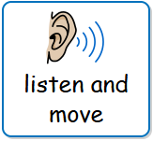  Miss Chisnall | Miss Chisnall | Miss Chisnall
 | Miss Chisnall | Miss Chisnall |   Miss Chisnall | Miss Chisnall | 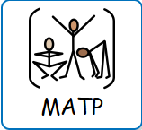  Mrs Reynolds | Mrs Reynolds
 | Mr Croft | 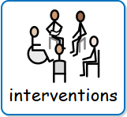 | Miss Chisnall |   Miss Chisnall | 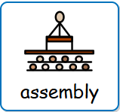  Miss Chisnall |   Miss Chisnall

