Key Stage 4P Maths – Adding Money using Decimals (top-level)

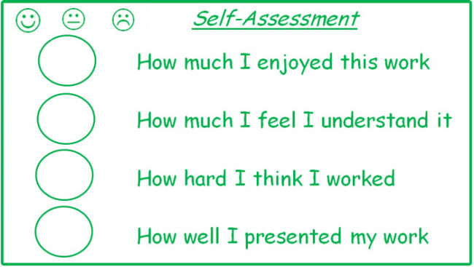
Self-Assessment – Score yourself 1 to 5 for your work today in the circles
My next step would be…

