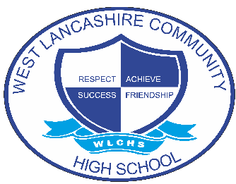
INTERVENTION OVERVIEW

NAME OF INTERVENTION
Lego Therapy
AREA OF FOCUS (PLEASE HIGHLIGHT)
COGNITION AND LEARNING | COMMUNICATION AND INTERACTION | SOCIAL, EMOTIONAL AND MENTAL HEALTH | PHYSICAL AND SENSORY | SELF-HELP AND INDEPENDENCE
INTENT
Lego-based therapy (LeGoff et al 2014) is an evidence based approach that aims to develop social communication skills in autistic children or those who require further social communication support, such as sharing, turn-taking, following rules, using detailed language and problem-solving within groups.
Through the 3 tier programme we aim to provide pupils with the key skills that enable them to access the wider world and reach individual potential.
IMPLEMENTATION
The program is split into 3 stages which increase in complexity.
- Level 1 - To develop basic skills needed for successful communication and Lego building sessions (turn taking, following instructions, shape and colour recognition, prepositional language skills etc). Students have the opportunity to work individually and in pairs at this stage for adult led activities.
- Level 2 - To build on the skills gained in stage 1 to work as a group of 3 or 4 students to build a Lego set collaboratively. Students are given specific roles at this stage (Builder, Engineer, Supplier, Architect). Each role allows students to develop different skills and they rotate jobs to develop a range of communication skills. The focus here is working together to solve both building and communication problems. Discrete sessions linked to teamwork, conflict resolution and further communication strategies support this phase.
- Level 3 - A this stage, students progress to transferring skills learned to other activities. The focus here is to be able to work in pairs and groups in a variety of situations and to practice using communication skills learned at Level 1 and Level 2. Activities are linked to life skills opportunities where possible such as cooking.
IMPACT
The skills developed within Lego Therapy sessions are transferrable across all areas of the academic and social curriculum.
- Improvement in spoken communication – structure, detail and content.
- Increased ability to understand and demonstrate positive listening skills.
- Awareness of the positive outcomes achievable when working as a team. Understanding the importance of turn taking and patience.
- Ability to follow structure, rules and routine in wider learning environments and the community.
- Implantation of spoken language within the community.
Impact for each pupil is monitored and recorded through reflection diaries, observations and PLG outcomes.

