15th June 2020

Dear Student,

I am writing to you to let you know that we are starting to welcome some of our students back to school.

I know that some students may feel anxious about returning to school and it is ok to have these feelings. Staff at school have been working hard to prepare classrooms so that when you do come to school you feel safe.

School will look a little bit different and the changes may worry you. It is ok to feel worried and staff at school will support you and help you get used to the changes.

When you arrive at school you will notice that there are signs placed around school to remind us all of what we need to do. These signs will remind us to;

- Keep our distance
- Wash our hands
- Use hand gel
- To place rubbish in the bins

Some signs and displays may look like this
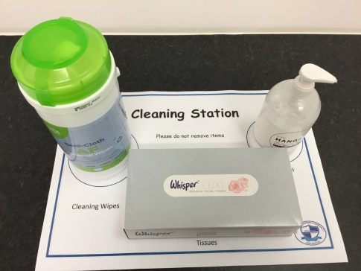
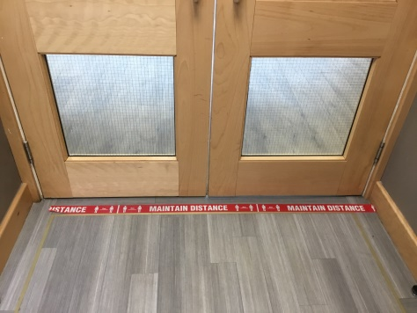

To help you enjoy your time back at school, you will have your own work place in the classroom and you will be given your own equipment.
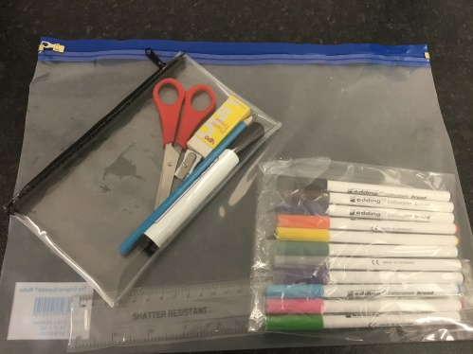

Staff at school have been busy preparing your timetable for when you return and this will be shared with you as soon as possible.

The way you travel to school may also change and this may make you feel nervous or sad. It is ok to feel nervous or sad and staff at school will support you to help you manage your thoughts and feelings.

We all look forward to welcoming you back to school.

Mr Fazackerley
Headteacher

