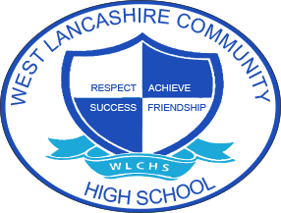
3 Year Long Term Overview
Subject  Computing | Autumn Term Theme | Spring Term Theme | Summer Term Theme
2020 – 2021 | Fair Trade  Finding Information and Presenting using appropriate applications.  Safely Searching for Information  (Information Technology and Digital Literacy) | My Environment  Algorithms and programming  Keeping Your Information Safe  (Computer Science and Digital Literacy) | Space  3D Digital Art  Cyberbullying  (Information Technology and Digital Literacy)
2021 – 2022 | Around the World  Using Data in Spreadsheets in a Functional Way  Using Social Media Safely  (Information Technology and Digital Literacy) | Farm to Fork  Programming and Automation  Stranger Danger  (Information Technology and Digital Literacy) | Lights Camera Action  Using Digital Media  Hacking and Viruses  (Information Technology and Digital Literacy)
2022 – 2023 | Best of British  Computer Architecture  Input/Output  PowerPoint  Data Security  (Information Technology and Digital Literacy) | Looking After Me  Algorithms and Programming  File Sharing  (Computer Science and Digital Literacy) | Animal Kingdom  Using Word Processing Software and Emails  My Online Identity  (Information Technology and Digital Literacy)

