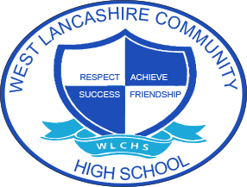

3 Year Long Term Overview
Subject  English | Autumn Term Theme | Spring Term Theme | Summer Term Theme
2020 – 2021 | Fair Trade  Information texts  Reading and writing leaflets, brochures and magazines focusing on layouts. Planning and writing information texts using technology. | My Environment  Creative writing  Visiting a range of settings in the environment as a stimulus to write captions/ stories. Focus on descriptive writing skills | Space  Non-fiction texts  Non-fiction Space themed texts to explore features of non-fiction texts: glossaries, index pages, contents page, photographs, diagrams, labels, facts, headings and subheadings.
*2021 – 2022 | Around the World  Storytelling  Retelling stories through speaking and listening, writing composition skills, using storytelling traditions and methods from around the world as a stimulus for writing. | Farm to Fork  Writing instructions  Reading and writing recipes, shopping lists, food labels and packaging, instructions for operating machinery and planting, safety procedures. | Lights Camera Action  Drama and role play  Reading and exploring features of plays, theatre, spoken word, script writing, expressive language skills. Class play focus and performing own play.
2022 – 2023 | Best of British  British poets  Reading and analysing famous British poems, spoken and written verse, rhyming, poem structures. Julia Donaldson, William Wordsworth, TS Eliot, Edward Lear, Michael Rosen, Lewis Carroll. | Looking After Me  Autobiographies  Writing in the first person, famous autobiographies, chronology, memory and recall of information, adverbials and conjunctions. | Animal Kingdom  Fiction texts  Class fiction text including animal characters e.g. Jungle Book, Charlotte’s Web, The Wind in the Willows. Focus on features of fiction texts, personification, setting and characters.
*DENOTES THE CURRENT YEAR

