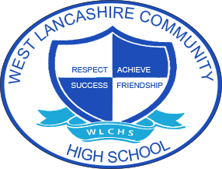

3 Year Long Term Overview
Subject  Science | Autumn Term Theme | Spring Term Theme | Summer Term Theme
2020 – 2021 | Fair Trade  Materials | My Environment  Energy and earth’s resources, weather, climate change, water cycle | Space  Earth and beyond, solar system
*2021 – 2022 | Around the World  Soils, rocks, fossils and dinosaurs | Farm to Fork  Plants, diet and nutrition, digestion, food chains | Lights Camera Action  Light, sound and electricity
2022 – 2023 | Best of British  Forces, gravity, speed, magnets, friction, air resistance, buoyancy | Looking After Me  The human body | Animal Kingdom  Classification and variation, life cycles, food chains
*DENOTES THE CURRENT YEAR

