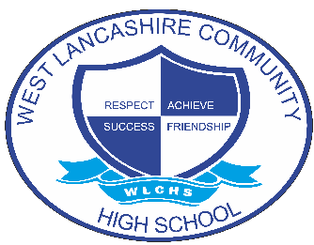
INTERVENTION OVERVIEW

NAME OF INTERVENTION
Motor Activity Training Programme

AREA OF FOCUS (PLEASE HIGHLIGHT)
COGNITION AND LEARNING | COMMUNICATION AND INTERACTION | SOCIAL, EMOTIONAL AND MENTAL HEALTH | PHYSICAL AND SENSORY | SELF-HELP AND INDEPENDENCE
INTENT
The Motor Activity Training Programme is part of the Special Olympics and is designed for students who are unable to participate in official sports competitions due to their functional abilities. It is designed to prepare out students, including those with severe or profound disabilities and significant physical disabilities, for sport-specific activities appropriate for their ability and need.
Key skills students will develop are:
- Gross motor skills
- Fine motor skills
- Kicking skills
- Throwing skills
IMPLEMENTATION
The Programme is usually done over 6-10 weeks, ending in a Challenge Event where staff, parents, governors, and students come together to celebrate everyone's achievements throughout recent participation in the programme.
Programme Structure:
- Warm-Up Activities – General awareness activities, relaxation activities and stretching
- Skill Stations – Activities that develop basic motor skills of Mobility, Dexterity, Striking, and Kicking
- Group Game – A fun way for participants to apply the skills practiced at the skill stations. Also provides opportunity for participants to learn rules of a certain game and interact with peers and volunteers
- Conclusion – Conduct range of motion/stretching and relaxation activities to cool down
IMPACT
Students who access the Motor Activity Training Programme develop:
- Confidence and self-esteem in sport
- Progress with gross and fine motor skills
- Progress with kicking and throwing skills
- Ability to participate in sport in an accessible way

